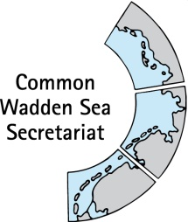
MEETING DOCUMENT
Task Group World Heritage (TG-WH 30)
29 April 2020
Virtual Meeting

Agenda Item: 3
Subject: Announcement Hamburg
Document No.: TG WH 30/3/4
Date: 28 April 2020
Submitted by:

- Anniversary: 30 years ago the Nationalpark of Hamburg has been established. Our senator wants to support a new building for the voluntary nature conservation.

- In Germany we celebrate e.g. flower of the year and soil of the year. 2020 the “soil of the year” is the tidal flat soil. For more information:
https://boden-des-jahres.de/
www.umweltbundesamt.de/publikationen/flyer-boden-des-jahres-2020-wattboden.

- Due to the Corona crisis the island is locked and all events are cancelled. The beginning of the touristic season is uncertain. The anniversary is not explicitly celebrated. There is some media respnse.

