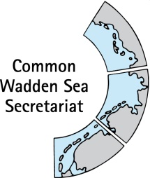
MEETING DOCUMENT
Task Group World Heritage (ad-hoc TG-WH)
Virtual meeting
27-28 January 2022
Thursday 27.01.2022: 9:00 – 12:30
Tuesday 28.01.2022: 9:00 – 12:30
https://commonwaddenseasecretariat.my.webex.com/commonwaddenseasecretariat.my-en/j.php?MTID=maa609db53a218d527629a302d8653c25

Agenda Item: 4. Single integrated management plan
Date: 17 January 2022
Submitted by: CWSS and the Chair
WSB 33 (27 August 2021) endorsed the draft SIMP document version 0.6, and the proposed revised roadmap as the basis for the upcoming work for the further discussion and agreement of the activities in the five SIMP key topics and to carry the SIMP Consultation Phase during March-June 2022. The WSB 33 advised to define activities as concrete as possible seeking ambition and articulating policy and site management in the SIMP. Ambitious policy priorities should be taken up in the Ministerial Declaration.
Discussions to define the activities for the SIMP key topics took place in workshops with the site managers followed by discussions and amendments in the TG-M and TG-WH ad-hoc SIMP drafting subgroups for the five key topics and in TG-WH 34 (13-14.12.2021). In the latter, also the draft text on the relevant EU Directives was further developed, the definition and composition of site managers in the three countries was improved and the TWSC structure graph was updated. Finally, some ideas for the Wilhelmshaven Declaration regarding the SIMP were discussed including the contribution to the EU Biodiversity Strategy, the implementation of the SIMP, a progress report on the implementation of the SIMP by 2026 and the wish to include at least one aspect from each key topic.
Attached to this document is the Draft SIMP version 0.7 including the updated key topics' activities and a draft executive summary. The latest changes in the draft SIMP version 0.7 are highlighted in green to ease your review.
This document also includes a table previously agreed by TG-WH with a list per country of who to involve in the Consultation Phase, when and how as a base for discussion in TG-WH 35.
Finally, and also as a base for discussion, this document presents suggestions of general aspects and key topics activities to include in the Ministerial Declaration and an updated timeline.

Proposal: The meeting is invited to:
- Review the SIMP document 0.7 and provide written minor comments by 02 February (all major important suggestions need to be discussed in TG-WH 35). All comments and elements highlighted in version 0.7 will have to be discussed. Ideally, the aim is to agree on the whole of the highlighted text.

- Discuss and agree on the steps before (incl. translation to the three languages), during and after the Consultation Phase including who to involve and what to request from them.

- Reflect and discuss the suggestions about the SIMP for the Ministerial Declaration to support its implementation.

- Review and agree on the draft updated timeline.

- Review the SIMP document version 0.7
The draft SIMP document version 0.7 is in Annex 1. Note that it includes a draft executive summary, the latest additions regarding the EU Directives, the definition and composition of site managers and the updated key topics’ activities. The input regarding the relevant regulation in the Wadden Sea countries was added to the nature conservation management structure graphs (pp. 62-64 in the draft SIMP v0.7) as suggested in TG-WH 34.

- Consultation Phase: steps before, during and after, who and how to involve and what to request from them
TG-WH 31 (23.09.2020) defined that the Consultation Phase aims to inform the advisory boards and stakeholders in their networks in the region and to ask for their suggestions on how to collaborate with them to implement the SIMP. The ad-hoc TG-WH meeting in July 2021 agreed to postpone the Consultation Phase from September-December 2021 to March-June 2022 to allow for more time to refine the SIMP activities.
TG-WH 32 in January 2021 gathered the following information (Table 1) from the three countries regarding who to involve, when, how and what do you need.
Please review and update Table 1 where necessary. Reflect, discuss and agree on the steps needed in the Consultation Phase, including the translation of the draft SIMP version 0.7 to the three languages, a cover page with clear requests to the groups consulted and how and when to process their input in the SIMP.
Table 1. Consultation Phase: who, when, and how.
 | Denmark | Schleswig-Holstein | Hamburg | Lower Saxony | The Netherlands
Who | Wadden Sea Advisory Board (WSAB)  The municipalities will be consulted with the WSAB and the municipal representation in the Danish delegation to the WSB.  Consultation with the Region of South Denmark (regional development plan) will also be part of the WSAB consultation. | Two advisory boards (via National Park Authority)  Information of the relevant ministries in SH (via Maren Bauer) | BA, BWVI, SK (Hamburg port authority)  Also update to the National Park Authority and Verein Jodsand, BUKEA internally and Inselsprecher. | Advisory board  Also inform the all the neighbouring ministries: agriculture, economy, Education, etc. | Policy Council  Ministries will be informed previous consultation with the Policy Council
When | 1st consultation with WSAB on May 18th 2021 and 2nd consultation in March-June 2022.  Consultation with municipalities will be integrated in the 2nd WSAB consultation. | Advisory Boards were informed in 2021  March-June 2022  After approved by WSB 35 (10 March) and translated. | March-June 2022 after approved by WSB 35 (10 March) and translated. | Advisory Board was informed in 2021  March-June 2022  After approved by WSB 35 (10 March) and translated. | March-June 2022  After approved by WSB 35 (10 March) and translated.
How | Approach them individually, give them the translated SIMP document.  Stepwise approach: first give a short general presentation and provide them with the translated SIMP document.  The second step is to get organised with them and see where they want to contribute. | Hand in and present the translated SIMP.  Use the 2 official meetings planned (advisory board meetings & joint; working group meetings)  Ministries: in a written form letter from the Env. Ministry | Send the translated SIMP document. | Advisory board: One meeting for introducing the draft and the work and one for getting feedback.  Ministries: in a written form letter from the Env. Ministry | Presentation of the translated SIMP in the planned meeting of the Policy Council.
What you need | Translated SIMP document, executive summary and ppt*. | Translated SIMP document, executive summary and ppt*. | Translated SIMP document executive summary and ppt*. | Translated SIMP document, executive summary ppt*.  We need to be very clear on what we are asking to avoid misunderstandings on what they give to us as input. | Translated SIMP document executive summary and ppt*.
Expected outcome | Formal advice in written form to collaborate and implement the SIMP.
*The executive summary provides the most relevant information to introduce the SIMP. Ppt: Power point presentation with some slides adapted for every country (relevance of the SIMP for the specific group that is being addressed).

- Suggestions about the SIMP for the Ministerial Declaration to support its implementation
The following suggestions are based on the discussions held in TG-WH 34, where it was also agreed that the Ministerial Declaration should include at least one paragraph for each of the five key topics in the SIMP. The suggestions listed below need to be discussed and summarised/adapted for the Ministerial Declaration according to the TG-WH 35 discussion.
General
- (Ongoing discussion) contribution to the EU Biodiversity Strategy and other international commitments through the SIMP activities/ambition.
- A paragraph on the implementation of the SIMP in the three countries (schedule for the upcoming four years?).
- Progress report on the SIMP implementation linked to the management cycle by 2026.
- position the Wadden Sea World Heritage as a model for….

Fisheries
Activity 3
The TWSC to discuss and propose how to organise the exchange and information management (Activity 1 and 2) within the remit of the cooperation considering the fisheries mentioned above, their management, and national policies in the Wadden Sea. This should be organised efficiently and effectively in order to keep an overview of other existing groups treating fisheries and aquaculture at the local, national, and regional levels (e.g. MSC, OSPAR, North CFP Scheveningen Group) and feed the relevant info for the Wadden Sea World Heritage to the TWSC.

Tourism
Activity 3
The TWSC, through the responsible trilateral group, to strengthen initiatives for cross-border cooperation for fostering the nature conservation aspect of sustainability in tourism. (by:…)

Shipping and Ports
Activity 1
The TWSC in cooperation with the competent national authorities, to discuss the further implementation of the Operational Plans for the Wadden Sea PSSA (Annex 5, Tønder Declaration 2014), and including issues proposed by the nature conservation site managers and an assessment of the response capacity to shipping accidents in each country.
In connection to Activity 4 (one operational plan is awareness and education and shipping sector requested support)
The TWSC through coordination of the CWSS and WSB and in communication with the competent authorities, the site managers and the Round Table Shipping and Ports, to raise awareness and education among the public and shipping and ports stakeholders about e.g. the Wadden Sea World Heritage values and vulnerability, best practices, the existing regulations and standards regarding safety, speed limits/zoning, pollution, introduction of invasive species.

Energy
Activity 3
The TWSC to extend the existing trilateral agreement (in the WSP 2010 and World Heritage Nomination Dossier) prohibiting the construction of wind turbines, oil and gas exploration and exploitation, and construction of new installations for oil and gas in the WSWH Site to other upcoming large-scale forms of energy capturing platforms like solar panels.

Coastal Flood Defence and Protection
Activity 1
Site managers to enhance and maintain communication and collaboration with the agencies and authorities responsible for coastal flood defence and protection to:
- Use the window of opportunity to introduce, where adequate and feasible as no-regret measures, nature-based solutions when the obligatory repairing or maintaining costal flood defence and protection structures takes place.
- Advocate for considering the Wadden Sea World Heritage OUV in the application of environmental impact assessments and regulations.

- Updated timeline
Date | Milestone
27 and 28 January 2022 | TG-WH 35  Final comments and agreements on the draft SIMP document version 0.7, discussion on the SIMP suggestions for MD and planning Consultation Phase.
02 February 2022 | Final deadline for TG-WH members to send minor written comments on the draft SIMP document version 0.7 (allowing sufficient time for the finalisation of the Draft SIMP 0.7)
17 February 2022 | Deadline to upload documents for WSB 35.  Updated draft SIMP version 0.7 and inform them about the planned steps for the Consultation Phase
February - March 2022 | Translation of the SIMP document to the three languages and language check by TG-WH members in the three countries.
10 March 2022 | WSB 35 Release of the draft by the Wadden Sea Board for stakeholder participation in the Consultation phase.
March-June 2022 | Consultation phase: Substantive involvement of the Advisory Boards, Policy Board, WST and WSF, and site managers.
24-26 March 2022  (to be defined) | TG-WH 36  Discuss Input from TG-WH to MD.
07 April 2022 | Deadline to upload documents for WSB 36.
28 April 2022 | WSB 36 meeting: main topic MD 2022 including TG-WH suggestions for MD.
June-July 2022 | Update the content of the draft SIMP, considering the comments received during the Consultation Phase.  Language checks, edit and layout of the SIMP document.
26. August 2022 | WSB 37 endorses the SIMP for adoption in the Ministerial Conference.
November 2022 | Adoption by the Governmental Council at the 14th Trilateral Governmental Conference in Wilhelmshaven.

Single integrated management plan (SIMP)
Annex 1. Draft SIMP version 0.7 (17 January 2022)
Wadden Sea World Heritage

Draft version 0.7
Authors: Trilateral Wadden Sea Cooperation (TWSC)

This publication should be cited as:
Common Wadden Sea Secretariat. 2022. Single integrated management plan for the Wadden Sea World Heritage. Common Wadden Sea Secretariat, Wilhelmshaven, Germany.

Preface/Foreword

Contents
Preface/Foreword 2
Executive Summary 4
1. Introduction 7
1.1. Background 7
1.2. The Purpose of the SIMP 8
1.3. The Status of the SIMP 9
1.4. The Scope of the SIMP 9
1.5. The Process of Developing the SIMP 12
1.6. The Added Value 13
1.7. Review of the SIMP 13
2. The Outstanding Universal Value of the Wadden Sea 14
2.1. The OUV: Criteria and Key Values 15
2.2. The OUV: Integrity 16
2.3. The OUV: Protection and Management Requirements 17
3. Nature Conservation Management 18
3.1 Trilateral Cooperation Structure 21
3.2 National Administration and Management Systems 22
3.3 Site managers 24
3.4 Management Cycle 25
4. Climate Change Vulnerability and Adaptation 31
4.1 Climate Stressors in the Wadden Sea 31
4.2 Adaptation and Mitigation Agreements 31
4.3 Proposals for Management Activities 32
5. Towards a Sustainable Management of the Wadden Sea 34
5.1. Cross-cutting Topics 35
5.2. Key Topics 36
6. Complementary Activities to Support Management 47
6.1 Science and Research 47
6.2 Monitoring and Assessment 48
6.3 Knowledge Management 49
6.4 Education for Sustainable Development and Interpretation 50
6.5 Communication 51
6.6 Collaborations and Partnerships 52
7. Global Dimensions 54
7.1 Global Interconnections 54
7.2 International Cooperation 55
7.3 Contributions to the EU Biodiversity Strategy for 2030 56
7.4 Contributions to the Sustainable Development Goals of the UN Agenda 2030 57
8. Glossary and Abbreviations 59
9. References 59
Annex 1 60

Executive Summary
The global importance of the Wadden Sea as the largest unbroken intertidal back-barrier sand and mudflat ecosystem in the world, the longstanding conservation efforts of the trilateral cooperation, and the support from the region and its stakeholders are recognised by its World Heritage status. With the inscription of the Wadden Sea on the UNESCO’s World Heritage List, came the request by the World Heritage Committee to develop a single integrated management plan (SIMP) with the purpose of further facilitating the continuous improvement of management coordination for the protection and maintenance of the Outstanding Universal Value (OUV).
The SIMP provides a clear overarching description of the nature conservation management structures in Denmark, Germany, and the Netherlands and at the trilateral level. It also describes how existing management elements are implemented trilaterally in the context of the management cycle. In the process of developing the SIMP, five key topics were prioritised as pending management tasks and activities were discussed and agreed upon to give further steps. The SIMP also presents useful information about the main existing complementary activities to support management in the Wadden Sea and shows how the Trilateral Wadden Sea Cooperation (TWSC) is addressing the overarching effects of climate change. The SIMP highlights the Wadden Sea World Heritage Site’s global role and its link to global responsibilities. Cooperation with partners in the area and globally is instrumental in and supportive of the long-term protection of the Wadden Sea.
The main target audiences of the SIMP are decision and policy makers and the site managers working in nature conservation of the Wadden Sea area in the three countries. Further important target audiences are environmental NGOs and other strategic partners, the scientific community, administrations, and colleagues from socio-economic sectors (e.g. fisheries, tourism and shipping) addressed in the SIMP, and the local population.

Main messages
- The single integrated management plan (SIMP) for the Wadden Sea is a political agreement within the Trilateral Wadden Sea Cooperation (TWSC), meaning it is a legally non-binding document of common political interest. Existing policy documents and legally binding instruments at the trilateral, regional, national, or local level are not altered or affected by the SIMP. The SIMP does not change either the content or the function of existing national or trilateral plans, thus it is complementary to the Wadden Sea Plan (WSP).
- In the process of developing the SIMP, different trilateral groups and site managers from Denmark, Germany, and the Netherlands were involved. The SIMP went through a consultation phase in the three countries before its adoption in the Wilhelmshaven Declaration 2022.
- The management system of the Wadden Sea World Heritage Site is a combination of the existing national protection and management systems and the trilaterally coordinated management of the Cooperation Area. By providing a clear and up to date overview of the existing nature conservation structures and the relevant European Union law and international conventions, the SIMP aims to improve the understanding of the Wadden Sea World Heritage management system.
- Climate change adaptation measures in the Wadden Sea are guided by the Trilateral Climate Change Adaptation Strategy (CCAS). Mitigation measures in the Wadden Sea are politically supported by the ministers’ declaration in 2010 “…to work towards developing the Wadden Sea Region into a CO2-neutral area by 2030 or before”. CO2-reduction policies and plans at the national and regional levels include the transition to renewable energy. Further proposals for management activities require the further operationalisation of the CCAS, as well as improved communication of the World Heritage value and climate change effects in relation to economic, social, and cultural values, and trilateral knowledge exchange and interdisciplinary discussions.
- In the process of developing the SIMP, five aspects have been prioritised as key topics for joint management. By referring to them as “key topics” it is not meant that other topics (i.e. related to nature conservation) are less important. The SIMP key topics are related to human activities relying on ecosystem services and taking place inside of and adjacent to the World Heritage property. The five key topics are: 1) Fisheries, 2) Tourism, 3) Shipping and Ports, 4) Renewable Energy and Energy from Oil and Gas and 5) Coastal Flood Defence and Protection.
- These key topics were identified in an iterative and participative process that included the selection criteria submitted in the Leeuwarden Declaration (2018), Wadden Sea’s site managers’ recommendations, and prioritisation by Task Group World Heritage. Additionally, the Statement of Outstanding Universal Value (OUV) notes that these topics may pose key threats to the integrity of the Wadden Sea World Heritage Site and therefore need continuous attention. At the same time, if practices in the key topics evolve towards more sustainability, these topics will support the area’s conservation.
- The activities agreed upon for the prioritised five key topics should be performed the TWSC in collaboration the relevant groups. In the implementation of the activities, the existing standards are to be maintained or improved enhancing the area’s OUV. The implementation of the activities shall in no way lead to the lowering the existing standards.
- Common to the five key topics’ activities are the trilateral exchange of knowledge and best practices for the benefit of nature conservation management and raising awareness/advocacy. Both have been major elements of cooperation of the TWSC for decades and continue to be important. Trilateral knowledge exchange and advocacy activities need to be continuously improved to strengthen the Cooperation’s joint arguments for nature conservation and to be able to adapt to thematic as well as technological and societal changes.
- As Science and Research, Monitoring and Assessment, Knowledge Management, Education, Communication, and Collaboration and Partnerships are fundamental complementary activities to support management in the Wadden Sea, the SIMP comprises useful information, challenges, and outlook in these fields.
- The global dimension of the Wadden Sea is not only apparent in its status as World Heritage property, but also in the fact that it is highly interconnected with other sites. Collaboration in programmes like the Wadden Sea Flyway Initiative, international cooperation with other World Heritage properties, and the UNESCO World Heritage Centre thematic programmes allow for mutual learning and developing solutions.
- The Wadden Sea World Heritage Site, as one of the largest protected areas in Europe, contributes to the EU Biodiversity Strategy for 2030, especially to the nature protection targets of protecting at least 30% of the EU’s land and sea, with 30% thereof for strict protection, but most importantly aids in “ensuring a coherent Trans-European Nature Network”.
- The TWSC actively contributes to the implementation of the Agenda 2030 for Sustainable Development, with its globally accepted Sustainable Development Goals (SDGs). Important contributions are delivered to SDG 14 “Life under water” and SDG 15 “Life on land”, as well as SDG 13 by strengthening the natural resilience and adaptive capacity to climate-related effects. Current initiatives protecting and restoring water resources and water-related ecosystems contribute to SDG 6, and initiatives supporting the area’s sustainable economy and leveraging local culture contribute to SDGs 8 and 12. SDG 4 is addressed through education for sustainable development and the International Wadden Sea School, and the SDG 17 “Partnerships for the Goals” is contributed to by the “Trilateral Partnership in support of the Wadden Sea World Heritage”.
- The SIMP will be evaluated regularly (every 10-12 years) by the Wadden Sea Board (WSB) presenting the opportunity to adapt the SIMP to the management requirements of the TWSC, including the selection of key topics, with the support and participation of all parties involved in implementing the plan. It is intended that the SIMP review will be aligned as much as possible with other process.

- Introduction
  - Background
The Wadden Sea was inscribed on UNESCO’s World Heritage List in 2009 (and extended in 2014) in recognition of its Outstanding Universal Value (OUV). The global importance declared in the Statement of OUV recognises that the Wadden Sea is the largest unbroken intertidal back-barrier sand and mudflat ecosystem in the world. Natural processes continue to thrive largely undisturbed, creating a variety of barrier islands, channels, flats, gullies, saltmarshes, and other coastal and sedimentary features. The Wadden Sea is rich in species specially adapted to these environmental conditions. These conditions also make the Wadden Sea a vital spot for migratory birds in the East Atlantic Flyway, which plays a critical role in the conservation of African-Eurasian migratory waterbirds.
To ensure the protection of this unique ecosystem for the benefit of present and future generations of humankind, Denmark, Germany, and the Netherlands are committed to working together to build a comprehensive national and international nature conservation system. In this framework, the Trilateral Governmental Cooperation on the Protection of the Wadden Sea, in short Trilateral Wadden Sea Cooperation (TWSC) was established in 1978 as a tool for cooperation and coordination of nature conservation. This commitment, the Objective of the Cooperation, its Guiding principle, Vision, the areas of cooperation as well as institutional and financial agreements are specified in the Joint Declaration on the Protection of the Wadden Sea: Working together to meet present and future challenges (1982, revised in 2010). The listing of the Wadden Sea as a World Heritage property, the utmost international acknowledgment for a natural area, shows great appreciation and is the recognition of the longstanding trilateral cooperation, the support from the region and its stakeholders, and the conservation efforts.
The overriding and overarching objectives of the TWSC are framed by the Vision for the Wadden Sea and the Guiding Principle and are in line with the Outstanding Universal Value of the Wadden Sea World Heritage (Figure 1). Denmark, Germany, and the Netherlands have built independently, and jointly during their over 40 years of trilateral cooperation, a comprehensive management system addressing some of the most urgent and important key aspects. In addition to the Wadden Sea Plan (WSP, 2010) which is the commonly agreed policy and management plan, there are various trilateral, regional, and local strategies, management plans, plans of actions and networks. In short, plenty has already been achieved and the work towards important milestones is under way, but there are still challenges to be faced.

Figure 1. Guiding Principle, Vision and Objectives of the Trilateral Wadden Sea Cooperation (Joint Declaration 2010) and Management Principles (Wadden Sea Plan 2010, p. 9) as basis for the SIMP.

  - The Purpose of the SIMP
Considering the wealth and diversity of management systems and instruments that are in place in the Wadden Sea World Heritage Site, the purpose of the SIMP, as agreed by the TWSC and stated in Annex 1 of the Leeuwarden Declaration (2018), is to further facilitate the continuous improvement of management coordination for the protection and maintenance of the Outstanding Universal Value by:
- providing a clear overarching description of the management system at the regional, national, and trilateral level,
- addressing key topics presenting concrete threats to the Outstanding Universal Value which have been prioritised as pending management tasks,
- present existing joint management activities across the property and showcase gaps which need enhanced joint efforts to maintain the area’s Outstanding Universal Value.
  - The Status of the SIMP
The SIMP for the Wadden Sea is a political agreement of the Trilateral Wadden Sea Cooperation (TWSC), meaning it is a legally non-binding document of common political interest.
Existing policy documents and legally binding instruments at the trilateral, regional, national, or local level are not altered or affected by the SIMP.
The SIMP does not change neither the content nor the function of existing national or trilateral plans, thus it is complementary to the Wadden Sea Plan (WSP) (further detail about WSP is presented as the foundation of Section 3. Nature Conservation Management). The SIMP acts as an umbrella for existing plans and policies and provides information on how these are implemented trilaterally for nature conservation management.
  - The Scope of the SIMP
The focus of the SIMP is the Wadden Sea World Heritage Site and the conservation of its Outstanding Universal Value (OUV, explained in Section 2). The SIMP presents (Figure 2) a clear overview of the nature conservation management structures in Denmark, Germany, and the Netherlands and at the trilateral level, describes how the work is done together. The existing management elements in the context of the management cycle (as defined in § 111 of the Operational Guidelines for the Implementation of the World Heritage Convention) are also presented.
In the process of developing the SIMP (Section 1.5, Figure 3), five aspects have been prioritised as key topics for joint management. By referring to them as “key topics” it is not meant that other topics (i.e. related to nature conservation) are less important. The SIMP key topics are related to human activities relying on ecosystem services and taking place inside of and adjacent to the World Heritage property.
The five key topics are: 1) Fisheries, 2) Tourism, 3) Shipping and Ports, 4) Renewable Energy and Energy from Oil and Gas and 5) Coastal Flood Defence and Protection. These were identified in an iterative and participative process that included the selection criteria submitted in Annex 1 of the Leeuwarden Declaration (2018, see Box 1), the recommendations of the Wadden Sea’s site managers in 2019, and the prioritisation by Task Group World Heritage. Additionally, the Statement of OUV notes that these topics may pose key threats to the integrity of the Wadden Sea World Heritage Site and therefore need permanent attention. At the same time, if practices in the key topics evolve towards more sustainability this can support the area’s conservation. Furthermore, these topics are challenging, since the work of the TWSC on these topics has to actively engage the competent authorities and integrate the range of competences of site managers in those key topics. Addressing these at a trilateral level leverages the existing opportunities.

As Science and Research, Monitoring and Assessment, Knowledge Management, Education, Communication, and Collaboration and Partnerships are fundamental complementary activities to support management in the Wadden Sea, the SIMP compiles useful information for site managers in these fields. In the same way, the SIMP shows how the TWSC is addressing the overarching effects of climate change.
Additionally, the SIMP highlights the Wadden Sea World Heritage Site’s global role and its link to global responsibilities. Cooperation with partners worldwide is instrumental in and supportive of the long-term protection of the Wadden Sea.
The main target audience of the SIMP are decision and policy makers and the site managers working in nature conservation of the Wadden Sea area in the three countries. The SIMP should inform decision and policy makers, and the site managers and improve the coordination of management among the site managers. Further important target audiences are environmental NGOs and other strategic partners, the scientific community, administrations, and colleagues from socio-economic sectors (e.g. fisheries, tourism and shipping) addressed in the SIMP, and the local population.

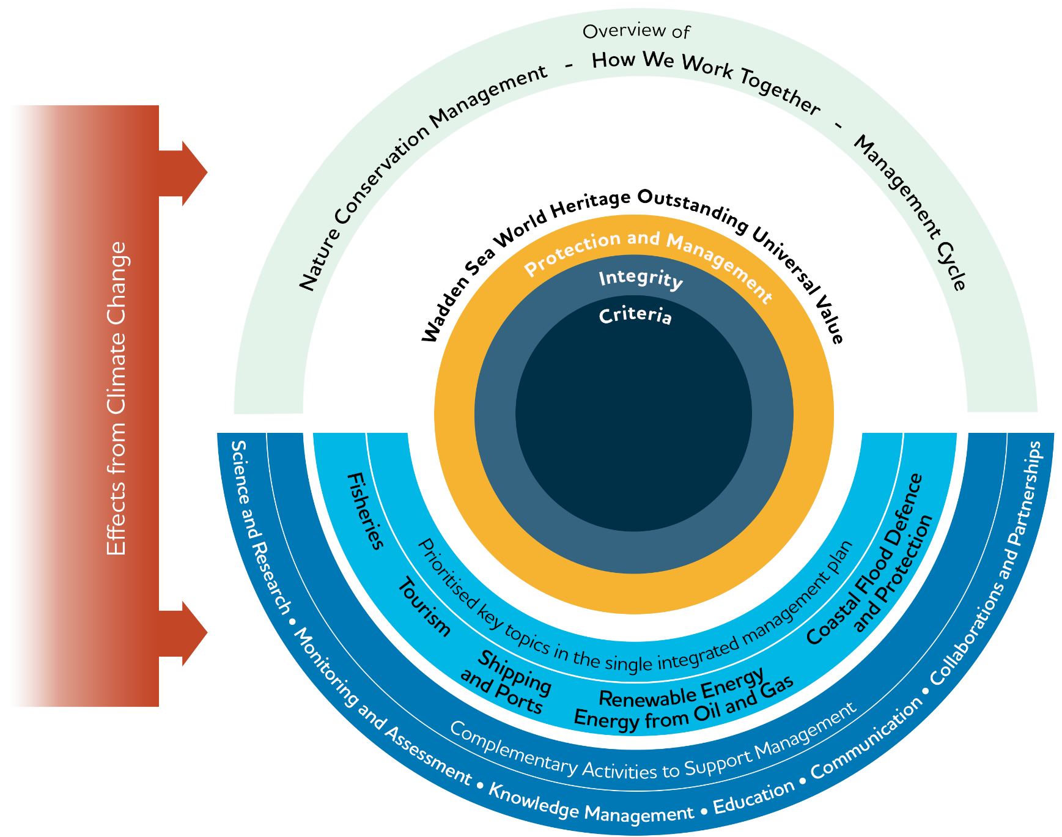

Figure 2. The scope of the SIMP has the Wadden Sea World Heritage Outstanding Universal Value at the core. The SIMP acts as an umbrella providing an overview of the management systems, tools, and collaboration. Five prioritised key topics are addressed considering how to improve information exchange and dissemination to better coordinate nature conservation management activities. To maintain the Wadden Sea World Heritage Outstanding Universal Value, the SIMP provides information about the complementary activities to support management. All considering the crosscutting effects of climate change.
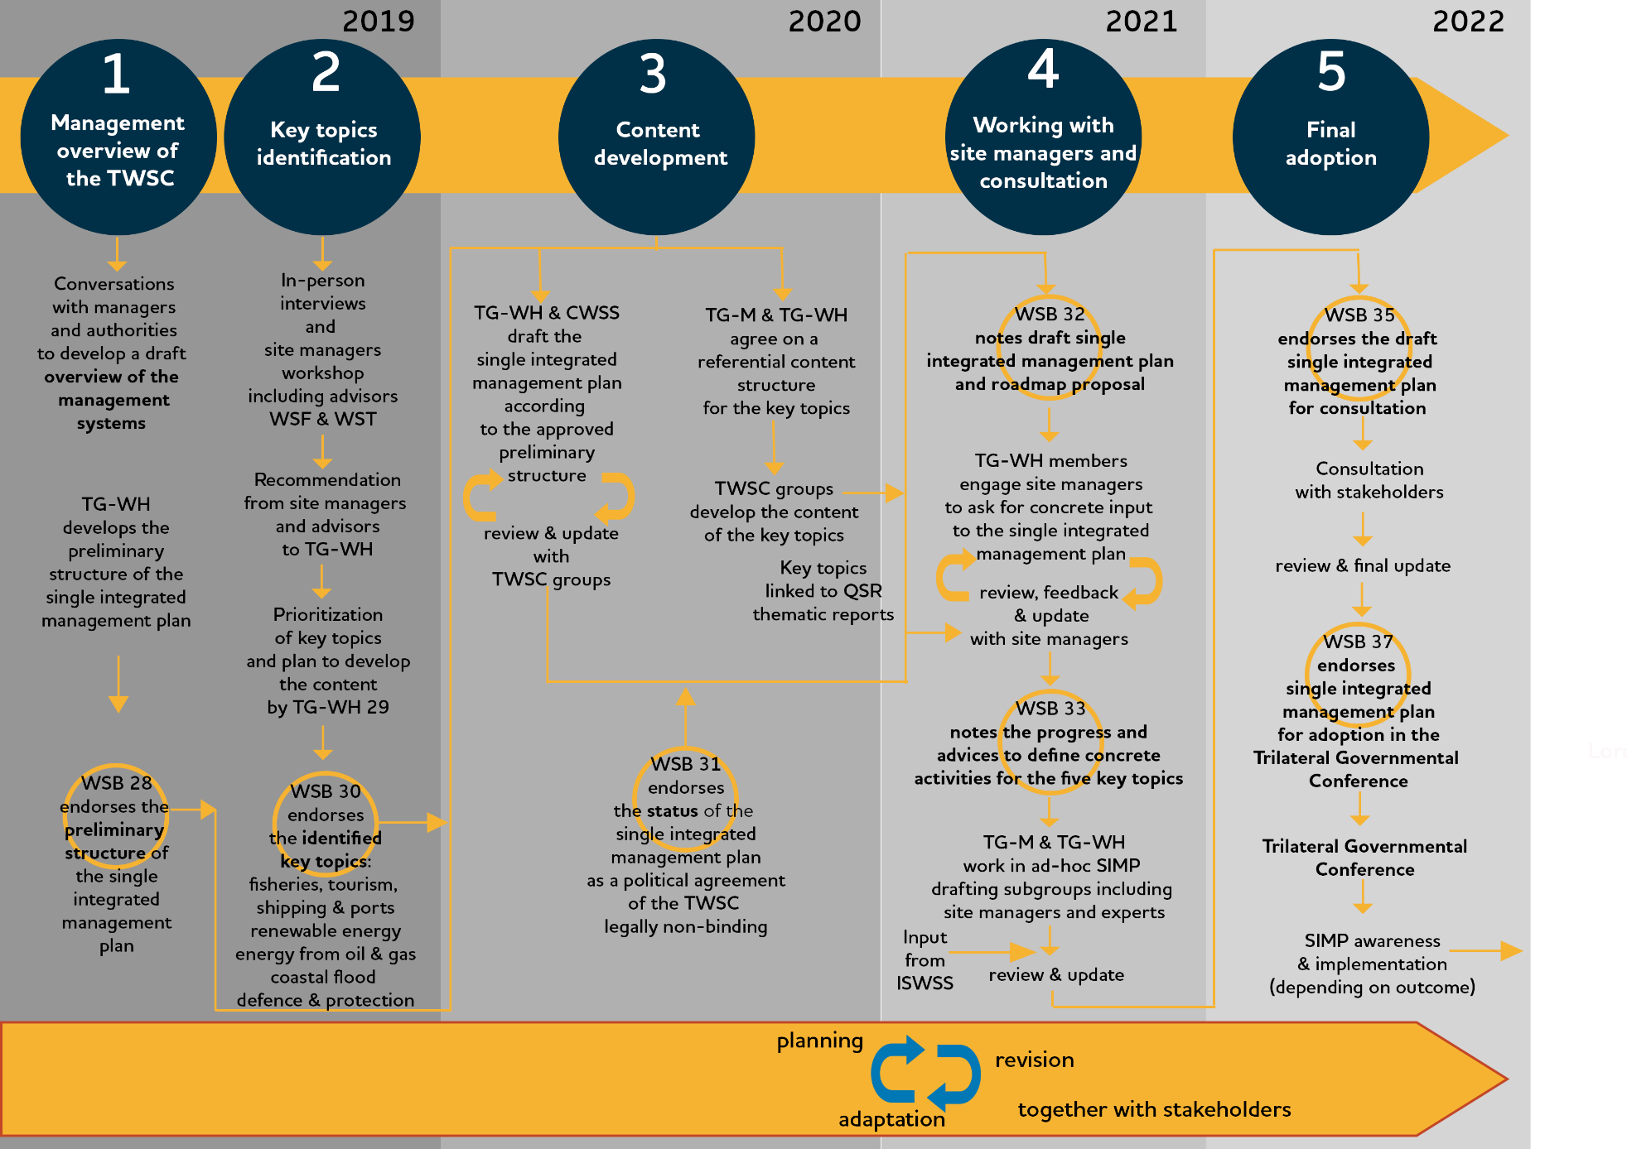
  - The Process of Developing the SIMP

[Note In the future this figure will be simplified to show only the main steps relevant for site managers and other readers.]

Figure 3. The five phases of the development of the SIMP 2019-2022, and the detail of each phase.

Abbreviations:
CWSS: Common Wadden Sea Secretariat
ISWSS: International Scientific Wadden Sea Symposium
TG-M: Task Group Management
TG-WH: Task Group World Heritage
TWSC: Trilateral Wadden Sea Cooperation.
WSB: Wadden Sea Board

  - The Added Value
There are several important added values in the SIMP. By providing a clear and updated overview of the existing nature conservation structures, the SIMP aims to improve the understanding of the Wadden Sea World Heritage management system.
The SIMP compiles the status and management approaches to manage the key topics affecting the property addressed in a comprehensible and accessible way, which can be easily communicated and used on the operative level. The SIMP links each key topic directly to the OUV, describes the common ground expressed in the WSP and other trilateral tools and shows how each country implements measures.
The SIMP contributes to the definition of feasible and innovative means to further the exchange of management approaches, experiences, knowledge, and lessons learned at different levels of management and among site managers, partners of the Wadden Sea Area, decision makers, multipliers, and volunteers.
Such an exchange supports the joint development or the review of trilateral initiatives. Exchange further allows for connecting the existing and the future trilateral strategies and plans with regional and local strategies and plans, thus showing how the work is done together and highlighting the key aspects on which the cooperation could be further strengthened. In this way, local, regional, and national actions are backed at the trilateral level and trilateral decisions are integrated into the local, regional, and national strategies and plans.
Finally, in the framework of the SIMP, the TWSC, including the site managers agree on aspects where trilateral cooperation can contribute towards their tasks of protecting the OUV (see Section 5). These agreements respect the differences in the legal responsibilities and competences of site managers among the three countries.
  - Review of the SIMP
The SIMP will be evaluated regularly by the Wadden Sea Board (WSB). Given the nature of the SIMP, a review cycle of 10-12 years is foreseen. This review presents the opportunity to adapt the SIMP to the management requirements of the TWSC, including the selection of key topics, with the support and participation of all parties involved in implementing the plan. Regular evaluation processes under trilateral and national obligations (i.e. Wadden Sea Quality Status Report, UNESCO Periodic Reporting, Natura 2000 Reports, etc.) will feed into the SIMP review. It is intended that the SIMP review will be aligned as much as possible with other process.

- The Outstanding Universal Value of the Wadden Sea
The OUV describes why a property is among the most remarkable places on Earth. Its conservation is of importance for the present and future generations of all humanity.
The World Heritage Committee considers a property as having Outstanding Universal Value if the property meets at least one out of ten selection criteria and whether it meets the requirements of integrity, and protection and management (Figure 4). The World Heritage Committee adopts a Statement of the OUV when inscribing a property in the World Heritage List which describes how the criteria and the requirements of integrity, and protection and management are met. The Statement of OUV for the Wadden Sea World Heritage can be found in the UNESCO website.

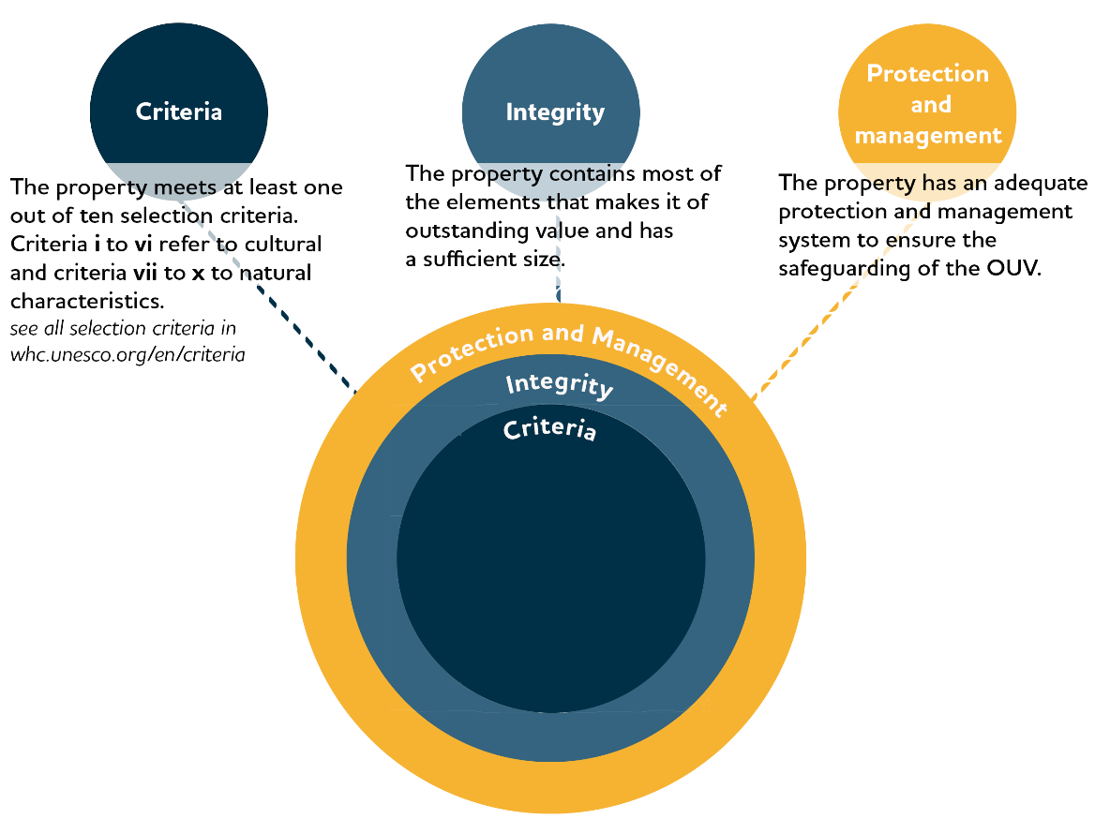

Figure 4. The Outstanding Universal Value (OUV) consists of three conditions: selection criteria, integrity, and protection and management.

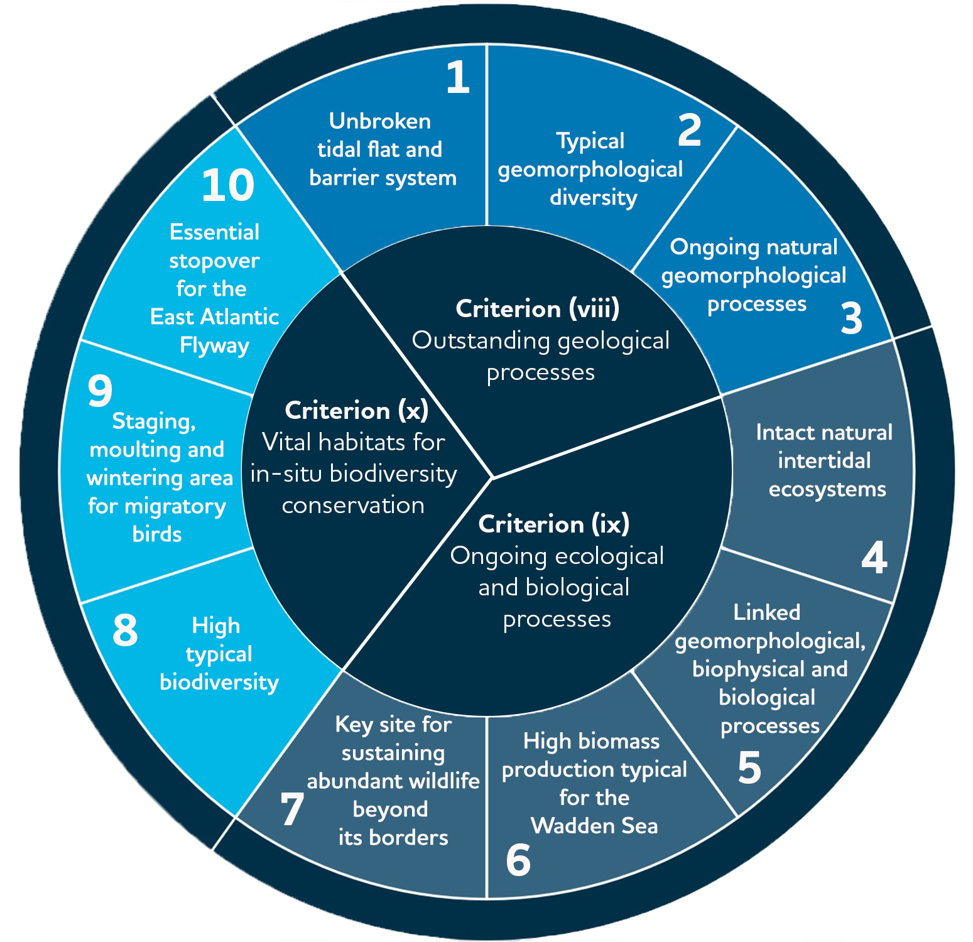
Figure 5. The WSWH criteria and the respective 10 key values derived from the Criteria described in the Statement of OUV of the Wadden Sea whc.unesco.org/en/decisions/1946/.

  - The OUV: Criteria and Key Values
The Wadden Sea World Heritage Site meets three out of four criteria for natural sites:
- (viii) Outstanding geological processes
- (ix) Ongoing ecological and biological processes
- (x) Vital habitats for in-situ biodiversity conservation
The fourth Criterion (vii) Exceptional natural phenomena and beauty has not been applied for.
Criteria viii, ix and x described in the Statement of OUV of the Wadden Sea World Heritage, are expressed through 10 key values (Figure 5) that show the elements that make the Wadden Sea of universal importance.

  - The OUV: Integrity
Integrity is a measure of the wholeness and intactness of the natural heritage and its attributes (§ 88, Operational Guidelines for the Implementation of the World Heritage Convention). The integrity is given by the elements included in the property that reflect its OUV, as well as to the appropriateness of the property’s size to maintain the features and processes, and its ability to cope with exposure to adverse effects, including those from outside the property.
In that respect, the Wadden Sea World Heritage Site, from Denmark through Germany to the Netherlands, includes all the Wadden Sea ecosystem components and features (species, habitats, processes) that constitute a natural and dynamic Wadden Sea. The area is large enough to ensure that these exceptional aspects are included and maintained (see the Statement of OUV 2014).
The Wadden Sea World Heritage Site is subject to a comprehensive protection, management, and monitoring system. The Statement of OUV (2014) recognises that the key threats require ongoing attention to maintain the integrity of the property. Key threats include fisheries activities, developing and maintaining harbours, industrial facilities surrounding the property including oil and gas rigs and wind farms, maritime traffic, residential and tourism development and impacts from climate change.

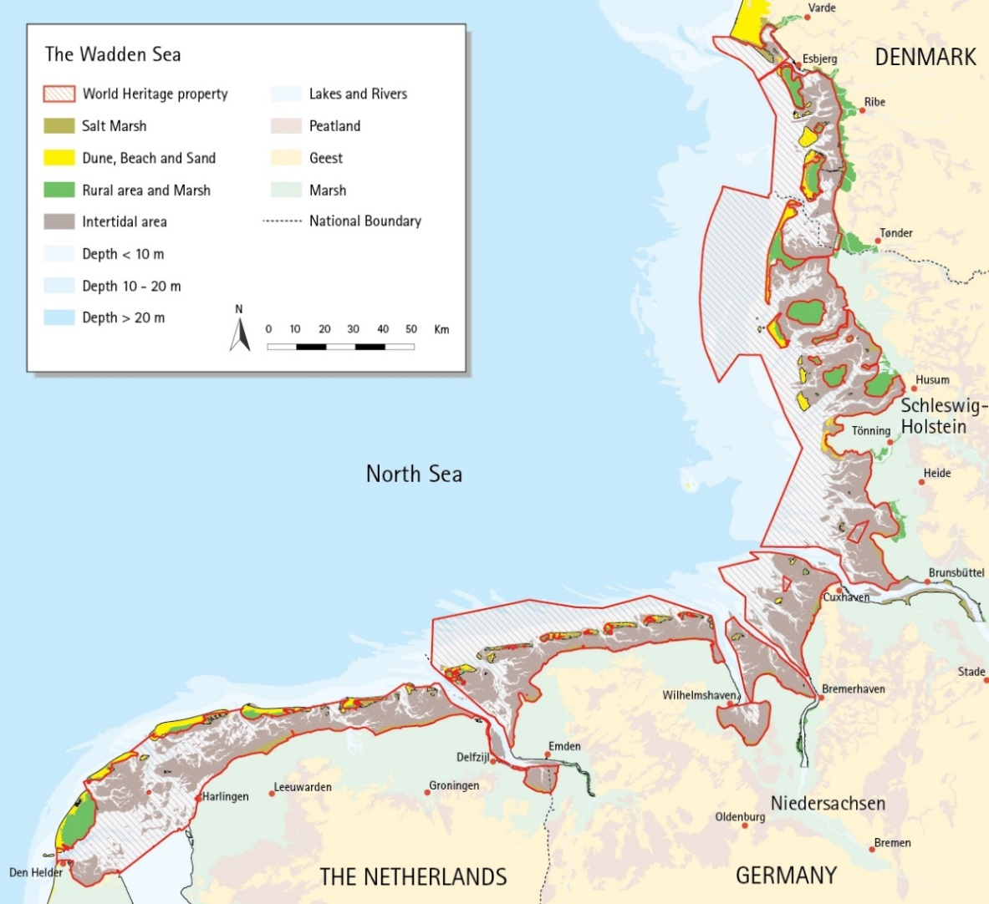

Figure 6. The Wadden Sea World Heritage Site encompasses all the natural habitats, species and processes that constitute the Wadden Sea ecosystem.

  - The OUV: Protection and Management Requirements
The TWSC provides the overall framework and structure for integrated conservation and management of the Wadden Sea World Heritage Site as a whole, and coordination between all three States including national, regional, and local levels. In fact, the Wadden Sea’s highly effective conservation status is the result of four decades of joint nature protection efforts of Denmark, Germany, and the Netherlands, where the Wadden Sea has been designated as national parks, nature reserves and Natura 2000 sites. Each State Party has comprehensive legal protection measures in place. Working together in the TWSC, these countries ensure the coordinated management of the area (see the Statement of OUV 2014).
- Nature Conservation Management
At the beginning of the Trilateral Wadden Sea Cooperation in the late 70’s, nature conservation management of the Wadden Sea was mainly a national matter. But for the past 30 years, the European Union (EU) has made increasing effort to protect the European natural heritage and therefor the present-day management system of the Wadden Sea World Heritage Site is almost entirely covered by European Union law and international conventions.
In 1979 the Birds Directive was adopted, which was the first EU regulation aimed at protecting the environment and since then nature protection has been a cornerstone in the EU. But practical planning- and implementation steps need to be taken at national, regional, and local levels and with support from the responsible authorities. The environmental laws comply with the principle of subsidiarity, leaving it as far as possible to the responsible authorities to set up their priorities and manage their programs. Differences in political and administrative structures in the three Wadden Sea countries regarding the implementation of EU law into national legislation, present challenges in complying with the expressed political intentions of managing the Wadden Sea as a common entity.
Since 1939, when the first game reserve was established in parts of the Danish Wadden Sea the area has been subject to an increasing degree of protection until 1998 when the present level of protection was reached with the inclusion of provisions based on Natura 2000 (Birds and Habitats Directives). Thus, the national implementation processes of EU legislation into national law and subsequently into binding management plans for the public authorities, consider as well trilateral strategies and plans, such as Declarations and most recently the SIMP, which can be characterized as a meta-strategy and other specific strategies listed in Figure 7. In 1985 a major update of the Statutory Order on conservation of the Danish Wadden Sea was derived from the Copenhagen Declaration of 1982. The latest example is the inclusion of the SIMP in the MSFD action plan, along with more specific action areas (fish, alien species, marine mammals, and birds) building upon some of the TWSC strategies approved by the three countries.
Due to the federal system in Germany, the (political, administrative, and legal) structures differ from those in Denmark and the Netherlands. In Germany, a nature conservation law for the Wadden Sea on federal as well as on federal state level has long been in place. EU directives are usually implemented by national laws and legal ordinances, so existing laws had to be supplemented with the EU regulations. The entire German Wadden Sea is designated as protected area under the Habitats and Birds Directives and it is within the scope of the MSFD. The inner Wadden Sea is subject to the scope of the WFD. When implementing the EU directives, the main goal is to use the synergies between the various directives.
The Netherlands implements EU directives …
The five most important European Union directives which the member states are obliged to implement through national legislation are described in Table 2.

Table 2. Overview of the “Big-5” most significant European Union legislation, laws in which these are transposed and plans.
EU-directive | Adop-tion | Status in The Netherlands | Status in Germany | Status in Denmark
Natura 2000 Directives  (Birds Directive 2009/147/EC and Habitats Directive 92/43/EEC) | Birds: 1979  Habitats: 1992 | Transposed in the Nature Conservation Act  Current Natura 2000 plan will be prolonged until 2023;  Preparations are starting for the update. LINK? | Transposed in:  Federal Nature Conservation Act (Bundesnaturschutzgesetz BNatSchG)  State Nature Conservation Acts (SH, HH, LS) (Landesnaturschutzgesetz)  National Park Acts (SH, HH, LS)  Specific conservation objectives for each N2000 site (SAC and SPA) are covered by the National Park Acts in LS & HH, SH has a separate document published by the Ministry for the Environment of SH.  Wadden Sea Plan (WSP 2010) functions as the Habitats & Birds Directive management plan for the German part of the Wadden Sea, partly concretised by local/ regional plans/ action sheets. LINKS? | Transposed in the Marine Protection Act, the Environment Protection Act and the Nature Conservation Act  Plans: https://mst.dk/natur-vand/natur/natura-2000/natura-2000-planer/natura-2000-planlaegning-2022-2027/
Water Framework Directive 2000/60/EC | 2000 | Transposed in the Water Act, the  National Water Policy Plan, the  Regional water policy plans of the provinces (tbc) Plans? Links? | Federal Water Resources Act (Wasserhaushaltsgesetz)  State water law (Landeswassergesetz)  Management plan for the river basins LINKS? | Transposed in the Environment Protection Act  Plans: https://mst.dk/natur-vand/vandmiljoe/vandomraadeplaner/vandomraadeplaner-2021-2027/
Marine Strategy Framework Directive 2008/56/EC | 2008 | The Marine Strategy Framework Directive is not implemented in the Dutch Wadden Sea | Federal Water Resources Act (Wasserhaushaltsgesetz)  State water law (Landeswassergesetz)  Management plan is the Programme of measures 2016 (currently working on an update) LINKS? | Transposed in the Danish Marine Strategy II and the Danish Marine Strategy Act.  Plan: https://mim.dk/natur/hav/#
Marine Spatial Planning Directive 2014/89/EU | 2014 | Transposed in…  National water policy plan (tbc) | Spatial Planning Ordinance Raumordnungsverordnung (ROV).  Lower Saxony Regional Planning Act (Niedersächsisches Raumordnungsgesetz ROG)  Schleswig-Holstein State Planning Act (Landesplanungsgesetz – LaplaG) | Transposed in the Marine Spatial Planning Act (Bekendtgørelse af lov om maritim fysisk planlægning – 2020)  Plans:https://www.soefartsstyrelsen.dk/vaekst-and-rammevilkaar/havplan

In summary, the management system of the Wadden Sea World Heritage Site is a combination of the existing national protection and management systems and the trilaterally coordinated management of the Cooperation Area.
The Wadden Sea Plan (WSP) 2010 constitutes the common framework for the protection and sustainable management of the Wadden Sea as an ecological entity and is the accepted coordinated management plan for the Wadden Sea World Heritage property, as stated in the Nomination dossier presented to the World Heritage Committee (2013). The WSP presents the trilaterally agreed targets, policies, and measures for the Wadden Sea Cooperation Area as an ecological entity, as well as its landscape and cultural heritage, within the cultural entities. The targets agreed upon for landscape and culture, water and sediment, salt marshes, the tidal area, beaches and dunes, estuaries, the offshore area, the rural area, birds, marine mammals, and fish are the base for the trilaterally and regionally existing topic specific visions, strategies, and plans. In Germany, the WSP serves as the Natura 2000 and national parks' management plan, that can, if deemed necessary, be supplemented by further detailed management tools (such as for certain habitat types, sectoral plans, or management concepts).
Section 3 provides an overview of the management system and serves to communicate and disseminate the trilateral management framework in an easy and clear way to national site managers as well as to all stakeholders and the general public.
  - Trilateral Cooperation Structure
The Trilateral Wadden Sea Cooperation (TWSC) comprises two levels of decision making (Governance Arrangements, 2010):
I. The Trilateral Wadden Sea Governmental Council, composed of the responsible ministers of the participating governments to oversee the Cooperation, provides political leadership and strategic guidance, assures international policy development, harmonisation, and decision-making between the three governments. Every period of three to four years, the three countries alternate the presidency of the Cooperation. Presidencies are handed over during the Trilateral Governmental Conferences (TGC).
II. The Wadden Sea Board (WSB) is the governing body composed of delegations appointed by each participating Government. Each delegation includes a representative from the lead Ministry for the Cooperation, and three further members from decentralised governments, other related Ministries, or experts. The WSB oversees the operational and advisory bodies and secures relations with key stakeholders.
The WSB receives further support from Advisors outside the governmental Cooperation, but with expertise and experience relevant to the Cooperation. Appointed advisors are the Wadden Sea Forum, representing stakeholders from the different sectors of society including municipalities and counties, and the Trilateral Wadden Sea Team of environmental NGO’s.
The Common Wadden Sea Secretariat (CWSS) is responsible for supporting the WSB and the Council and for implementing the CWSS’s workplan.
The operational bodies of the TWSC are four types of groups with specific functions and composition:
- Task Groups (TG) are appointed by the WSB to prepare expert topics for the Board and to undertake specific tasks, plans or projects in line with the Ministerial Declarations. TGs are usually time limited.
- Expert Groups (EG) are generally long-term or permanent technical groups. They have operational and advising tasks.
- Network Groups (NG) are similar to Expert Groups but with more of a networking platform character, stakeholder involvement is explicitly necessary and appreciated.
- (ad hoc) Working Groups (WG) are temporarily installed by TGs or the WSB for elaborating on certain aspects of issues targeted in the corresponding TG.
All trilateral groups are requested to generally foster exchange with other groups during the various processes (TWSC review process, 2019). The structure of the TWSC is reproduced in Figure A.1 in Annex 1. Members, supporting organisations and advisors of the WSB are presented in Figure A.2 in Annex 1.

  - National Administration and Management Systems
Denmark
The Ministry of Environment and the Danish Environmental Protection Agency are responsible for writing national legislation and national management plans which are enforced by themselves and/or by other agencies and municipalities. Among their responsibilities are the implementation of Natura 2000, Marine Strategy Framework- and Water Framework Directives, and more specifically the Nature Protection Act and its Statutory Order on the Wadden Sea Nature and Wildlife Reserve. Marine physical planning, also concerning the Wadden Sea, is under the responsibility of the Danish Maritime Authority.
The Danish Nature Agency (as the Environmental Protection Agency) is a unit under the Ministry of Environment and is responsible for the Nature and Wildlife Reserve management administration in the Wadden Sea area through a statutory order issued under the Nature Protection Law. The Nature Agency is also a considerable landowner in the area.
The Varde, Fanø, Tønder and Esbjerg Municipalities, within or adjacent to the Wadden Sea, are responsible for the enforcement of the Nature Protection Act and the implementation and enforcement of Natura 2000. In an advisory function to the government agencies in the Wadden Sea area, an Advisory Board is established, governed by the four municipalities and with representatives of a wide range of stakeholders of the Wadden Sea (Annex 1, Figure A.3).
The Danish National Parks have been established within a framework of a common law as a state-owned foundation, and for each national park, a statutory order has been issued according to the law. Following this, a National Park Board is appointed by the Minister and is responsible for implementing a strategic plan for the National Park. The National Park secretariat has no management or authoritative tasks as such but do play a role in the governing concept of the World Heritage in the group of site managers especially in communication, interpretation, and educational activities. Further, the National Park has an Advisory Board consisting of local community members.
Germany
The overall legal framework for nature conservation is the Federal Nature Conservation Act. Due to the federal system in Germany, the implementation of the Act lies in the responsibility of the federal states Hamburg, Lower Saxony, and Schleswig-Holstein. The Federal Nature Conservation Act includes provisions for the establishment of Nature Reserves and National Parks but also for procedural matters concerning impact assessments, esp. regarding Art. 6 of the Habitats Directive (Nomination Dossier, 2008). The Federal Nature Conservation Act is supplemented by federal state level legislation that may vary in detail. Hence, the Federal Nature Conservation Act and the nature conservation acts of the federal states together, form the legal basis for nature conservation and management. Especially the National Park Acts of Hamburg, Lower Saxony, and Schleswig-Holstein, establishing the respective Wadden Sea National Parks within each of the three federal states, provide the legal basis for safeguarding protection and management of the Wadden Sea World Heritage. At the federal state level, the highest nature conservation authorities are the Ministries of Environment. The National Park Authority in each federal state is the competent nature conservation authority for the Wadden Sea area and is responsible for management and for the enforcement of their respective National Park Acts (Annex 1, Figure A.4).
National Park Advisory Boards are important in terms of consultation, advice, and the involvement of local stakeholders. In Schleswig-Holstein and Lower Saxony, the respective advisory boards are composed of representatives from the regional and local governments and regional stakeholders concerned with commercial, recreational, and environmental interests and of scientific institutions. The boards are consulted and provide advice to the National Park Authorities and give their consent on principal matters and long-term planning.
The Netherlands
In 2020, the Dutch Government installed a new governmental organisational structure for the Dutch Wadden Sea comprising three groups (Annex 1, Figure A.5). The first is the Wadden Sea Management Authority chaired by the Ministry of Agriculture, Nature and Food Quality, the second is the Policy Board of the Wadden Sea Region chaired by the Ministry of Infrastructure and Water Management, and the third is the Stakeholder Council of the Wadden Sea Region chaired by the King’s Commissioner of the Province of Fryslân. The chair of the Stakeholder Council is also the vice-chair of the Policy Board, ensuring the proper connection between stakeholders and the policy level.
  - Site managers
In the SIMP, the definition of site manager is: “The professionals with direct responsibilities for nature conservation and management of the Wadden Sea World Heritage Site”. Table 3 presents the composition of nature conservation site managers in the three countries.
Table 3. composition of site managers in the three Wadden Sea countries.
Country | Composition of site managers in the Wadden Sea
The Netherlands | Rijkswaterstaat, Natuurmonumenten, Staatsbosbeheer, Ministry of Agriculture, Nature and Food Quality, the three provinces (Groningen, Friesland, and Nord Holland), Landschap Noord-Holland, Groninger Landschap, It Fryske Gea and private owners (each with their own management plans for the areas that they support in the Wadden Sea).  The Wadden Sea Management Authority is working on integral site management of the Wadden Sea.  The main tasks of the site managers concern: physical site management, nature recovery, permitting procedures, monitoring, surveillance and enforcement, hospitality, practical research and Wadden Sea World Heritage.
Germany
Hamburg | National Park Authority  Free and Hanseatic City of Hamburg, Ministry of Environment, Climate, Energy and Agriculture Department of Nature Conservation (BUKEA),  Wardening NGO contracted by the National Park Authority  The main tasks of the site managers concern:  * part of the Hamburg Ministry of Environment
Schleswig-Holstein | National Park Authority*  Ministry for Energy, Agriculture, the Environment, Nature and Digitalisation (MELUND)  Wardening NGOs contracted by the National Park Authority  The main tasks of the site managers concern: monitoring and practical research, permitting procedures, surveillance, physical site management, communication and education, coordination of networks.  * part of the State Agency for Coastal Defense, National Park and Marine Conservation Schleswig-Holstein as a subordinate authority of the MELUND
Lower Saxony | National Park Authority*  Ministry for Environment, Energy, Building and Climate Protection of Lower Saxony (NLPV)  Wardening NGOs contracted by the National Park Authority  The Lower Saxon National Park Authority as site manager is responsible for monitoring, scientific studies, and research coordination; surveillance and wardening; communication, information and education; maintenance, development and restoration; species protection; exceptions and exemptions; fines; acts as stakeholder in planning and permission procedures; coordinates the UNESCO Biosphere Reserve.  * part of the Ministry for Environment, Energy, Building and Climate Protection of Lower Saxony
Denmark | Municipalities of Esbjerg, Fanø, Varde, Tønder  Danish National Park Wadden Sea  Nature Agency*  Environmental Protection Agency*  Coastal Authority*  The main tasks of the Agencies and Authority part of the Ministry of Environment concern: nature protection, monitoring and recovery, implementation of the Natura 2000. The Municipalities contribute with implementation of the Natura 2000, are responsible for the environmental impact reports and initiatives for restoration. The National Park runs projects for nature conservation, communication, education, and awareness, and is responsible for sustainable tourism initiatives.  *part of Ministry of Environment of Denmark

  - Management Cycle
The Operational Guidelines for the Implementation of the World Heritage Convention (§ 111) state that a management cycle of planning, implementation, monitoring, evaluation, and feedback is among the elements of an effective management (Figure 7). The existing TWSC management instruments are organised in the phases of the management cycle.
Planning
The Guiding Principle of the TWSC (see Figure 1) since 1991, is the guideline for management planning at all levels (Esbjerg Declaration 1991). An essential element of the management system and the backbone of the planning phase in the management cycle is the WSP. The WSP was adopted at the 8th Trilateral Governmental Conference in Stade in 1997 and updated in 2010 (Sylt Declaration 2010) to take the inscription of the Wadden Sea World Heritage and new developments of European Union (EU) Directives into account.
The Ministerial Declarations issued on the occasions of the TGC every four years, are political declarations, in which agreements are made between the governments, which are relevant for all areas of the cooperation such as management, monitoring, international cooperation, etc. The declarations are therefore an integral part of the total protection and management scheme of the property to which the governments have committed themselves and are politically binding for the appropriate authorities in the three countries.
At the national level, management and monitoring activities are guided by the requirements of the national management systems and relevant EU law. Among these are: Natura 2000 management plans in Denmark and the Netherlands, National Park Management Plan in Denmark, and several management plans for the Wadden Sea area in the Netherlands. In Germany, the WSP serves as the management plan for Natura 2000 areas within the Wadden Sea and the Wadden Sea National Parks and is accompanied by sectoral and regional management plans and regulations.

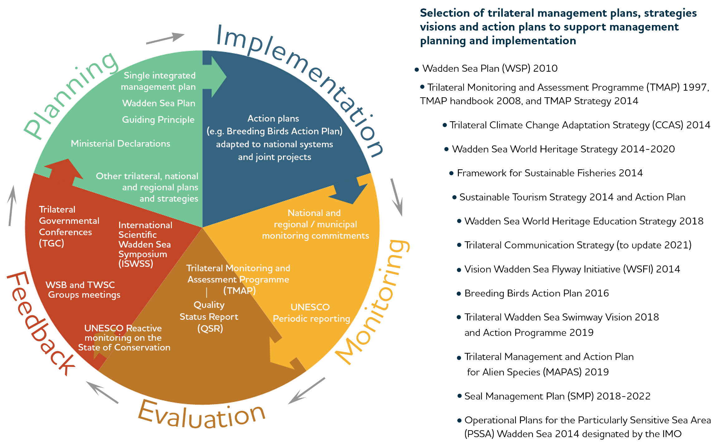

Figure 7. Phases of the management cycle required for an effective management system (as defined in § 111 of the Operational Guidelines for the implementation of the World Heritage Convention) adapted to the Wadden Sea World Heritage by including the elements in each phase. List of trilateral plans, strategies, and action plans to support management. All TWSC management plans, visions, strategies, and action plans can be found in www.waddensea-worldheritage.org.

Implementation
Trilateral visions, policies and agreements are implemented in the three countries according to their laws, management structures, political frameworks, and cultures. Specific action plans and joint projects assist the implementation on the ground by specifying who, where, when and how. Inversely, TWSC political decisions are fuelled by the local and national approaches and requirements (see an example in Box 2).

Examples of successful joint projects that promoted the development and current implementation of the Sustainable Tourism Strategy are the Interreg projects PROWAD, PROWAD LINK, Wadden Agenda and Wadden Agenda 2.0, and NAKUWA. The Wadden Sea Flyway Initiative (WSFI) collaborates with partners beyond the trilateral cooperation to jointly protect and manage the important sites along the East Atlantic Flyway (see Section 6. Global Dimensions).
Monitoring
The Trilateral Monitoring and Assessment Programme (TMAP) is one of the cornerstones of the TWSC and a prerequisite for the inscription on the World Heritage List. The aims of the trilateral Wadden Sea monitoring, assessment and research are:
- to provide a scientific assessment of the status of the ecosystem,
- to assess the status of the implementation of the Ecological Targets of the WSP,
- to use ecological monitoring and assessment to fulfil the UNESCO obligations for the World Heritage.
The assessment results are presented in periodic Quality Status Reports (QSR) authored by TWSC experts and independent scientists.
Further, the World Heritage Convention (Art. 29) requests the State Parties to participate in regular periodic reporting on the implementation of the World Heritage Convention. The report is submitted every six years to the World Heritage Centre (§ 199, Operational Guidelines for the Implementation of the World Heritage Convention).
Additionally, the three countries as EU member states, are obliged to monitor the conservation status for all habitats and species (§ 11 of the Habitats Directive) of community interest (as listed in Annex I, II, IV and V) and bird species under the Birds Directive as well as the status of marine waters under the Water Framework and the Marine Strategy Framework Directives.
Evaluation
Since 1993 the TWSC between Denmark, Germany and the Netherlands has periodically produced QSRs describing and evaluating the current ecological status of the Wadden Sea. The QSRs identify changes in this status and their possible causes, classify issues of concern and indicate possible measures of improvement, including evaluation of the likely effectiveness of these measures. They also indicate knowledge gaps. Between 1993 and 2022, six QSRs have been produced. The QSRs are part of the TMAP. The latest QSR reports are published online.
Additionally, the World Heritage Committee may request the state parties to report on the state of conservation of the property through the reactive monitoring procedure (§ 169-176, Operational Guidelines for the Implementation of the World Heritage Convention). In the reactive monitoring procedure, the State Parties shall submit specific reports and impact studies each time exceptional circumstances occur, or work is undertaken which may have an impact on the Outstanding Universal Value of the property or its state of conservation (§ 172-173). Replies to the World Heritage Centre requests regarding information from other sources than the State Parties (§ 174) are done jointly by the three Wadden Sea countries.
Cyclically, the World Heritage Centre develops regional reports with the periodic reports submitted for each property. This is presented to the World Heritage Committee for examination, adoption, and formulation of recommendations.
As most of the Wadden Sea World Heritage area is also designated as EU Natura 2000 sites, each EU member state reports every six years about the progress made on the implementation of the Habitats Directive, specifically on the status and trends of the habitat types and species (§ 17, Habitats Directive Reporting), as well as the Birds Directive, Water Framework Directive, and the Marine Strategy Framework Directive.
Feedback
Feedback as part of the management cycle takes place at all levels of the TWSC structure (Section 3.1. Trilateral cooperation structure and Figure A.1 in Annex 1).
Feedback from the task, expert, network and working groups of the TWSC flows between the groups and to the WSB. TWSC groups meet three to four times per year to exchange information, coordinate monitoring, assess results and provide advice on the scientific basis for management. The WSB meets at least two times per year.
The external advisors in the WSB for example, representing the Wadden Sea Forum of stakeholders and the Wadden Sea Team of environmental NGO’s meet at least once a year to exchange and coordinate with their sector. They give advice and feedback to the WSB.
During the Wadden Sea Conferences, including the International Scientific Wadden Sea Symposium (ISWSS), the Youth Conference, the Wadden Sea Day and additional thematic workshops, the research community, site managers, environmental NGO’s, stakeholders, and the younger generation, give their views and advice on management and political decisions addressing the Trilateral Governmental Council.
The QSR recommendations represent scientific advice to the Trilateral Governmental Council about priority issues that need further attention.
The Trilateral Governmental Council, as the politically responsible body of the TWSC, meets generally every four years at the TGC, which serve to assess the implementation of the planning instruments in terms of policy and management and to prioritise the issues that need further attention. Trilateral Governmental Council meetings result in Ministerial Council Declarations and the adoption of annexed strategies and plans, which completes the management cycle.
Since the time of inscription, the World Heritage status has been an integral part of all phases of the Wadden Sea management cycle.

- Climate Change Vulnerability and Adaptation

  - Climate Stressors in the Wadden Sea
Three key climate stressors impacting the Wadden Sea OUV in a time frame of 50 and 100 years were identified by applying the Climate Vulnerability Index (CVI) rapid assessment method: 1) temperature trend (air and/or water), 2) extreme temperature events and 3) sea level rise (see the CVI report). In a “business as usual” scenario, representing the most probable outcome of current greenhouse gas emissions policies worldwide, the OUV vulnerability was assessed high, meaning there is potential for major loss or substantial alteration of the majority of the key values that convey the OUV. Enhanced sea level rise may seriously affect structure, functions, and the characteristic biodiversity of the Wadden Sea ecosystem. As substantiated in trilateral reports of the former working group on coastal protection and sea level rise in the Wadden Sea (2005 and 2010), strong sea level rise may lead to a significant reduction in tidal flats and salt marshes as well as in safety of the inhabitants of the region. Furthermore, climate change may severely impact the present distribution and abundance of species. Also, additional climate stressors (like precipitation trend, storm surge, ocean acidification) may have an impact on the OUV.

  - Adaptation and Mitigation Agreements
Adaptation measures in the Wadden Sea are guided by the Trilateral Climate Change Adaptation Strategy, which was adopted by the responsible ministers in awareness of these implications at the 12th Trilateral Governmental Conference on the Protection of the Wadden Sea in Tønder, Denmark in 2014. The aim of this strategy is to enhance and promote policies and measures necessary for increasing the resilience of the Wadden Sea. A trilateral expert group evaluates the possible impacts of climate change and looks at possible strategies for adaptation in the Wadden Sea region. In order to successfully counteract or minimise these impacts to the extent possible and to restricting measures to what is necessary, seven strategic objectives and guiding principles are considered, such as the use of natural dynamics and flexibility, interconnectivity of habitats as well as site-specific approaches, trilateral cooperation with long-term planning, and the participatory approach. The seven principles are being applied in a wide range of projects and policies in the trilateral Wadden Sea Area. The implementation of the strategy focuses on trilateral cooperation, not only in the application of responses, but also in the areas of policies and management, monitoring and evaluation, and communication and education. Particular attention is paid to sea level rise and increasing temperatures – both underlined by the CVI process-, and also to precipitation patterns as these are predicted to have the greatest impact on people and nature in the Wadden Sea Region.
Responses to adapt to sea level rise build upon local and regional established scientific and technical support. These might have significant influence on the OUV as they will most likely lead to an increase of activities for coastal defence and protection, such as dike strengthening and sand nourishments. Limited responses for adaptation are currently known and ready to implement to adapt to increasing air and water temperatures or extreme temperature events thus improved knowledge is needed to develop additional management options.
Imperative for combating climate change impacts are local and global climate mitigation measures, such as CO2-reduction as outlined in the Paris Agreement on Climate Change of 2016. Mitigation measures in the Wadden Sea are politically supported by the ministers’ declaration in 2010 “…to work towards developing the Wadden Sea Region into a CO2-neutral area by 2030 or before, putting the focus on the special threats for coastal zones by global warming and sea level rise”. Thereby, agreed to “support the global and national efforts to mitigate causes of climate change at the regional level, by calling especially upon local and regional competent authorities and stakeholders”. CO2-reduction policies and plans at the national and regional levels include the transition to renewable energy.
Potential conflicts as well as opportunities related to coastal flood defence and protection and renewable energy are addressed in Section 5.

  - Proposals for Management Activities
Preliminary proposals for management activities:
- Stimulate and maintain trilateral knowledge exchange and interdisciplinary discussions about, among other: best practices for adapting to climate change, projects for restoration and re-dynamizing of threatened habitats as an adaptation measure, methods to limit the damage or prevent negative impact of climate change on the OUV, cumulative and combined effects of both climate change and human use of the Wadden Sea, the islands and adjacent mainland to inform permit procedures, water withdrawal and water management on the islands, improve knowledge about the potential effects of climate change on economic, social, and cultural areas.
- Develop operational guidelines or an action plan for the Trilateral Climate Change Adaptation Strategy and make it more publicly known.
- Continue monitoring the Trilateral Climate Change Adaptation Strategy and embed the results in long-term trilateral climate change policies.
- Improve OUV key values and climate change communication in relation to economic, social, and cultural values.
- Reflect about the Wadden Sea as “blue carbon” ecosystem. As marine and coastal ecosystems naturally store carbon, a natural and resilient Wadden Sea ecosystem plays an important role in mitigating climate change.

- Towards a Sustainable Management of the Wadden Sea
The World Heritage Convention (1972) commits each State Party with the duty of ensuring the protection, conservation, presentation, and transmission of the cultural and natural heritage to future generations. Since the beginning, the TWSC aims to protect the Wadden Sea. In the Joint Declaration (2010), the governments of the Wadden Sea countries renewed their commitment to continue to manage the Wadden Sea as a single ecological entity for its natural, landscape and cultural heritage values, for the benefit of present and future generations. As stated in the Wadden Sea Plan (2010) as the commonly agreed policy and management plan, human activities in ecosystems must be managed for all aspects: species, habitats, processes, and interactions.
The effective management of the Wadden Sea needs to assure nature conservation and an ecosystem approach that integrates the management of the existing protected areas with other key activities occurring in the property, including the most important economic activities, whilst safeguarding the OUV. In this way, the continued priority for the protection and conservation of the Wadden Sea is an overarching objective of the planning and regulation of use (Statement of OUV 2014).
In line with the existing protection regimes, human uses have been combined as best as possible to the Wadden Sea World Heritage Site and surrounding area. Participation of the civil society in actions towards protection and sustainable use in the Wadden Sea Region is facilitated by the Wadden Sea Forum (WSF) and the Wadden Sea Team (WST) of environmental NGO’s.
The level of integration of sustainable use and protection of the OUV regarding the prioritised key topics is different. Nevertheless, the Statement of the OUV identifies the topics as requiring ongoing further attention. Fundamental to the SIMP is to enhance the TWSC joint efforts to maintain the area’s OUV.
This section includes for each of the five key topics, the objectives setting the level of ambition, a summary description of the main risks associated with these topics and the enabling environment including basic agreements and common strategies, which constitute a favourable and conductive framework for future action. Finally, activities are defined for all key topics based upon the site manager’s, experts, and policy makers suggestions. The activities agreed upon for the prioritised five key topics should be performed the TWSC in collaboration the relevant groups. In the implementation of the activities, the existing standards are to be maintained or improved enhancing the area’s OUV. The implementation of the activities shall in no way lead to the lowering the existing standards.
Common to the five key topics’ activities are trilateral exchange of knowledge and best practices for the benefit of nature conservation management and raising awareness/advocacy. Both have been major elements of the TWSC for decades and continue to be important. Trilateral knowledge exchange contributes to bringing trilateral experiences together to build common approaches and thus to strengthen the Cooperation’s joint arguments for nature conservation. Consequent and consistent awareness raising, and advocacy may influence activities and behaviours in favour of maintaining the Wadden Sea’s OUV. Trilateral knowledge exchange and advocacy activities need to be continuously improved to adapt to thematic as well as technological and societal changes.
Dealing with the five key topics, two further cross-cutting activities have been identified: a) trilateral exchange of knowledge and best practices for the benefit of nature conservation management, and b) raising awareness/advocacy. Both have been major elements of cooperation of the TWSC for decades and continue to be important. The site managers have shared a desire for these activities to meet specific needs present at the site managers’ level. Trilateral knowledge exchange and advocacy activities need to be continuously improved to be able to adapt to thematic as well as technological and societal changes.
  - Cross-cutting Topics
Trilateral Exchange
Objective 1
Improve, expand, and maintain trilateral exchange on site management for the benefit of nature conservation management.
Activity 1
To define the need of the site managers regarding exchange of knowledge and best practices and develop a proposal that meets this need. Implement pilot projects to test most effective method(s) of exchange considering the different cultures and current opportunities such as the existing working groups, initiatives, and projects.

Awareness raising
Objective 2
Raise awareness about the existing trilateral, international, and national nature conservation and management instruments among the site managers, policy makers, environmental NGOs, the scientific community, and the relevant administrations and societal groups (for example seafarer associations, tourists). Basis for all awareness raising activities will be the Statement of OUV.
Raise awareness about best practices and knowledge among the site managers accompanied by good information material/arguments to use for advocacy.
Activity 2
Specific awareness activities about best practices, the existing trilateral agreements, and their link to the international, trilateral, and national nature conservation and management instruments and regulations should be part of the further work on each key topic.

  - Key Topics

Fisheries
Objective
Advance towards the implementation of the Framework for Sustainable Fisheries, which elaborates on the catalogue of principles about impact assessments, best practice, closed areas, monitoring and control, stock assessment, best available knowledge and learning by doing, with the fishing sector in a collaborative approach.
Main risks
- Significant harm of habitats and species due to fishing and aquaculture activities including bycatch and overfishing, habitat destruction, negative effects of non-indigenous species, litter pollution, underwater noise and reduced recolonisation possibilities for reef-building and other species.
- Damage to vulnerable ecosystems, habitats, and species due to fishing activities in closed areas within the Wadden Sea World Heritage.
- Increase of fishing pressure in the Wadden Sea due to expanding other use of the EEZ (by for example offshore wind energy) which entail exclusion of fishery.

Enabling environment
- Trilaterally agreed Framework for Sustainable Fisheries (Annex 3, Tønder Declaration 2014).
- Existing national effective good examples for fisheries and aquaculture management to learn from.
- Studies on ecological impacts and projects on best practices, transdisciplinary research and use of the results in management.

Activities
- The TWSC to stimulate exchange of information, knowledge, best practices, management experiences about fields of action especially important for their potential impact on the Wadden Sea World Heritage Site. The thematic exchange takes place at least twice per year and in the form of i.a. webinars, workshops, round tables inviting the groups of people related to the topic to come together. Depending on the topic treated, participants may include site managers, nature protection administrations, fishery administrations, aquaculture administrations, universities, research institutes, fisheries, aquaculture sector, and civil society. The outcome of such exchange may lead to identify and develop, where adequate, pilot studies while including stakeholders and site managers.

Potential subjects for the dialogue process:
- Fisheries management measures including co-management of fishing activities, the effects of implementing management measures and regulations such as closed areas, spawning protection, and fish sanctuaries.
- Scenarios and risk analysis of shifting fishing areas in the context of the current and future EEZ use expansion.
- Ecosystem-compatible fishing techniques (results of projects).
- Permitting procedures, effective control mechanisms and future developments in fisheries including opportunities offered by digital methods.
- Mitigation, handling and monitoring of bycatch of undersized target species (e.g. flatfish, brown shrimps) and non-target species (e.g. invertebrates, protected species, migratory fish, sharks, rays, etc.), manipulation procedures to release bycatch alive.
- Recreational fisheries (status and significance, including ecological impact and best practices).
- Scenarios and risk analysis of introduction and expansion of innovative forms of aquaculture and fisheries targeting new species, also in the light of North Sea warming.
- The TWSC to collect the national information relevant to the most important types of fisheries taking place in the Wadden Sea, especially shrimp and blue mussels (and, to a lesser extent, industrial fisheries) which are gathered by the national competent authorities. This should be complemented by geographic and legislative information of closed areas within the World Heritage Site. The information gathered, which could be managed at CWSS, will serve as a basis for selecting topics and assessing the appropriateness of complementary approaches to be pursued for an exchange on a trilateral level to implement the framework (Activity 1).

- The TWSC to discuss and propose how to organise the exchange and information management (Activity 1 and 2) within the remit of the cooperation considering the fisheries mentioned above, their management, and national policies in the Wadden Sea. This should be organised efficiently and effectively in order to keep an overview of other existing groups treating fisheries and aquaculture at the local, national, and regional levels (e.g. MSC, OSPAR, North CFP Scheveningen Group) and feed the relevant info for the Wadden Sea World Heritage to the TWSC.

- The TWSC and the fishing schools to continue to improve the awareness of the Wadden Sea World Heritage values and vulnerability, location of closed areas, their need and potential benefits, ecosystem-compatible and sustainable fishing techniques and fishing gear, waste prevention and the problems associated with marine litter (e.g. ghost nets, dolly ropes). This can be accompanied by information to the broad public through visitor and information centres, and the work of the International Wadden Sea School (IWSS).

- The TWSC to request the science and fisheries sectors to develop and test new methods and practices, e.g. further sustainable and ecosystem-compatible fishing techniques and practices with the aim of reducing impacts on the sea bottom and by-catch, and to share the knowledge gained to foster their implementation.

- The TWSC to through the trilateral groups responsible for science and fish to support/conduct basic fish research (e.g. quantity and quality, ecosystem function, nursery function for juvenile fish, endangered species, food chain) to support the OUV and sustainable management.

Tourism
Sustainable tourism in the Wadden Sea World Heritage includes a range of aspects from services offered in the region (i.e. accommodation, traffic infrastructure), visitor attractions, activities offer, marketing and promotion, as well as management to avoid negative impacts and leverage conservation of the Wadden Sea ecosystem. In the SIMP, the agreed activities focus on the nature conservation aspect of the holistic view of sustainability.
Objective
Maintain and increase the support of visitors, local entrepreneurs, destination marketing organisations and other stakeholders in the tourism sector for nature conservation by continuing to advance the implementation of the Sustainable Tourism Strategy and Action Plan in the work fields: tourism operations and nature conservation, One World Heritage destination, transport, accommodation and gastronomy, environmental education and interpretation and capacity building and raising standards in a collaborative approach.
Main risks
- Negative effects of existing touristic activities especially those of high intensity on the fauna, flora, and habitats of the Wadden Sea.
- Damages on the environment caused by infrastructure for tourism in the Wadden Sea World Heritage Site and adjacent region.
- Disturbances caused by future trend recreational activities and sports.
- Increased pressure on the system due to future growth of number of guests and the associated spatial demand.
- Possible increase of emissions and pollution in relation to tourism.

Enabling environment
- Existing trilateral Sustainable Tourism Strategy and Action Plan developed by the TWSC together with Stakeholders and NGOs (Annex 1, Tønder Declaration 2014).
- The trilateral network group including stakeholders and NGOs collaborates on the implementation of the Strategy since several years and coordinates the regular update of the Action Plan.
- Existing national experiences and best practices to share.
- Visitor centres and other information and education facilities, rangers and NGOs promoting nature friendly visitor behaviour
- Existing projects that support international collaboration and exchange.
- The trilateral Partnership Hub as a management structure to enhance networking, better achieving joint intersectoral agreements on common projects and activities.

Activities
- The TWSC to continue to improve the awareness of the Wadden Sea World Heritage environment, suitable behaviour at the sites, and the motivations to maintain or improve the environmental quality by providing consistent information for the sites, through visitor centres and partnership programmes.

- Dependant on their specific competencies in the three countries, continue or start to connect site managers to the Sustainable Tourism Strategy in order to add their expertise on nature conservation. If necessary, they could be deployed as spokesperson for implementation and advisor on the effectiveness of the current national/local policies on sustainable tourism. Involvement of site managers is focussed on their experience in the field and their country specific role in monitoring, visitor management, surveillance, and enforcement. Desired results could be, where adequate or needed, the improvement of zoning schemes, taking into account that the existing nature conservation standard should not be deteriorated.

- The TWSC, through the responsible trilateral group, to strengthen initiatives for cross-border cooperation for fostering the nature conservation aspect of sustainability in tourism by:
- Addressing gaps of knowledge regarding the impacts of tourism on the OUV, i.a. by research projects.
- Analysing existing national monitoring data in terms of effects from tourism and considering cumulative effects (obligation in Habitats Directive in case of projects or plans seeking permission).
- Developing appropriate trilateral tools to support visitors understanding for suitable and required behaviour in the natural environment and towards wildlife, while making the experience of nature possible,
- Improving the Wadden Sea World Heritage brand visibility emphasising that it promotes nature conservation via responsible tourism practices,
- Enhancing coordination of the various supra-regional and regional projects and activities.
- Exchanging information about training and education initiatives.
- Strengthening and expanding the communication and collaboration with the authorities, agencies, and SMEs responsible for touristic activities.
- Strengthening interdisciplinary dialogue and research between natural and social sciences and humanities on values in nature conservation, protected area management and sustainable development.

Shipping and Ports
Objective
Further improve shipping safety, build on the current high status of prevention of accidents, preparedness and emergency response and foster nature friendly operations including the maintenance of ports, enhance awareness, education, and cooperation in a collaborative approach at trilateral level.
Main risks
- Potential ship accidents resulting in the release of pollutants.
- Pollution from ongoing shipping operations including discharges of scrubber washwater, the use of dispersants in emergency response operations and the introduction of alien species, esp. by ballast water and biofouling.
- Disturbances due to underwater noise from ships and physical impacts from collisions with marine mammals and displacement due to visual disturbance.
- Negative impacts on natural dynamic processes due to dredging and dumping of dredged material.
- Increase of disturbance, accidents (collisions) and other negative impacts due to marine traffic including water sports.

Enabling environment
- The Wadden Sea is a Particularly Sensitive Sea Area (PSSA). The TWSC Operational Plans for the Wadden Sea PSSA aim to improve on prevention of accidents, operational pollution, awareness and education, preparedness and response and cooperation.
- As contracting parties af the OSPAR Convention, the three countries are required to apply Best Available Techniques (BAT) and Best Environmental Practice (BEP) including, where appropriate, clean technology, in their efforts to prevent and eliminate marine pollution.

Activities
- The TWSC in cooperation with the competent national authorities, to discuss the further implementation of the Operational Plans for the Wadden Sea PSSA (Annex 5, Tønder Declaration 2014), and including issues proposed by the nature conservation site managers and an assessment of the response capacity to shipping accidents in each country.

- The TWSC to stimulate and facilitate trilateral exchange and dialogue among site managers and involving the experts and/or institutions working on e.g. the following points with direct impact on the Wadden Sea World Heritage Site and its key values and taking in consideration other ongoing initiatives and groups at the national and regional levels (such as e.g. MSFD groups dealing with underwater noise, speed limits, definition of Good Environmental Descriptors for under water noise, OSPAR groups handling sediment movements regulations). This trilateral exchange can result in the identification of priorities to address with related sectors (Activity 3) or in technical papers providing advice:
- Introduction of speed limits in or close to vulnerable areas if not in place or inadequate.
- Improvements of ships to e.g. lower noise emissions, use electric motors (initiatives and rules at the EU and international levels).
- Research about the impacts of noise on marine animals (especially species with little investigation such as diving birds, fish, and invertebrates).
- Possibility to develop Wadden Sea wide nature friendly navigation guidelines for marine traffic in the property considering the existing local (federal states, provinces, municipalities), national and regional (EU, North Sea) regulations.
- Research and exchange on nature friendly practices for dredging of shipping lanes and within Wadden Sea ports and related dumping (existing regulation, studies, good practices), where dredging and dumping is necessary.
- Identification and research on potential effects of climate change and adaptive measures for shipping and ports on the OUV of the Wadden Sea.
- The Wadden Sea PSSA in the framework of IMO including Associated Protective Measures and the Operational Plans.

- Site managers to participate as nature conservation stakeholders in trilateral initiatives such as the Round Table Shipping and Ports including shipping authorities, ship-owners, seafarer associations, and harbour operators, the Wadden Sea Forum, and the Wadden Sea Team of environmental NGOs to discuss about specific priorities (e.g. identified in Activity 2) and explore ways to implement:
- Best practices (showcase exemplary cases of environmentally friendly practices in ships and ports e.g. regarding the use of ship fouling for controlling the spread of introduced species -in recreational and commercial shipping-, environmentally friendly ports);
- Effective ship traffic tracking systems and monitoring.
- Appropriate international standards regarding e.g. safety, speed limits, and pollution.

- The TWSC through coordination of the CWSS and WSB and in communication with the competent authorities, the site managers and the Round Table Shipping and Ports, to raise awareness and education among the public and shipping and ports stakeholders about e.g. the Wadden Sea World Heritage values and vulnerability, best practices, the existing regulations and standards regarding safety, speed limits/zoning, pollution, introduction of invasive species.

Energy
Objective
Intensify the application of common best practices to protect the Wadden Sea, to support a nature friendly energy transition, and to foster a level playing field at highest applied environmental standards for all three countries in a collaborative approach with the energy sector.

Main risks
- Impairment of habitats (especially sea floor) and disturbance of natural processes within the Wadden Sea World Heritage due to cable and pipeline laying.
- Disturbances of the natural migratory routes as well as mainland areas for breeding and resting birds, as well as increased risk of collisions with animals due to energy plants construction near the Wadden Sea World Heritage and ongoing operations, including the risk of accidents causing the release of harmful substances.
- Future steep increase in number and density of plants and transmission infrastructures including increased maintenance and supply traffic to meet the raising energy transition targets will exacerbate risks within the WSWH and in adjacent areas.
- Ground surface subsidence caused by gas exploitation and salt mining may affect habitats and species and in the future its effects can be exacerbated by sea level rise.
- Unknown effects of new types of energy production and transmission including hydrogen production, transport and storage and potential carbon capture and storage.

Enabling environment
- Existing trilateral agreement (in the WSP 2010 and World Heritage Nomination Dossier) prohibiting the construction of wind turbines, and installations for oil and gas, and not allowing oil and gas exploration and exploitation in the WH property.
- Existing trilateral agreement supporting global and national efforts to mitigate causes of climate change at the regional level and to work towards a Wadden Sea Region as CO2-neutral area by 2030 (Sylt Declaration 2010).

Activities
- Site managers to enhance and maintain dialogue and collaboration with the agencies and authorities responsible for spatial planning and technical design to:

- Learn in time about future plans and projects related to energy transition near the Wadden Sea World Heritage and get involved early in the process of planning and design of projects.
- Use the window of opportunity of planning and designing new projects to advocate for the application of best practices for the reduction of impacts from e.g. emissions of light and noise, implementation of buffer zones and functional safety distances.
- Compile lessons learned from the most advanced projects and from pilot projects and share this knowledge trilaterally (Activity 2).

- The TWSC to facilitate trilateral exchange in regular events for site managers involving the experts and/or institutions working on e.g. the following points with direct impact on the Wadden Sea World Heritage Site and its key values. This trilateral exchange can result in the identification of priorities to discuss with the agencies and authorities responsible for spatial planning and technical design (Activity 1) or in technical papers providing advice:

- Cable and pipeline laying: optimisation of routing and laying techniques, research on cumulative effects, application of EIA Law and avoidance and mitigation of impacts of the upcoming planning and building of new subsea cables and pipelines. This exchange could lead to the development of a common Mitigation Toolbox and enhanced transboundary coordination of integrated grids and interconnectors.
- Potential impacts of large-scale solar platforms, floating solar plants in the offshore area on the marine ecosystem and other renewable energy installations in the Wadden Sea World Heritage: influence on key values of the Site, especially bird migration.
- Feasibility of alternative technologies to transport energy from offshore wind farms to the mainland or to places of energy consumption, especially hydrogen technology, including the assessment of potential impacts on the marine ecosystem and bird migration.
- Existing carbon capture, its storage and transport.

- The TWSC to extend the existing trilateral agreement (in the WSP 2010 and World Heritage Nomination Dossier) prohibiting the construction of wind turbines, oil and gas exploration and exploitation, and construction of new installations for oil and gas in the WSWH Site to other upcoming large-scale forms of energy capturing platforms like solar panels.

- The TWSC through the trilateral groups responsible for energy and for research and in collaboration with the relevant groups and experts, to formulate relevant research questions to investigate (potential) effects of new types of energy production, storage and transmission while considering nature conservation management (and when possible, develop trilateral research projects).

Coastal Flood Defence and Protection
Objective
Enhance the use of nature friendly measures and maintenance practices in a collaborative approach with the competent authorities, considering the Climate Change Adaptation Strategy, which aims at resilience to climate change effects and consists of seven basic elements: Natural dynamics, interconnectivity, integration, flexibility, long-term approach, site specific approach and participation.
Main risks
- Alterations of the natural dynamic processes and the biodiversity of the Wadden Sea Cooperation Area due to the existing measures (for example fixation of the coastline due to i.a. dikes, loss of tidal flats and alteration of sediment supply (and salt) and erosion due to construction of groins, revetments and extraction of sand and clay, loss of connectivity due to existing structures and their maintenance).
- Increase in number and size of coastal flood defence and coastal protection measures to adapt to sea level rise may cause habitat and species loss. Sea level rise may cause difficulties with inland drainage i.e. tide gates are being converted into pumping stations that hinder connectivity between Wadden Sea and mainland.
Enabling environment
- Existing trilateral Climate Change Adaptation Strategy (CCAS) with guiding principles aiming to improve resilience of the Wadden Sea Region to climate change for the benefit of nature conservation the safety of the inhabitants and visitors (Annex 4, Tønder Declaration 2014).
- Existing permanent expert group which stimulates the implementation of the CCAS and updates the priorities, supports initiatives for knowledge exchange, studies to assess effects of climate change as well as adaptation measures.
- Existing knowledge and experience that site managers have in combination with the existing good cooperation with the coastal flood defence and protection agencies.

Activities
- Site managers to enhance and maintain communication and collaboration with the agencies and authorities responsible for coastal flood defence and protection to:

- Use the window of opportunity to introduce, where adequate and feasible as no-regret measures, nature-based solutions when the obligatory repairing or maintaining costal flood defence and protection structures takes place.
- Advocate for considering the Wadden Sea World Heritage OUV in the application of environmental impact assessments and regulations.
- Encourage cooperation of site managers and the agencies and authorities responsible for coastal flood defence and protection in pilot projects.

- The TWSC, to stimulate and facilitate regular trilateral exchange among site managers to:
- Continue to- and strengthen sharing best practices, experiences, and knowledge about specific topics of interest (e.g. nature-based possibilities for coastal flood protection and defence (no-regret measures), good practice examples for coherence and compensation measures).
- Formulate relevant research questions to investigate nature-based solutions, adaptation measures to climate change and social, economic, and cultural aspects in the frame of safeguarding the OUV and considering nature conservation management (and when possible, develop trilateral research projects).
- Continue to support and stimulate, where necessary, the agencies and authorities responsible for coastal flood defence and protection to implement more environmentally friendly solutions contributing to the safeguarding of the OUV. Where possible and appropriate, assist in identifying sources to finance the additional costs of realigning costal flood defence and protection measures.

- The TWSC through site managers and, where not being part of it, the responsible nature conservation authorities, to continue to improve the awareness of the Wadden Sea World Heritage natural geological dynamic processes (sediment dynamics), the role of natural factors in coastal protection (islands, dunes, saltmarshes), the significance of river and marsh water body connectivity for fish and ecological processes, the role of tidal processes for some coastal habitats, among authorities and agencies responsible for planning, construction and maintenance of coastal flood defence and protection measures. This shall be accompanied by information to the broad public through visitor and information centres, and the work of the International Wadden Sea School (IWSS).

- Complementary Activities to Support Management

  - Science and Research
The more than four decades long Trilateral Wadden Sea Cooperation (TWSC), is based on science and research. To assess the status of implementation of the targets of the Wadden Sea Plan (WSP), reliable scientific evidence is crucial. The Trilateral Monitoring and Assessment Programme (TMAP), which also underpins the criteria for the inscription on the UNESCO World Heritage List, provides the necessary information in this regard. By regularly publishing Wadden Sea Quality Status Reports (QSRs), in which more than 100 scientists (QSR 2017) from the three Wadden Sea states are involved, the development of the Wadden Sea ecosystem is described, and trend analyses are reported (more detail in Section 6.2. Monitoring and Assessment).
Upon the invitation of the TWSC, the scientific community from the Netherlands, Germany and Denmark was invited to develop a Trilateral Research Agenda. This Trilateral Research Agenda gives an overarching, comprehensive, and integrated view on the trilateral research needed in the Wadden Sea Region. It focuses on three challenges addressing human-nature interactions, coping with climate change and sea level rise, and working towards a sustainable coastal region. Concrete research topics relevant for the management of the Wadden Sea Region are laid down in thematic lines touching upon 1) climate, water, sediments and subsurface, 2) ecology, biodiversity, and spatial processes, 3) cultural heritage, identity, and historical embedding and 4) economy, society, and sustainable development. Further integral parts of the Trilateral Research Agenda are monitoring, organisation and funding and outreach, communication, and education. The TRA was welcomed at the last Trilateral Governmental Conference (TGC, Leeuwarden 2018). To strengthen the cooperation with the scientific community a Trilateral Programming Committee on Wadden Sea Research (TPC) was installed in order to establish a joint programme on research issues relevant to the Wadden Sea World Heritage, taking into account the TRA. The members of this Committee represent science and policy-management of the three states.
Challenges and Outlook
The TPC will serve as focal point to foster science cooperation and applied research on the Wadden Sea World Heritage Site. Part of the assignments given to the TPC also includes the exploration of funding possibilities.
The incorporation of upcoming management requests resulting from the SIMP process is encouraged to be considered in the agenda of the TPC and/or in the Joint Trilateral Programme on research issues relevant to the Wadden Sea World Heritage.
  - Monitoring and Assessment
The main technical purpose of monitoring the ecosystem and human activities is to collect data necessary for a scientific evaluation of the status of the ecosystem and the intensity and impact of human use and its implications to the system. This scientific assessment is an important basis for the formulation of policies and measures. Scientific knowledge is a prerequisite for the development of appropriate monitoring, for the application of assessment criteria and for the formulation of policy goals for the protection of the ecosystem.
The TMAP covers the entire Wadden Sea Cooperation Area and spans a broad range from physiological processes over population developments to changes in landscape and morphology. The TMAP was implemented based on a decision made during the TGC in Stade 1997 and has been further developed to also respond to the needs of various national and international monitoring obligations; in particular those from the EU Habitats, Birds, Water and Marine Strategy Framework Directives, and since the inscription of the Site the World Heritage reporting.
Due to the further development of the reporting under these directives, the TWSC aims to foster the adjustment of the TMAP to today’s obligations (for example climate change and its impact) and to guarantee a future-proof approach with the necessary synergies with existing monitoring programmes. Focus is also on increasing the visibility and outreach of the TMAP and the advantage as a sound basis for reporting through the QSR (TMAP strategy, 2014).
The QSR Thematic Reports are written by scientists in consultation with relevant TWSC groups and edited by an Editorial Board in cooperation with CWSS. The QSR Thematic Reports are updated at regular intervals based on data availability, trilateral events, or emerging issues. A QSR Synthesis will combine the findings from the Thematic Reports and will be issued prior to the TGC every four years, to provide a condensed overview on the status of the ecosystem with relevant information for management and decision making.
Challenges and Outlook
In the coming years new requirements may apply for the TMAP. These requirements may be influenced by or have an influence on (new) trilateral policies and plans (like the SIMP), among other these could be:
- Impacts of climate change (see the Trilateral Climate Change Adaptation Strategy, CCAS)
- Invasive Alien Species (see the Trilateral Management and Action Plan for Alien Species (MAPAS)
- Tourism management (Sustainable Tourism Strategy)
- Other trilateral strategies (such as the WSFI) serve as roof for the TMAP parameters
- EU Directives, Habitats Directive (Habitat types with unknown status, especially sublittoral), Marine Strategy Framework Directive (Wadden Sea relevant descriptors), Birds Directive, Water Framework Directive, and Alien Species Regulation
- Marine litter and new pollutants
Proposal for new or amended parameters and methodologies will be weighed and coordinated by the trilateral group responsible for monitoring and assessment in close cooperation with other trilateral expert and task groups, also considering input from relevant research and monitoring projects.
  - Knowledge Management
The TWSC is a globally outstanding example for the knowledge and experiences it holds when it comes to policy, management, research and monitoring of a large-scale mudflat and barrier islands ecosystem. To make this knowledge available to site managers and stakeholders has high priority for the TWSC. Management of the Wadden Sea as a single ecosystem shared by three countries, requires knowledge of the entire system. A milestone to collect and make this knowledge available started with the Wadden Sea network of engaged scientists in the 1960s. This resulted in the first scientific Wadden Sea symposium 1975 where scientists called for a better protection of the Wadden Sea and a trilaterally coordinated effort. Today, the scientific symposia, which take place about every four years, play a crucial role in the TWSC, by enhancing exchange between scientists, site managers, and stakeholders, and giving advice to the TGCs.
The CWSS, since its establishment in 1987, has developed into a trilateral “knowledge management hub”, providing access to data, publications and reports relevant for trilateral policy, management, research, and monitoring.
The annual Wadden Sea Day, dealing with management and research topics, supports exchange between site managers and provides the most recent knowledge across the three countries.
Trilateral working groups on expert and manager levels meet regularly to compile, assess, and provide recommendations for the three governments. They connect local and national management with trilateral management and policies.
On an international level, an ongoing exchange of knowledge and experiences with site managers from other Marine World Heritage Sites or mud-flat ecosystems sites is carried out to enhance understanding of natural systems and how to manage them.
Challenges and Outlook
The main challenge today, is how knowledge creation and exchange can be organised trilaterally and passed to the next generations. Furthermore, how diverse target audiences can be actively involved across various topics and governance structures.
New forms of cross-sector collaborations (such as “communities of practice” which are organised groups of people that collaborate regularly to share information, improve their skills, work on advancing the knowledge on a specific topic of their common interest) could be developed to foster knowledge exchange trilaterally. In addition, an enhanced use of appropriate technologies could be considered (such as knowledge bases, expert systems, information technology cooperative work and data exchange) to support effective and positive experiences during exchange and collaboration.

  - Education for Sustainable Development and Interpretation
Visitor information, environmental education, and offers for nature experiences have evolved throughout the Wadden Sea regions for several decades and are provided by various organisations and networks (public, private, NGOs) with over 65 information facilities (from small information points to large visitor centres).
Education, information, interpretation, and awareness building are obligations that ensue from the World Heritage Convention and inscription on the World Heritage List. In order to protect and maintain the OUV of the Wadden Sea it must be known, understood and respected. Thus, the interpretation of the Wadden Sea World Heritage Site is essential for a broad acceptance of and support for the long-term protection of the Wadden Sea.
The Wadden Sea Strategy on Education for Sustainable Development and World Heritage Interpretation, adopted in 2018, provides a transboundary framework for environmental education and interpretation in the entire Wadden Sea World Heritage Site. It builds on the local, regional, and national concepts and activities with the aim to promote the Wadden Sea’s OUV in a transboundary and interdisciplinary approach. It also addresses the qualification and training on a national level, to enable multipliers to integrate the trilateral and global context into their daily work.
At the trilateral level, the trilateral group responsible for education oversees the implementation of the strategy with the coordination of joint activities provided by the International Wadden Sea School (founded by the TWSC and nature NGO´s in 2003) in cooperation with the CWSS.
At the national level, the activities are coordinated by the respective national site managers and stakeholders according to the individual national strategies and concepts.
The strategy links and contributes to the implementation of other important strategies for the Wadden Sea, namely the Sustainable Tourism Strategy. It also contributes to the UNESCO Programmes for “World Heritage Education” and “Education for Sustainable Development”.
Challenges and Outlook
Engaging the diverse multipliers in cross border cooperation and enhancing their trilateral and World Heritage perspective remains an ongoing process and is an integrated part of education and information.
The provision of trilateral information, education and interpretation resources will enhance the quality of information and support consistent communication of the OUV across the regions. Visitor centres, visitor information systems and educational resources, as well as guided tours, class trips and seminars are provided on the national level and networks.
  - Communication
Communication is vital in order to make the Wadden Sea World Heritage Site known, understood, respected and appreciated, and to support the protection of the site and maintain its OUV. The TWSC follows a joint Communication Strategy that includes the World Heritage designation.
The key audiences of the communication activities are politicians, nature conservation agencies, national parks, scientists, research institutions, environmental NGOs, national park partners, the local population and tourism marketing organisations. Beyond the TWSC, the audiences are the broader public and media.
The strategy defines four different approaches to be applied to the different target audiences according to their needs: scientific, popular science, general public including young people and child oriented. The strategy includes key messages about the Wadden Sea World Heritage Site, as well as other topics related to the TWSC. The key messages serve as input to partners, stakeholders and others while writing about the Wadden Sea World Heritage Site.
The CWSS coordinates trilateral communication activities among its partners, e.g. the publication and updating of general information on the Wadden Sea World Heritage Site (website, leaflet, video, etc.). At the national level, the communication strategy is implemented by the site managers and stakeholders and integrated in the individual communication strategies and concepts.
The approach to treat the Wadden Sea World Heritage Site as a brand, and the development of a brand management toolkit, is quite unique. The Wadden Sea World Heritage Brand Paper and Brand Activation Guide are the tools that underpin this approach and aim to go beyond a graphical design guidance by creating a sense of place to continuously strengthen ownership.
The Communication Strategy, as well as all brand related tools (including the design manual) are accessible to all via the website www.waddensea-worldheritage.org. Stakeholders can also use the Brandspace platform to obtain information on the Wadden Sea World Heritage Site brand and logo use. The platform also gives access to marketing material (texts, videos, photos) to use in their Wadden Sea World Heritage Site communication efforts.
Challenges and Outlook
World Heritage communication and co-branding at national and trilateral levels must reach consistency. The communication of the TWSC concept and objectives to internal partners and the public can be challenging. The global dimension of the Wadden Sea World Heritage and the shared ownership to safeguard its OUV for present and future generations is an essence in the communication of multipliers at trilateral, national, regional, and local level.

In the future, it is aimed to creating a pronounced profile of the TWSC and World Heritage communication principles and providing internal partners with a TWSC communication strategy which can be easily applied.

  - Collaborations and Partnerships
Local supporters have been of crucial importance in the protection of the Wadden Sea whether as individuals, enterprises or NGOs. The involvement of civil society at all different levels continues to be a great strength for the protection and sustainable development of Wadden Sea Region. Numerous site-specific partnership initiatives at local and regional levels, involving local businesses and communities, offer high-quality products and services from the region and by operating in an environmentally friendly manner. Local partners support protection and help to raise awareness for nature conservation and sustainable development among guests and locals.
The inscription of the Wadden Sea on the World Heritage List offered a further step and a unique opportunity to pool and strengthen the existing skills and experiences under one umbrella to ensure the protection and preservation of the Wadden Sea, whilst continuing to foster sustainable regional development within the entire Wadden Sea Region. Along this common path, the Trilateral Partnership in support of the UNESCO Wadden Sea World Heritage was founded in 2019, based upon the above mentioned existing proven structures and networks with a long history of achievements and contributions. The strategic partners including the Wadden Sea Forum, the Wadden Sea Team of environmental NGOs, the trilateral group responsible for sustainable tourism, the trilateral science community and the WSB chair representing the TWSC have been the first signatories of the Memorandum of Understanding sealing a mutual commitment to enhance the Wadden Sea World Heritage Site.
The management and organisation of the Trilateral Partnership is supported by the Trilateral Partnership Hub (the Partnership Hub). The Partnership Hub facilitates the strategic partners collaboration in effective and trustful relationships, while sharing information, knowledge, and experience. The Partnership Hub is intended to initiate and help with the planning of specific trilateral projects, common actions and assist with applications for funding.
Challenges and Outlook
The Partnership Hub aims at broadening the engagement for the Wadden Sea World Heritage Site beyond the governmental sector and unlock potentials and resources for delivering on the goals and intended activities of the Trilateral Partnership as described in the Memorandum of Understanding. It will build and intensify pathways for collaboration towards the realisation of the (Trilateral Partnership’s) vision and thus help to extend the network of strategic partners in line with the decisions of the TWSC and balanced intentions of the strategic partners while further considering the important role of the civil society.
All these forms of collaboration within the TWSC and with the business communities in the field of engagement with the World Heritage brand, marketing and sponsorship have and will be in line with the so-called ‘five C’s’ recognised by the World Heritage Committee: Credibility, Conservation, Capacity Building, Communication and Community.

- Global Dimensions

  - Global Interconnections
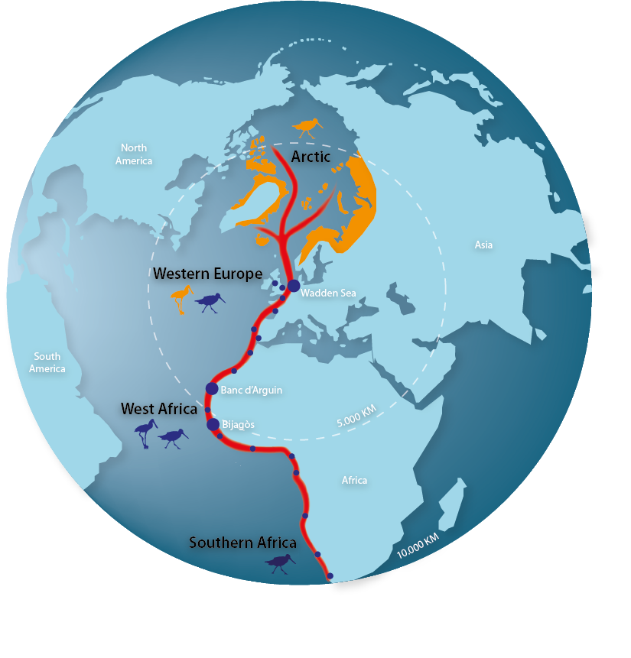
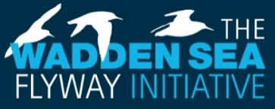
The global dimension of the Wadden Sea is not only apparent in its status as World Heritage property, but also in the fact that it is highly interconnected with other sites. In the statement of OUV it is explicitly mentioned that the Wadden Sea ecosystem sustains wildlife populations well beyond its borders and biodiversity on a worldwide scale is reliant on the Wadden Sea.
Figure 8. The East Atlantic Flyway Globus.
Many of the challenges for the Wadden Sea’s management are faced by protected areas all over the planet, such as the protection of migratory birds, dealing with impacts of climate change on ecosystems, or reduction of marine litter. This calls for close collaboration with partners beyond the Wadden Sea, since what may happen outside the Wadden Sea (for example in the Artic or in Africa) may have consequences for the management in the Wadden Sea (such as is the case with the protection of birds) and vice versa. The preservation of the Wadden Sea’s World Heritage key values is greatly influenced by the successful management of the interconnected sites. This underlines the importance of supporting the protection of other sites along the flyways.
Following the request of the World Heritage Committee on the occasion of the inscription 2009, the Wadden Sea Flyway Initiative (WSFI) was launched in 2012 to foster collaboration along the African Eurasian Flyways. The WSFI established a network of partners and important sites along the East Atlantic Flyway from the wintering sites along the West African seaboard through the Wadden Sea as essential staging site to the breeding sites in the Arctic areas.

Partners in almost 30 countries are working together to protect and manage their shared bird populations by cooperating in monitoring and capacity building activities. In the coming years, the WSFI aims for an autonomous bird management in the African partner countries, to combat the impact of climate change for a resilient flyway and improve the cooperation with countries in the Arctic. Successful cooperation has been established with West-African countries in particular with the World Heritage Site National Park Banc d’Arguin in Mauritania (Memorandum of Understanding 2014), but also with the Bijagòs Archipelago in Guinea Bissau with regards to the protection of intertidal ecosystems. The WSFI also aims to extend the long-lasting cooperation with Arctic countries.
  - International Cooperation
Putting the Wadden Sea on a global scene also offers new pathways for international cooperation, mutual learning and developing solutions for the preservation of the Wadden Sea in a rapidly changing world. Cooperation with other World Heritage properties also helps to raise the profile of the Wadden Sea internationally and within the World Heritage Convention.
The Wadden Sea World Heritage Site is contributing with its vast knowledge to support nomination efforts of future World Heritage properties. An exchange with the Yellow Sea countries has existed for many years, both are tidal mudflat ecosystems of global importance for being among other, stopover sites for migratory birds.
The Trilateral Wadden Sea Cooperation (TWSC) cooperates with the Republic of Korea (Memorandum of Understanding 2009) regarding the exchange of management experiences and approaches, monitoring, research, education, and communication. Over the years this collaboration has involved in total over 2,100 persons at both sites. The TWSC also supported the Republic of Korea in the preparation of the World Heritage nomination dossier on the Korean Tidal Flats. The World Heritage Committee at its 44th meeting in 2021 decided to add the Getbol, Korean Tidal Flats to the World Heritage List under criterion (x).
Knowledge exchange will be the main topic of collaboration with the Yellow Sea countries, and aims to share scientific knowledge for management, strengthen the capacity for communication and education, and provide many valuable examples for practitioners which they can apply at their site. A collaboration between the globally significant flyway sites, such as the African-Eurasian Flyway and East Asian-Australasian Flyway, can promote a mutual exchange in improving flyway management and research in mud-flat ecosystems worldwide.
The UNESCO World Heritage Centre, which serves as the global Secretariat to the World Heritage Convention, not only manages all official processes around the Convention, but also runs thematic programmes to help State Parties and the World Heritage properties to implement the Convention.
Since its inscription on the World Heritage List the Wadden Sea has been an active contributor to the UNESCO World Heritage Marine Programme. This is a network of site managers from all 50 Marine World Heritage properties across 37 nations. Tapping into the vast expertise contained within the network helps to accelerate achieving sustainable marine protected areas. Expertise is shared from across the network through site-to-site field visits, communication, and tri-annual global managers conferences.
The Wadden Sea also cooperates with the UNESCO World Heritage and Sustainable Tourism Programme. This Thematic Programme underlines the shared responsibility of stakeholders for conservation of cultural and natural heritage of Outstanding Universal Value and for sustainable development through appropriate tourism management.
As requested by the World Heritage Committee in 2009, a Strategy for Sustainable Tourism in the Wadden See World Heritage Destination was adopted in the Wadden Sea in 2014. Through regular exchange with the World Heritage Centre and stakeholders from other World Heritage properties, the Wadden Sea benefits from the networks when implementing or further developing the Sustainable Tourism Strategy and action plan. The Wadden Sea is acknowledged worldwide as a useful example of transnational collaboration, pooling resources, and engaging tourism stakeholders in the protection of the OUV for mutual benefit.
Engaging in international cooperation creates opportunities for sharing knowledge and experience in the management of World Heritage properties. Managers, NGO’s, and other stakeholders active in the Wadden Sea World Heritage Site have used these opportunities for mutual learning in areas such as protected areas tourism, monitoring and education.
  - Contributions to the EU Biodiversity Strategy for 2030
The Wadden Sea World Heritage Site, as one of the largest protected areas in Europe, contributes to the EU Biodiversity Strategy for 2030, most notably to the nature protection targets of protecting at least 30% of the EU’s land and sea, with 30% of strict protection thereof, but most importantly aids “ensuring a coherent Trans-European Nature Network”. The SIMP and the comprehensive management system of the Wadden Sea World Heritage Site including the Wadden Sea Plan (WSP) as joint management plan, can serve as a model for effective protected areas management.
Additionally, the management of the Wadden Sea World Heritage Site contributes to the nature restoration targets of “ensuring at least 30% of EU protected species and habitats are in favourable conservation status or have positive trends by 2030” and to “restore marine ecosystems”.
The Wadden Sea World Heritage Site, supported by the SIMP, also adds to the EU Biodiversity Strategy’s transformative change targets such as “building on an integrated and whole-of society approach”, “ensuring the full and timely implementation of the EU nature directives” and “improving knowledge and research”. Targets such as “tackle invasive alien species” are explicitly addressed in the TWSC’s own strategic approaches.
EU funding will continue to play an important role in advancing and enabling trilateral projects.
[Note: there will be a (new) “Post-2020 Biodiversity Framework” adopted by the CBD COP in the first half of 2022.]
  - Contributions to the Sustainable Development Goals of the UN Agenda 2030
The TWSC actively contributes to the implementation of the Agenda 2030 for Sustainable Development, with its globally accepted Sustainable Development Goals (SDGs). Not only does the Wadden Sea deliver important contributions to SDG 14 “Life under water” and SDG 15 “Life on land”, but it also strengthens the natural resilience and adaptive capacity to climate-related effects (SDG 13). Furthermore, the trilateral cooperation’s actions and plans to protect and restore water resources and water-related ecosystems contribute to SDG 6 and support the area’s sustainable economy and leverages local culture (SDGs 8 and 12). Education for sustainable development and the International Wadden Sea School, accessible in all languages of the cooperation, addresses SDG 4. The SDG 17 “Partnerships for the Goals” is contributed to by the “Trilateral Partnership in support of the Wadden Sea World Heritage” (Figure 10). [Note: After approval by the UN, in SDG17 can be added: “registered as transboundary, multi-stakeholder Partnership in the UN’s global registry on SDG partnerships”].

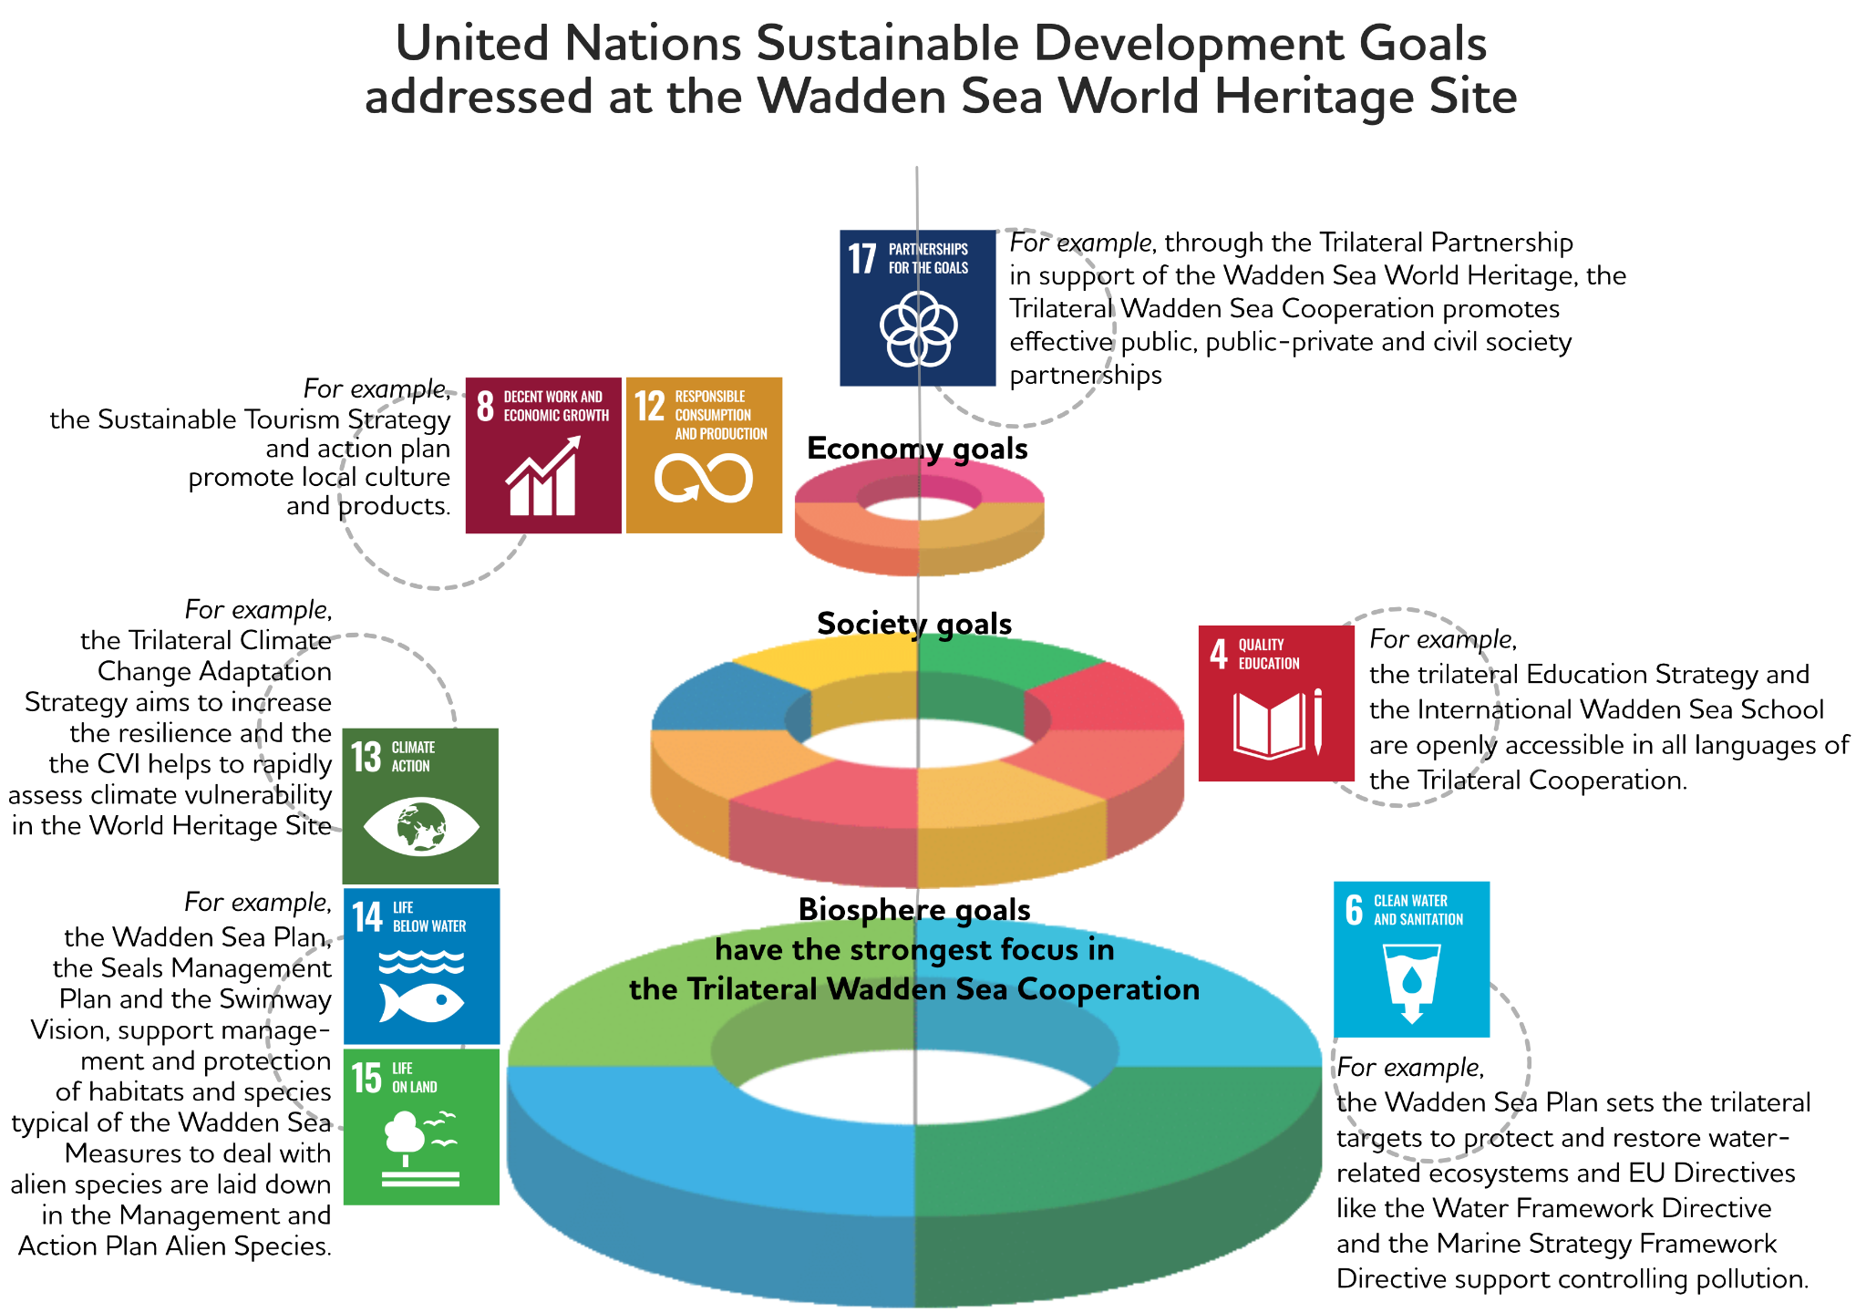

Figure 9. The TWSC addresses SDGs 4, 6, 8, 12, 13, 14, 15 and 17.

- Glossary and Abbreviations
CVI Climate Vulnerability Analysis
CWSS Common Wadden Sea Secretariat
EU European Union
NGO Non-governmental organisation
OUV Outstanding Universal Value
QSR Quality Status Report
SDGs United Nations Sustainable Development Goals
SIMP Single integrated management plan
TGC Trilateral Governmental Conference
TMAP Trilateral Monitoring and Assessment Programme
TPC Trilateral Programming Committee
TWSC Trilateral Wadden Sea Cooperation
UNESCO United Nations Educational, Scientific and Cultural Organization
WSB Wadden Sea Board
WSFI Wadden Sea Flyway Initiative
WSP Wadden Sea Plan

Nature-based Solutions: Nature-based Solutions are actions to protect, sustainably manage, and restore natural or modified ecosystems, which address societal challenges effectively and adaptively, simultaneously providing human well-being and biodiversity benefits (IUCN Global Standard for NbS, 2020).

No-regret measures: measures which are beneficial independently of which event or scenario actually occurs. In cases of considerable uncertainty like climate change and its impacts regarding direction, timing and magnitude (e.g. plausible sea level rise projections vary among 0.2 and 1.4 m) no-regret measures provide some flexibility to adapt policy and management in response to new information regarding actual and projected changes in drivers and impacts (CCAS, 2014).

World Heritage Site managers: The professionals with direct responsibilities for nature conservation and management of the Wadden Sea World Heritage Site.

- References
References to the documents used in the SIMP are included in the PDF version, and not in the printed version of the SIMP.

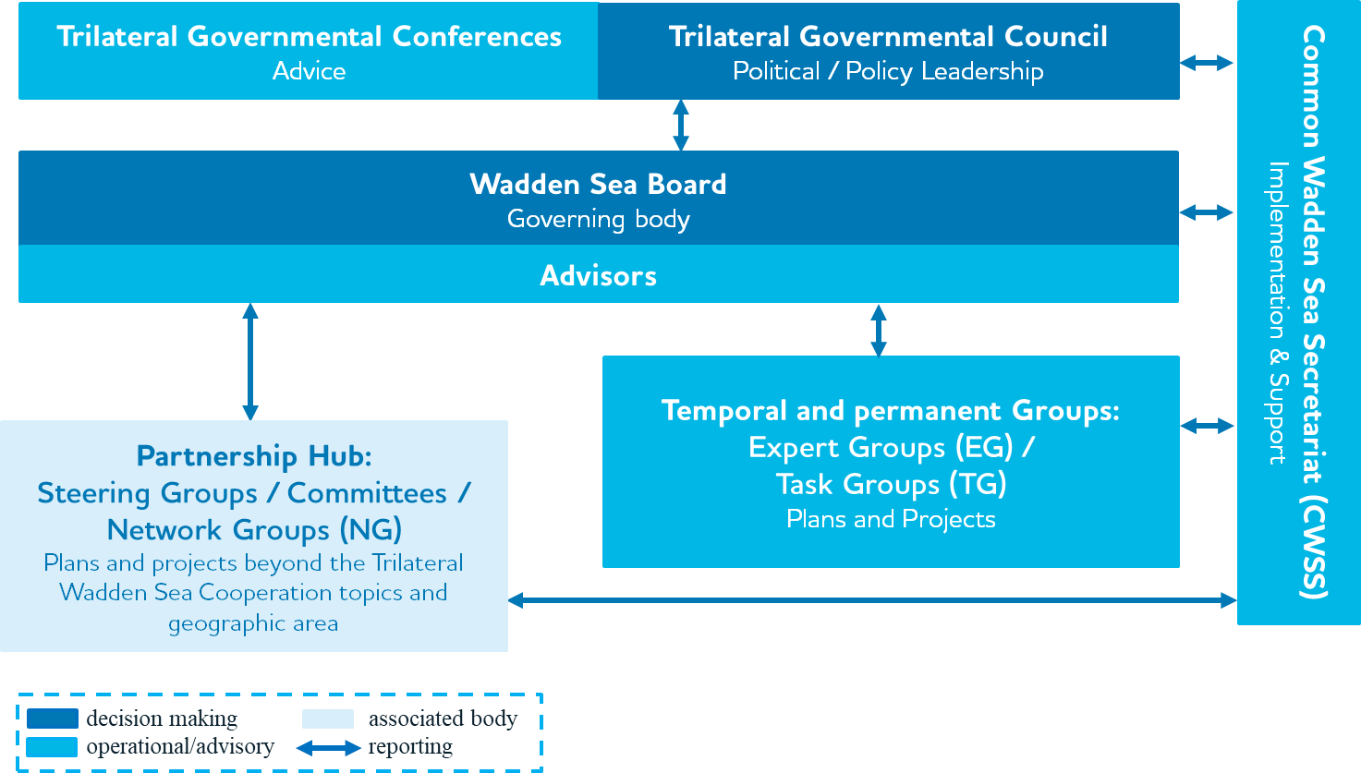
Annex 1

Figure A.1. Organisational structure of the Trilateral Wadden Sea Cooperation (TWSC). [Note: Pending on a WSB decision on the outcome of the evaluation of the pilot phase of the Partnership Hub by an external consultant, expertise is expected for early summer 2022].

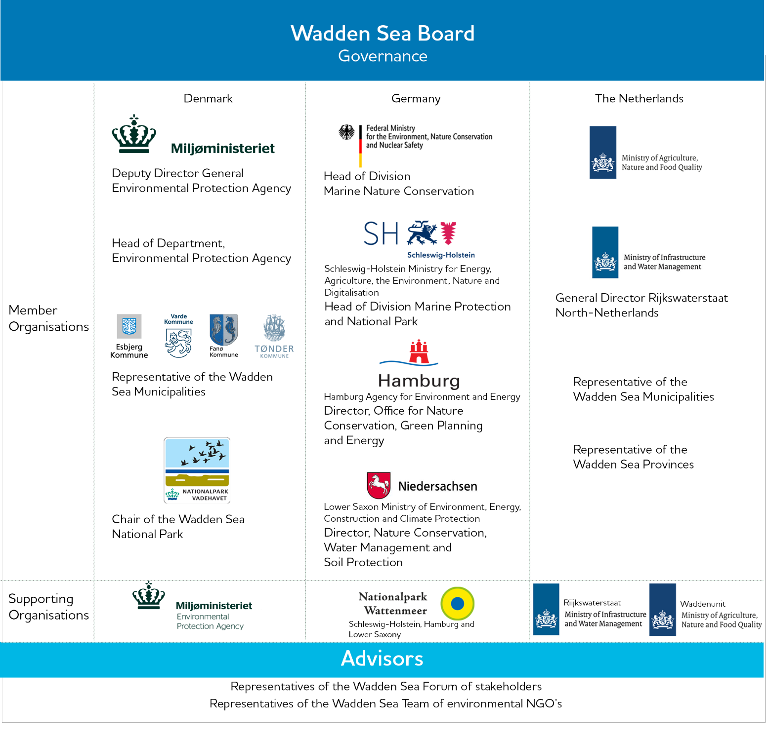
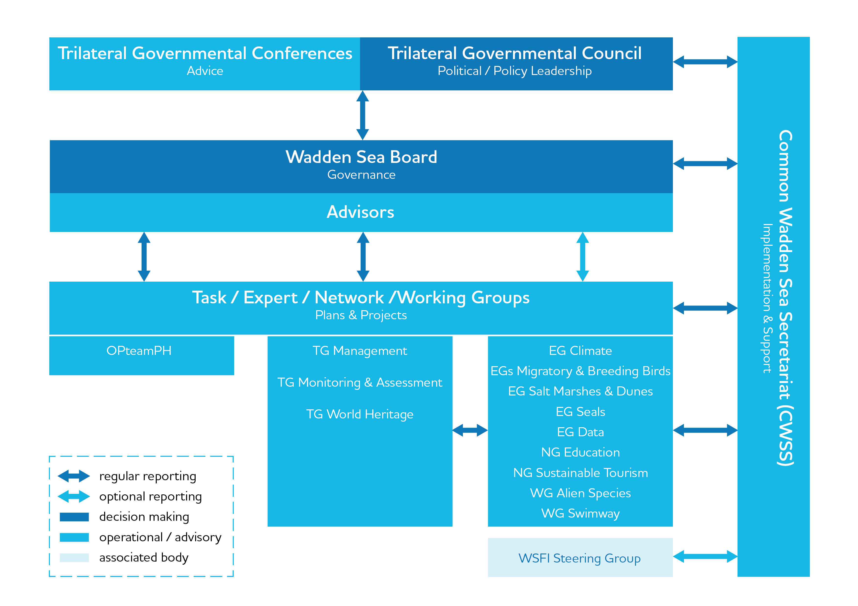

Figure A.2. Members, supporting organisations and advisors of the Wadden Sea Board. The supporting organisations are intricately involved in the task/expert/working groups of the TWSC and represent the link between policy and management.

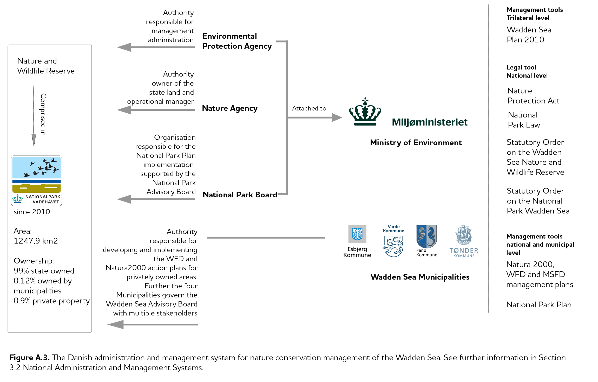

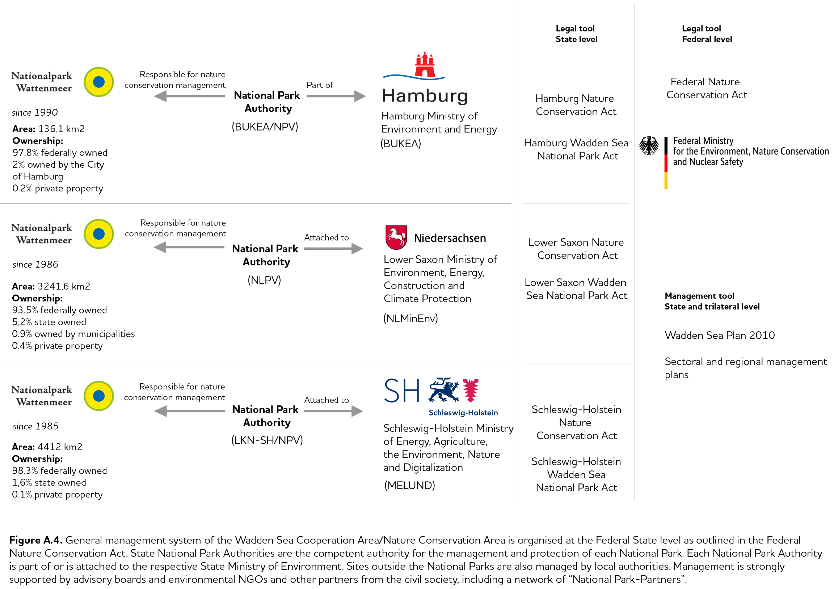

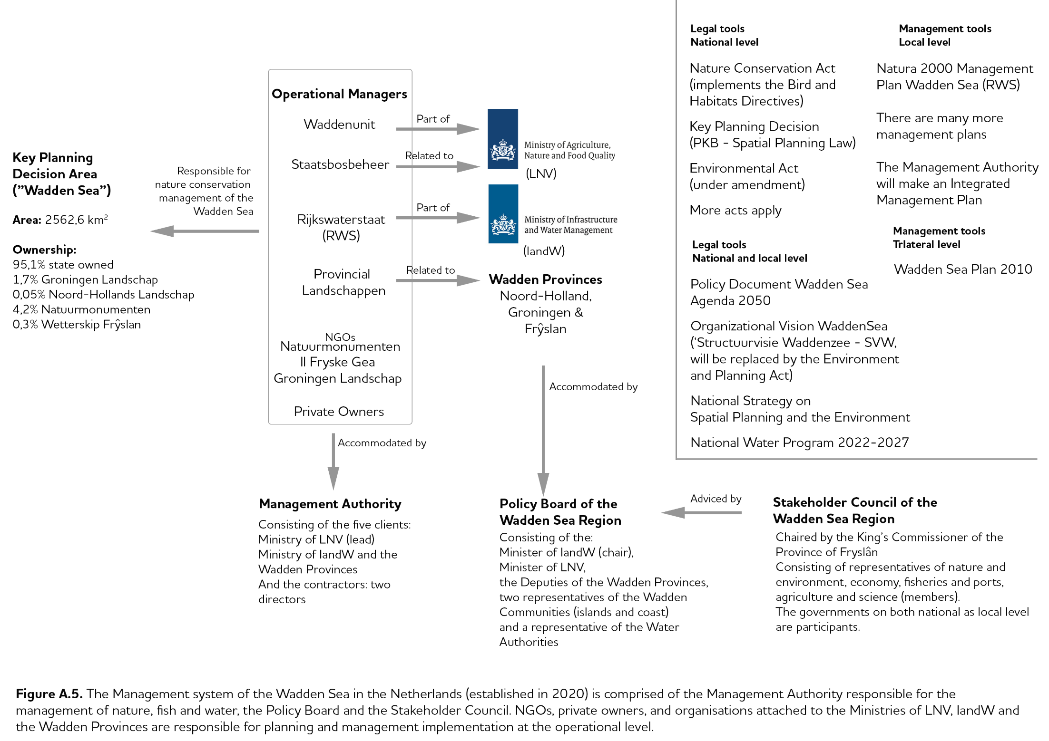

https://whc.unesco.org/en/decisions/1946/
https://whc.unesco.org/en/decisions/1946/
https://www.waddensea-worldheritage.org/prowad
https://northsearegion.eu/prowad-link/
https://www.ostfriesland.travel/service/watten-agenda-nl and https://www.watten-agenda.de/
https://www.interreg5a.eu/blog/projekt/nakuwa/
http://qsr.waddensea-worldheritage.org/
https://whc.unesco.org/en/periodicreporting/
https://www.waddensea-worldheritage.org/sites/default/ files/2020_CVI_Workshop_Report.pdf
https://www.waddensea-worldheritage.org/resources/ecosystem-21-coastal-protection-and-sea-level-rise
https://www.waddensea-worldheritage.org/sites/default/files/2010_Ecosystem28_cpsl.pdf
https://www.waddensea-worldheritage.org/sites/default/files/2014_TD%20annex%204%20climate%20strategy.pdf
No-regret measures: Measures which are beneficial independently of which event or scenario actually occurs. In cases of considerable uncertainty like climate change and its impacts regarding direction, timing and magnitude (e.g. plausible sea level rise projections vary among 0.2 and 1.4 m) no-regret measures provide some flexibility to adapt policy and management in response to new information regarding actual and projected changes in drivers and impacts (CCAS, 2014).
Nature-based Solutions: Nature-based Solutions are actions to protect, sustainably manage, and restore natural or modified ecosystems, which address societal challenges effectively and adaptively, simultaneously providing human well-being and biodiversity benefits (IUCN Global Standard for nature-based solutions, 2020).
https://www.waddensea-worldheritage.org/sites/default/ files/2018_Trilateral_Research_Agenda.pdf
https://www.waddensea-worldheritage.org/sites/default/ files/2018_Education_Strategy.pdf
http://www.iwss.org/
https://www.waddensea-worldheritage.org/sites/default/files/ 2014_tourism-strategy-en.pdf
https://waddensea.brandspace.online/b/ (beta version)
https://eur-lex.europa.eu/legal-content/EN/TXT/PDF/?uri=CELEX:52020DC0380&from=EN

