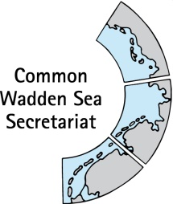
MEETING DOCUMENT
Ad hoc Working Group SWIMWAY (WG-SWIMWAY 20-2)
22 June 2020
Virtual meeting

Agenda Item: 6. SWIMWAY pillar: Monitoring
Subject: SWIMWAY monitoring report
Document No.: WG-SWIMWAY 20-2/6
Date: 04 June 2020
Submitted by: Paddy Walker

At WG-SWIMWAY 19-1, group members presented short outlines for initiation projects for SWIMWAY. Amongst these was Monitoring/Data exchange and access for SWIMWAY Wadden Sea.
Ms Paddy Walker was commissioned to compile a SWIMWAY monitoring report and an inventory trilateral fish monitoring, including implications for the setup of a trilateral expert group fish. Ms Walker presented a draft of the is report at SWIMWAY 19-3 meeting in Leeuwarden on 2 December 2019.
This document contains the final draft of the SWIMWAY monitoring report (this word document) and an inventory of fish monitoring and research activities in Denmark, Germany and the Netherlands (excel file WG-SWIMWAY 20-2-6-Inventory).

Proposal: The group is invited to adopt the monitoring report and to agree on responsible persons for regular updates of the inventory as living document.

Trilateral Fish Monitoring
Experimental fyke NL. © Paddy Walker.
Overview of monitoring and research for SWIMWAY DRAFT

Version: 2.0.0.2.3.4 (Draft two)
Authors: Paddy Walker

Publisher
Common Wadden Sea Secretariat (CWSS), Wilhelmshaven, Germany
Author
Paddy Walker, [Institution]
Editors
Julia A. Busch, Common Wadden Sea Secretariat
Annika Bostelmann, Common Wadden Sea Secretariat
Cover Photo
Paddy Walker
Layout
Creative Concern/Annika Bostelmann, Common Wadden Sea Secretariat
Published
2020

This publication should be cited as:
Walker, P.A. (2020) Trilateral fish monitoring: overview of monitoring and research for SWIMWAY - DRAFT. Common Wadden Sea Secretariat, Wilhelmshaven, Germany.
Content
Title X
Title X
Title X
Appendix A. Title XX

Summary
This report presents an overview of the monitoring and long-term research programmes for fish used to inform the Quality Status Report (QSR), as well as new programmes and research initiatives which provide information which can be used to implement the SWIMWAY Action Plan for the pillar ‘Research and Monitoring’.
The report presents an inventory of monitoring and long-term research programmes that include marine and estuarine fish in Denmark, Germany and the Netherlands with focus on the Wadden Sea tidal flats, gullies (tidal inlets and streams) as well as subtidal marine areas and estuaries bordering the Wadden Sea. A spreadsheet with metadata has been proposed which can be further developed. Once this has been finalised, it can be made publicly available. First results show the spatio-temporal coverage of the current monitoring programmes and highlight a lack of information and data on aspects of population dynamics, habitat requirements, anthropogenic effects etc., which are relevant for the implementation of quality objectives for Wadden Sea fish, the so-called trilateral fish targets.
Based on the inventory and on the outcomes of an international conference held in Hamburg in September 2019, an overview is presented of a future forum which provides access to the programmes, to the data sources and metadata, and which may act as the future access point within the trilateral monitoring framework (e.g., Trilateral Monitoring and Assessment Programme; TMAP). As a first important step, one of the outcomes of the conference was the proposal to create a TMAP Fish Parameter Group with representatives from the three countries. It is suggested that the tasks identified for the TMAP Fish Parameter Group in the first instance be addressed by the Ad hoc Working Group SWIMWAY, as a part of the process towards a future permanent Trilateral Fish Expert Group.
An overview of analyses of existing data which will help in implementing the fish targets has been made, which could translate to short-term, collaborative research projects.
1. Introduction
1.1 Background and scope
The populations of many fish species in the Wadden Sea have declined in recent decades (Tulp et al. 2017), and while there are several and sometimes contradictory possibilities to explain this observation, hard evidence of causal relationships is often missing. There are several reasonable options to protect fish in the Wadden Sea, yet basic understanding of essential processes and functional pathways often hampers effective and efficient fish conservation. For example, knowledge on functional species-habitat relationships is largely missing (but see Polte et al., 2006, Friese et al., 2018, 2020), making it difficult if not impossible to determine the population status, threats and conservation options for fish species which have a strong habitat affinity and, thus, usually go unnoticed by standard monitoring methods (Tulp et al., 2017).
To foster implementation of the Trilateral Fish Targets (CWSS, 2010; Tulp et al., 2017), a “SWIMWAY Vision” has recently been adopted at the Trilateral Governmental Conference in Leeuwarden, 2018 (Leeuwarden Declaration, 2018).
In March 2019, a corresponding SWIMWAY Action Programme (SWIMWAY, 2019) has been endorsed by the Wadden Sea Board. The main goal of the SWIMWAY activities will be the identification of population bottlenecks and the translation of this knowledge into effective management and conservation measures.
Written by a trilateral coordination and writers’ team, the programme contains actions for four pillars of the programme “research and monitoring”, “policy”, “measures”, and “stakeholder involvement, communication and education”. The underlying philosophy is that a wide range of projects will fall under this SWIMWAY umbrella, which will enhance knowledge on relevant processes, optimize population monitoring, adjust policies and develop and realise and evaluate measures towards reaching the Trilateral Fish Targets.”
This report addresses the pillar “Research and monitoring” of the Swimway Action Programme and will provide an inventory of available trilateral fish monitoring and long-term research programme data. The distinction between research and monitoring can, for the purpose of this document, be defined as follows:
Research is set up to test hypotheses or answer specific questions; the data are collected over a short- to medium-term (2-5 years) time frame and are used for the specific question/hypothesis;
Monitoring is long-term collection (> 5 years) of data at fixed locations in order to collect information for the evaluation of specific (management) measures.
The report is in accordance with Article 13 of the Leeuwarden Declaration (Leeuwarden Declaration, 2018) to “further develop and contribute to implementing the SWIMWAY Vision as an integrated approach to achieving the Trilateral Fish Targets by investigating, monitoring, managing and communicating topics concerning the ecology of fish of the Wadden Sea Area”.
The report provides:
1. An inventory of trilateral fish monitoring and reporting. Inventories of monitoring and long-term research programmes that include marine and estuarine fish in Denmark, Germany and the Netherlands with focus on the Wadden Sea tidal flats, gullies (tidal inlets and streams) as well as subtidal marine areas and estuaries bordering the Wadden Sea, including:
- Reference to reporting obligations and other motivations for data collection for those monitoring programmes;
- Programme metadata, such as responsible agencies and institutes, sampling locations and sampling frequencies, applied methods and Quality Assurance (QA) procedures;
- Data sources, and data formats and storage locations, access details (online, analogous access) and coordinates of responsible institutions.
2. Ideas for a future forum and implications for the setup of a trilateral expert group fish in 2020. A draft vision will be presented of a future forum which provides access to the programmes above, to the data sources and metadata, and which may act as the future access point within the trilateral monitoring framework (e.g., Trilateral Monitoring and Assessment Programme (TMAP)).
1.2 Trilateral Monitoring and Assessment Programme (TMAP)
The Trilateral Monitoring and Assessment Programme (TMAP) is a joint monitoring programme of the Wadden Sea countries and covers the whole Wadden Sea area, also including the islands and offshore. A wide variety of topics is covered in TMAP, ranging from morphology to human activities. The programme is coordinated between countries and provides the scientific base for implementation of policy and legislation at EU, regional and national levels thus supporting management. A Quality Status Report (QSR), based on the monitoring programme, is produced at regular intervals. The QSR has a number of thematic reports, arranged in five sections: geomorphology, habitats, species, human activities and pollution. Since 2017 the QSR can be accessed online.
1.3 Research and monitoring pillar
In the Swimway Action Plan (SWIMWAY, 2019) it is described how “Present knowledge of the factors driving fish population dynamics in the Wadden Sea is largely insufficient to establish measures for improvement. Funds, time and capacity are needed for generating this knowledge. A SWIMWAY research approach will be developed as part of the action programme, which contains applied research essential for deriving management recommendations in addressing the trilaterally defined targets. Therefore, an overview of gaps will be made to determine actions for filling these gaps. Connections will be made with other initiatives, such as the Trilateral Research Agenda (currently under development,) and the Trilateral Task Group Climate. The programme should be complementary to national research agendas.”
This report is aimed at providing an overview of the knowledge sources, both from monitoring and research, already available in order to help prioritise future actions for the implementation of the Trilateral Fish Targets, which are described in Section 1.4.
1.4 Trilateral Fish Targets
In order to address the status of fish in the Wadden Sea, Trilateral Fish Targets were formulated in 2010 and further developed in the 2017 QSR (Tulp et al., 2017) as follows:
Trilateral Fish Targets – 2010  - Viable stocks of populations and a natural reproduction of typical Wadden Sea fish species;  - Occurrence and abundance of fish species according to the natural dynamics in (a)biotic conditions;  - Favourable living conditions for endangered fish species;  - Maintenance of the diversity of natural habitats to provide substratum for spawning and nursery functions for juvenile fish;  - Maintaining and restoring the possibilities for the passage of migrating fish between the Wadden Sea and inland waters. | Trilateral Fish Targets – revised in 2017  Overall target:  There should be no human-induced bottlenecks in the Wadden Sea for fish populations or their ecosystem functions.  Targets (all in reference to the overall target):  Maintain or improve:  - Robust and viable populations of estuarine resident fish species;  - The nursery function of the Wadden Sea and estuaries;  - The quality and quantity of typical Wadden Sea habitats;  - Passage ways for fish migrating between the Wadden Sea and inland waters;  - Conservation of endangered fish species.

The challenge is to formulate quantitative and testable sub-targets for each target. These sub-targets must focus on fish parameters that are influenced by manageable human activities (see Section 3).

2. Inventory of Trilateral fish monitoring and reporting
2.1. Introduction
Taking the 2017 QSR as a starting point, background documentation on different monitoring and long-term research programmes has been collated from the three countries. These are the programmes described in the QSR (Table 1), as well as programmes which have just started or have 1 or 2 years of data (Figure 1).
Table 1. Overview of monitoring programmes utilized in the QSR (Tulp et al., 2017). The sampling areas are shown in Figure 1.
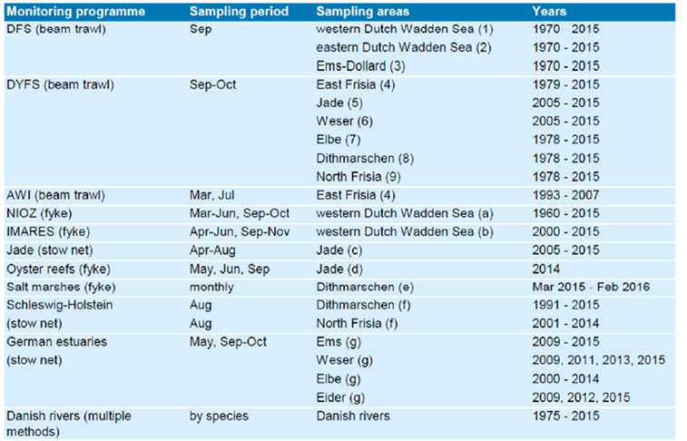

Map of the areas covered by the beam trawl surveys (numbered regions, see Table 1) and the sampling locations of fixed gears (positions indicated with + and  labelled with a letter, see Table 1). | 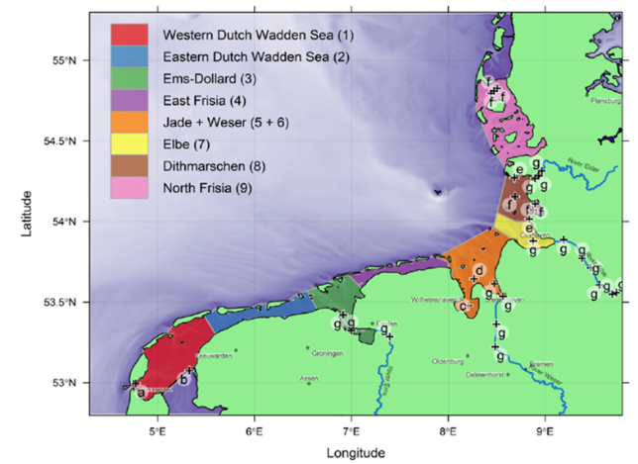
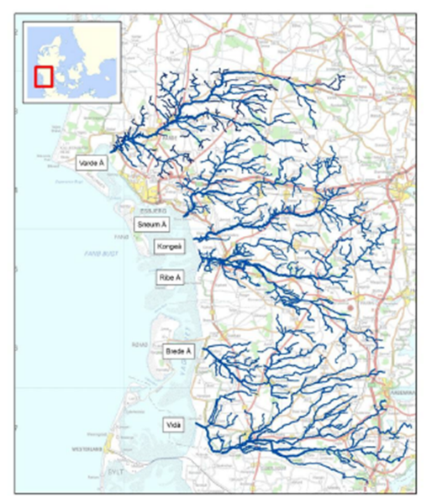 |  | Map of the main Danish Wadden Sea rivers (names in boxes, Å means river in  Danish) included in the Danish freshwater monitoring programmes.

Figure 1. Locations of fish monitoring programmes in Danish, German and Dutch waters as described in Table 1. Source: Tulp et al. (2017)
An overview of the programmes per country, including information on reporting obligations, programme details and data sources, is provided in Annex 1 and the data are summarised in an Excel spreadsheet. This spreadsheet will be one of the background documents for the Ad hoc Working Group SWIMWAY and will managed by the Working Group in an iterative fashion.
2.2 Application of available data and information
The monitoring and research programmes cover a wide geographical range and represent a variety of gears and methodologies. The majority of surveys is carried out in the deep tidal channels, during two research projects habitat-specific samples were collected. For the QSR analysis standardised trend analyses are carried out for selected species in the three beam trawl surveys (DFS, DYFS and AWI) and most of the stow net and fyke monitoring programmes (NIOZ, IMARES, Jade, Elbe and Schleswig-Holstein) (Tulp et al., 2017). This approach was not suitable for the other programmes due to the limited time series. The monitoring requirements for the Marine Strategy Framework Directive (MSFD) are currently being reviewed and these should also be considered. For example in Germany all monitoring programmes for MSFD up to March 2020 will be described in a monitoring handbook and made accessible to the public in the future.
Looking at the data from the point of view of addressing the Trilateral Fish targets it is important to build on the results of the QSR and see how the programmes can provide some understanding of characteristics such as population dynamics, fish habitat requirements, predator-prey interactions and anthropogenic effects. These requirements can be identified at the hierarchical ecosystem levels as shown in Table 2.
Table 2 Hierarchical ecosystem level approach and examples of the corresponding measurable characteristics
Level | Description | Characteristic
Species | A species is the basic unit of classification and represents a group of organisms capable of (inter)breeding | abundance, biomass, age, individual growth (in time and space), numbers going through fish passages  special attention for endangered species, mean trophic level
Population | A population is genetically delineated group of individuals of the same species living in a particular geographic area | age and length structure, growth rate, birth rate, mortality (fisheries (F) and natural mortality (M))
Community | An ecological community is defined as a group of actually or potentially interacting species living in the same place. | predator-prey interactions; anthropogenic effects
Ecosystem | An ecosystem is a community of living organisms in conjunction with the non-living components of their environment, interacting as a system. | fish-habitat interactions & requirements, connectivity within Wadden Sea, availability and connectivity of habitats for food and reproduction
Biome | A biome is a formation of plants and animals that have common characteristics due to similar climates and can be found over a range of continents. | migratory patterns and connectivity outside Wadden Sea (bottlenecks .. ), availability of freshwater sites for spawners or adults of diadromous species

A first analysis of the available monitoring programmes was made to see how they provide information for each of these levels and the results can be seen in Figure 2. Whilst all programmes give information on species, population and community parameters are poorly covered.
Spatio-temporal coverage of the data is also a limiting factor and the same data were analysed to gain some insight into the geographical range and time-series available. These data are shown in Figure 3.

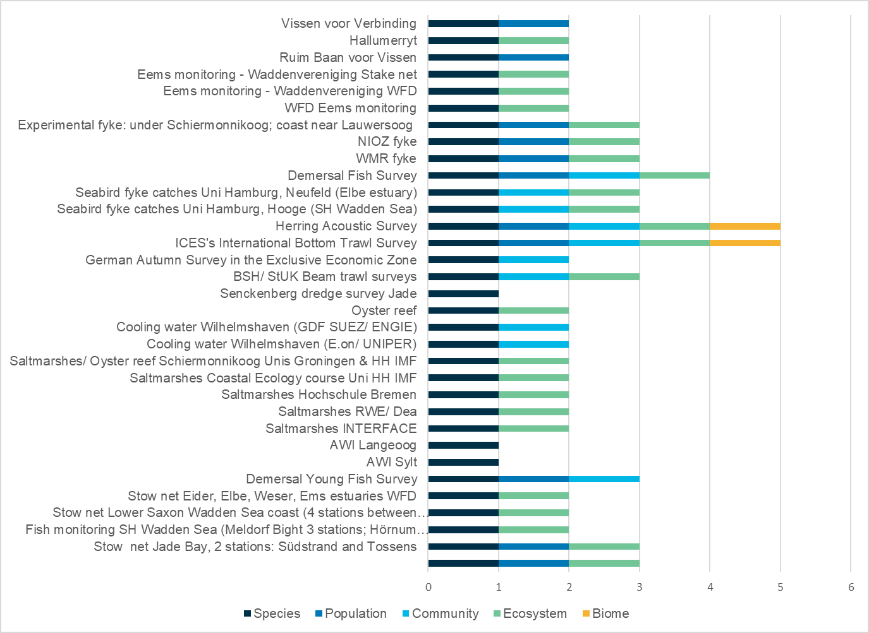
Figure 2. First overview of available information from monitoring and long-term research programmes for hierarchical ecosystem levels as described in Table 2.

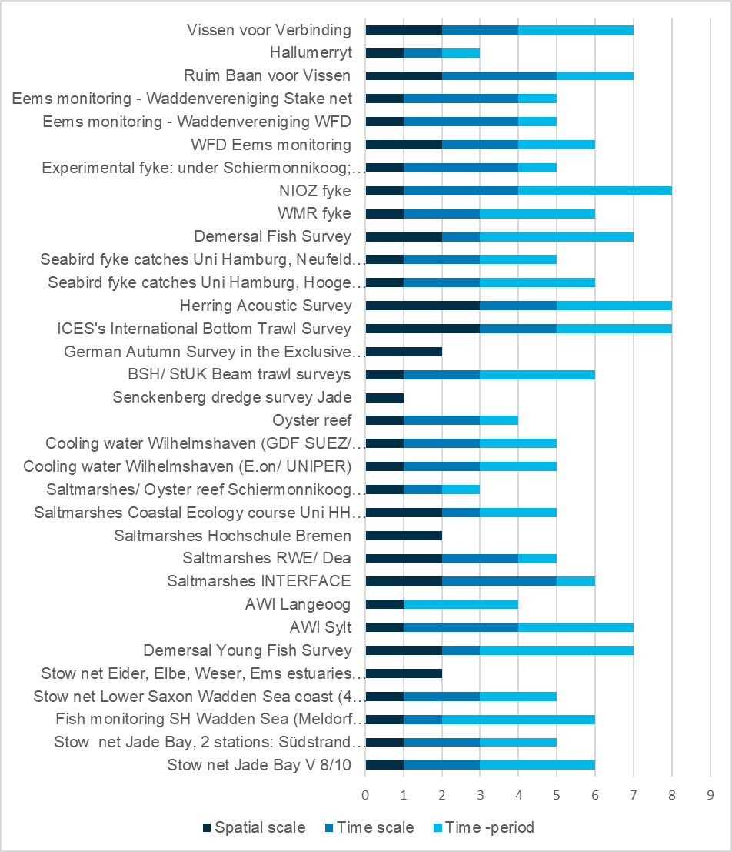
Figure 3. First overview of spatio-temporal coverage of monitoring and long-term research programmes. Spatial scale: 1 = local; 2 = regional, 3 = international waters; Time scale (frequency per year): 1 = 1 or 2 months; 2 = two periods; 3 = monthly; Time-period: 1 = 1 or 2 years; 2 = 3-9 years; 3 = 10-19 years; 4 = 20 years and above.

2.3 Next steps
Next steps will be to finish filling the database and to arrange the data in such a way that information can be compared and evaluated [and so remedy the DRIP (Data Rich Information Poor) situation we are presently facing]. This would mean including more parameters, such as country, area, gear, key spp. caught, and length-class and/or life-stage targeted. It might also be useful to include specific data on the flagship species which have been identified in the Action Plan. One of the outcomes might be ‘traffic light’ for comparability of programmes as far as parameters such as abundance, gear etc. are concerned. An integration with the policy objectives could also be considered. Further work will help inform the development of current and future monitoring programmes. In preparation for the proposed TMAP Fish Parameter Group, these tasks could be carried out by the Ad hoc Working Group SWIMWAY.
Moreover, this collation of the available monitoring and research data could also be applied to the question if the evident gaps in knowledge arise from a lack of data or from a lack of connectivity among monitoring programmes, among research projects and between these two. This has recently been carried out in the area of recruitment research (Rice & Browman, 2015). The authors argue that there is not necessarily a lack of recruitment research, but this is not evident as it has been “co-opted by more trendy, possibly ephemeral, research topics”.
One of the aspects in the Swimway Vision, and reinforced during the Swimway conference, is to better understand fishing mortality. It could be taken into consideration to include insights into the fishing mortality on the flagship and fleet species for the fleets currently active in the Wadden Sea and coast, such as shrimpers and beam-trawlers, as well as any passive gear that is deployed in the area.
In a broader sense, it has been recommended to assess the impacts of fisheries on the fish populations by including data from fisheries bycatch projects and surveys. This would link in to the Framework for Sustainable Fisheries as worded in the 2014 Tønder Declaration (Tønder Declaration, 2014) as shown below.
Tønder Declaration
Framework for Sustainable Fisheries
During the trilateral Tønder Conference on the Protection of the Wadden Sea (2014) a general framework and guiding principles on sustainable fisheries was agreed on. These guiding principles include trilaterally comparative impact assessments of all fisheries sectors in the Wadden Sea, facilitating a dialogue also between the industries and NGOs between the countries. The improvement of fishing gear, monitoring of fishing activities, stock assessments and pilot studies will also be trilaterally implemented to allow a Wadden Sea wide transition towards sustainable fisheries. The trilateral policies (Wadden Sea Plan 2010) state that mussel fishery will continue to be largely restricted to designated parts of the subtidal, with considerable areas left aside as feeding grounds for birds. Mussel culture lots will not be extended. Fishery practises are to be improved to further reduce impact.
3. Future forum and Trilateral Expert Fish Group
3.1 Introduction
The section will inform how the information from the programmes above may act as the future access point within the trilateral monitoring framework (e.g., TMAP) and will use input provided by the monitoring breakout session during the 2019 SWIMWAY fish conference in Hamburg, Germany 23-27 September 2019. See Annex 2 for the summary of the breakout session.
3.2. Implementing the fish targets
The challenge to implement the targets is the formulation of quantitative and testable sub-targets for each target. Two approaches have been explored, following discussions taking place at the Trilateral Swimway Scientific Conference in Hamburg in September 2019 (Dänhardt, 2019). One is to start a process to make the targets SMART (Specific, Measurable, Achievable, Realistic and Timely) and the other, based on work presented by Katja Philippart at the conference and discussed during the breakout session on monitoring (summarised in Annex 2), is to address the targets from the perspective of the Theory of Change.
SMART(er) Targets
At the conference a three level approach was suggested to SMARTen the targets:
1. The trilateral fish targets as they have been adopted by the minister’s conference in 2010 should be maintained. Generic as they are, everybody can agree that they should be implemented.
2. Delivering concise definitions on what is meant by the formulations, the generic targets should be specified to a level of detail so they can provide a framework for answerable questions and testable hypotheses to be specified in a third step.
3. The generic targets specified through concise definitions will allow to formulate research questions and hypotheses, which then form the backbone of dedicated, hypothesis-driven, cooperative and interdisciplinary research.
There should be an ongoing dialogue integrating monitoring, research, communication and education and involving stakeholders, countries and institutions in order to move the process forwards. This was summarised by Dänhardt (2019) in the diagram below.

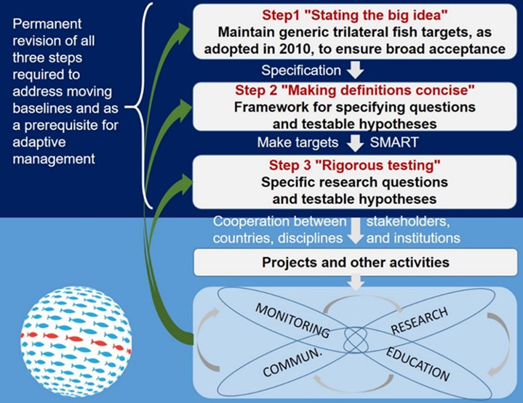

Theory of Change
The “Theory of Change” approach illustrates complex interactions between long term goals and the factors influencing these goals, as well as the development of indicators to address these (Philippart, 2019). Figure 4 below shows a simplified model.
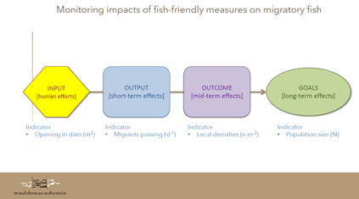

Figure 4. Theory of Change model showing relationship between human activities and long-term goals and what type of indicators can be developed along the pathway of change (Philippart, 2019).

During the Breakout Session at the Swimway conference the following question was addressed: What could be structure of the advice on the monitoring required for evaluation of the targets of the SWIMWAY vision?
As can be seen in Annex 2 it is suggested that by “Following the “Theory of Change”, such a monitoring program should start by identification of the indicators for the goals to be reached with respect to fish in the Wadden Sea area, being:
- indicators to evaluate the trilateral Swimway targets;
- indicators providing the framework for a minimum package of measurements that Denmark, Germany and the Netherlands are compulsory to carry out under national or European legislation or treaties (e.g. WFD, MSFD);
- indicators that are part of (often legally-forced) effect studies that are set up to examine the impacts of human activities that are potentially harmful (e.g. fisheries, dredging) or beneficial (e.g. restoration programs) for natural values (e.g. fish passages and restoration habitats)
Once the goals and indicators for the full pathway of change (e.g. indicators for all steps on the way from human activities to long-term goals) are identified, the list of required data should be checked by available data and possible gaps in data and knowledge (e.g. dose-effect relationships) made explicit. Gaps in knowledge should be filled by additional research, gaps in data in setting up additional monitoring. Monitoring should be part of an adaptive programme, where results are regularly used to evaluate the progress in reaching the goals.”
A next step might be to explore how these two approaches might complement each other as far as the development of indicators and resulting adaptive monitoring programmes are concerned.
As a thought experiment, the two approaches might be linked to show how the development of indicators could assist in the implementation of SMART targets. See Figure 5.

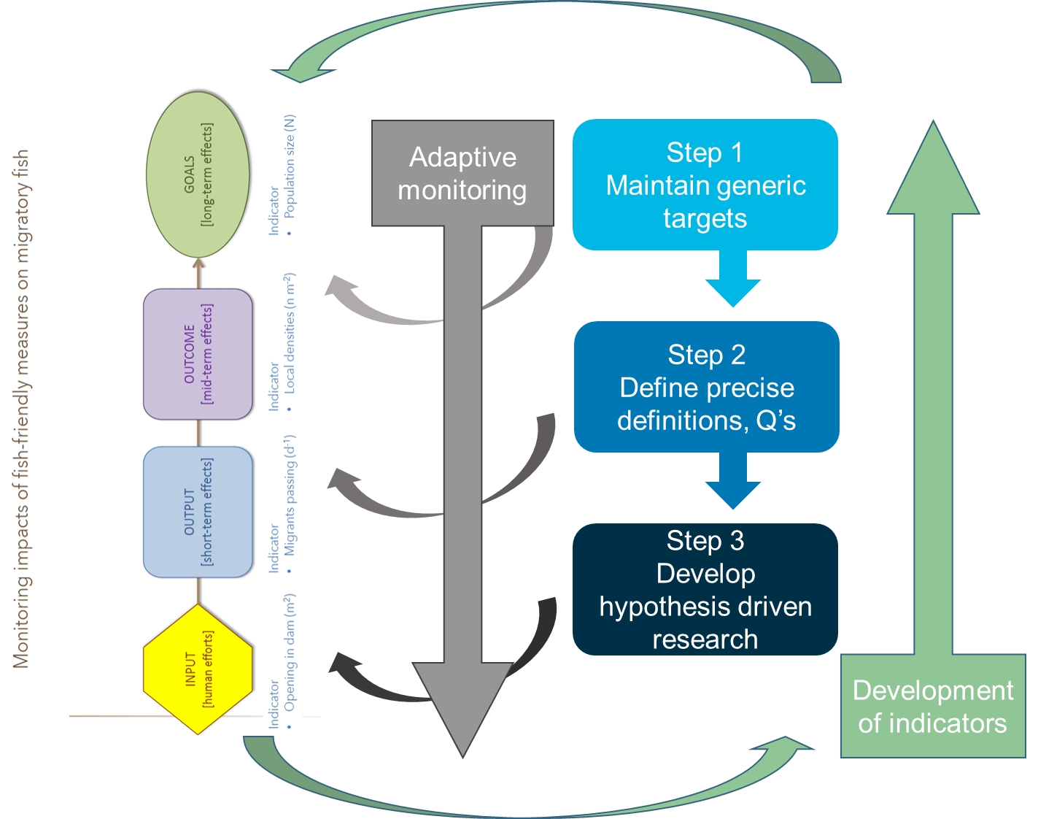

Figure 5. Rough sketch for possible interactions between the three-step approach and the theory of change approach.
3.3 Future forum - future SWIMWAY data collation and exchange systems
One of the outcomes from the SWIMWAY conference was the suggestion to set up a TMAP Fish Parameter Group with representatives from each country in which the existing and future research and monitoring programmes can be identified which can address the Fish Targets and will augment the programmes currently utilised (beam trawl surveys - DFS, DYFS and AWI). This Group could present its proposal on improving TMAP with respect to the Swimway targets during the 2nd Swimway Conference, which is tentatively planned for 2022. Based on the inputs from participants of this conference, a further prioritised and revised version should then be submitted as part of the “TMAP 2.0”.
A first inventory of existing monitoring and research programmes has been made and is compiled in a spreadsheet with metadata. This can become an interactive tool in order to gain insight into the parameters collected in each of the programmes, as well as how comparable they are as regards methodology and results and can be used and further developed by the Ad hoc Working Group SWIMWAY.
The Ad hoc Working Group SWIMWAY could take on the job of further developing the SMART targets and Theory of Change approaches and, in collaboration with TMAP, develop an adaptive framework for data collection and monitoring.
There are already data and information sources which could be enlisted to address some of the parameters which have been identified as being important to implement the fish targets. These actions could already be initiated in 2020 as individual collaborative trilateral research projects as shown in Table 3.
Table 3. Overview of parameters identified as being important for implementing the Trilateral fish targets and the current data sources and actions.
Parameters | Possible actions based on available data/information sources
Demographics, ageing and growth | Examine existing otolith collections, e.g. for ageing (and microchemistry)
Fish-habitat relationships | Develop (or expand on) fish habitat suitability models based on current research (e.g. importance of salt marshes for herring in Germany and cues for migratory fish in the Netherlands)
Spatio-temporal coverage to include whole life-cycle | Make use of information from international surveys for selected species such as herring, plaice and sharks
Sampling techniques to include all species (pelagic, non-commercial) | Explore role for fishermen and information from bycatch programmes
New techniques: eDNA, stable isotope analysis, otolith microchemistry, drones, telemetry | Learn from current eDNA research in NL and DK and mark-recapture programmes (NL, GER, DK)
Impact assessments | Analyse existing programmes, e.g. fisheries bycatch programmes and cooling water sampling
Historical reconstructions | Access existing data on species trends in abundance

During one of the other breakout sessions at the 2019 SWIMWAY fish conference in Hamburg, Germany 23-27 September 2019, ideas for exchange of knowledge were discussed. Two of the actions suggested in the discussions are relevant for the future forum:
- Create a SWIMWAY online forum: start with a searchable bibliography – initially per estuary – and upgrade to a portal where stakeholders can post their questions, in time;
- Identify the SWIMWAY core of people, carry out network analysis and identify connectors (nodes) who will be influential in future activities.
These actions could be added to the remit of the Ad hoc Working Group SWIMWAY in order to facilitate the exchange of knowledge.
To ensure continued participation of the SWIMWAY community it is suggested to create a calendar with time frame + include agreed meetings .. e.g. a next SWIMWAY conference in 2022. This calendar could be made available on the SWIMWAY website, and might include other meetings such as those organised by large projects and in other relevant fields. A first step has been made during the monitoring breakout session (Annex 2).
Further important conclusions from the breakout session on monitoring were made which are important for the future forum as follows:
- The continuation of the running fish monitoring programmes;
- Understanding of monitoring by civil servants should be enhanced;
- Fish monitoring interconnected with monitoring of other parameters in TMAP (and beyond);
- Open up relations with general public (“citizen science”);
- Scientists to come up with pragmatic suggestions for the use of monitoring in trilateral Wadden Sea management;
- There should be clarity on who is responsible for what, and explore who could take up additional roles (e.g. NGO’s in bridging gaps between science and society).
3.4 Trilateral Expert Fish Group
The steps described above could be part of the process towards forming a permanent Trilateral Fish Expert Group. The work of the current Ad hoc Working Group SWIMWAY would form the basis for this Trilateral Expert Group. The suggested tasks of the TMAP Fish Parameter Group could be addressed in the first instance by the Ad hoc Working Group SWIMWAY to create a forum for the necessary monitoring and data collection activities, which would then support the future Trilateral Expert Group, as shown below.
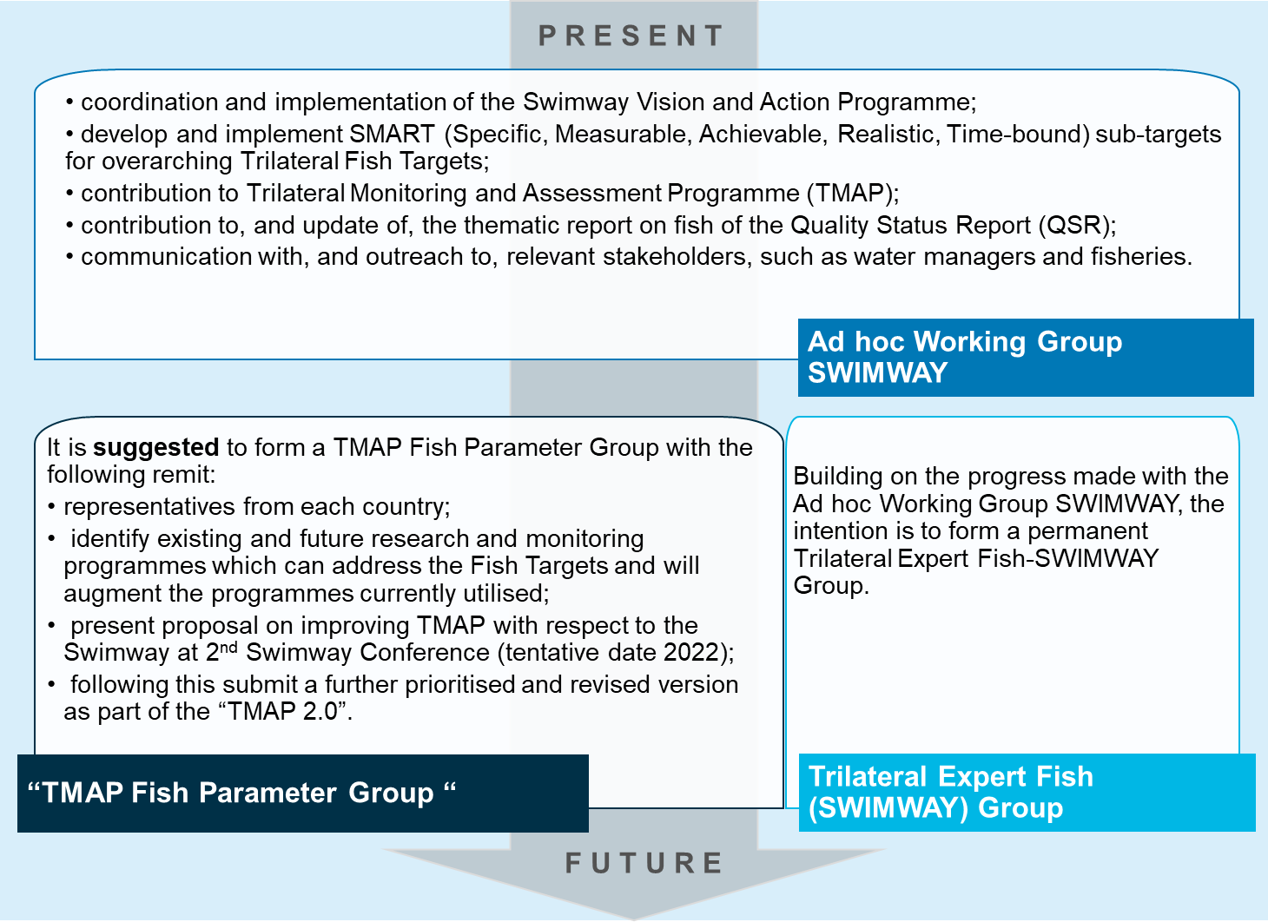

This proposal could be considered by the Ad hoc Working Group SWIMWAY as a way forward.
It is hoped that the information presented in this document will be an aid to shape the approach for the further implementation of the SWIMWAY Vision and Action Programme.

Acknowledgements
The author would like to thank the Ad hoc Working Group SWIMWAY for their input to this document, in particular Andreas Dänhardt. Thanks are also due to Julia Busch and Adi Kellerman for their support and contributions when writing the report. The very useful report of the Monitoring Breakout Group at the SWIMWAY conference is due to the excellent work of the chairpersons Katja Phillipart and Britta Diederichs and their rapporteur, Mikkel Jensen.

References
CWSS (2010) Wadden Sea Plan 2010. 11th Trilateral Governmental Conference on the Protection of the Wadden Sea. Common Wadden Sea Secretariat, Wilhelmshaven, Germany.URL https://www.waddensea-worldheritage.org/sites/default/files/2010_Wadden%20Sea%20Plan.pdf
Dänhardt, A. (2019) SWIMWAYs: Understanding connectivity within the life cycles of coastal fish. Conference report, 24-26 September 2019, Hamburg, Germany. Jesteburg/ Lüllau, 82 pages. Common Wadden Sea Secretariat, Wilhelmshaven, Germany.
Leeuwarden Declaration (2018) Ministerial Declaration of the 13th Trilateral Governmental Conference on the Protection of the Wadden Sea, Leeuwarden, May 2018. Common Wadden Sea Secretariat, Wihelmshaven, Germany. URL: https://www.waddensea-worldheritage.org/resources/2018-leeuwarden-declaration
Philippart, K. 2019. Concepts and cues for monitoring of fish migration. Key note speech Swimway Scientific Conference, Hamburg 24-26 September 2019.
Tønder Declaration (2014) Ministerial Declaration of the 12th Trilateral Governmental Conference on the Protection of the Wadden Sea, Tønder, February 2014. Common Wadden Sea Secretariat, Wihelmshaven, Germany. URL https://www.waddensea-worldheritage.org/resources/2014-t%C3%B8nder-decla...
Tulp I., Bolle L.J., Dänhardt A., de Vries P., Haslob H., Jepsen N., Scholle J. & van der Veer H.W. (2017) Fish. In: Wadden Sea Quality Status Report 2017. Eds.: Kloepper S. et al., Common Wadden Sea Secretariat, Wilhelmshaven, Germany. Last updated 21.12.2017.
Rice, J. and Browman, H.I. Where has all the recruitment research gone, long time passing? ICES Journal of Marine Science, 2015, 71. Jg., Nr. 8, S. 2293-2299.
Annex 1- overview of monitoring and long-term research programmes
Most of the information below has been taken from the 2017 QSR (Tulp et al., 2017).
Netherlands
DFS (beam trawl)
The Dutch Demersal Fish Survey (DFS) covers the coastal waters (up to 25 m depth) from the southern border of the Netherlands to Esbjerg, including the Wadden Sea, the outer part of the Ems-Dollard estuary, the Westerschelde and the Oosterschelde (van Beek et al., 1989). This survey has been carried out in September-October since 1970 (September in the Wadden Sea). The number of hauls and the area swept was kept as constant as possible. In several years, not all sampling points were sampled due to adverse weather conditions. Sample locations were stratified by depth. For each haul, the position, date, time of day and depth were recorded. Within the Wadden Sea, sampling was carried out with a 3 m-beam trawl. The beam trawls were rigged with one tickler chain, a bobbin rope, and a fine-meshed cod-end (20 mm). Fishing was restricted to the tidal channels and gullies deeper than 2 m because of the draught of the research vessel. The combination of low fishing speed (2-3 knots) and fine mesh size results in selection of the smaller fish species and younger year classes. The mean abundance per area was calculated for the period 1970-2014 weighted by surface area for five depth strata (intervals of 5 m) within the region. Surface areas of depth strata used were taken from ICES (2011).
NIOZ (fyke)
Since 1960, a kom-fyke trap has been operated at the entrance of the Marsdiep basin in the western Dutch Wadden Sea. The kom-fyke is a passive gear consisting of a 200 m long and 2 m high leader which starts above the high water mark and ends in two chambers in the subtidal region with a mesh-size of 10 x 10 mm. Fishing normally started in March - April and lasted until October. In winter the trap was removed because of possible damage by ice floes and from 1971 onwards no fishing took place during part of the summer because of fouling of the net and clogging by macroalgae and sometimes by scyphomedusae.
Usually, the kom-fyke was emptied every morning, except when bad weather prevented this. Pre-1973 the nets were sometimes emptied on alternate mornings, when catches were small.
Samples were selected according to the following criteria:
Fishing duration less than 48 h and longer than 12 h, no damage of the gear upon retrieval (loose mesh panels or tears) and/or not clogged with debris. All catches were sorted immediately and identified to species level. For each species, numbers were counted and sometimes, when numbers were large, only wet mass was determined.
Wageningen Marine Research (previously IMARES) (fyke)
Diadromous fish abundance is monitored since 2001 during three months in spring/summer and three months in fall/winter in a fyke program at the Wadden Sea side of the Afsluitdijk near the sluices of Kornwerderzand. The program is carried out with five fykes in the discharge basin and two along the Afsluitdijk. They are lifted twice a week by professional fishermen and the catch is counted and registered per species. All catches were sorted immediately and identified to species level. For each species, numbers were counted and classified in two size classes (large and small, with the division at commercial landing size for commercial species and for other species at intervals roughly separating mature from immature fish).
River Ems (stow net)
In order to meet the requirements for the Water Framework Directive (WFD), Dutch and German authorities have carried out a stow net sampling programme twice a year (May and September) in the river Ems since 2007. Due to the transboundary nature of the area, this monitoring is organized by both the German and the Dutch governments who take it in turns to finance the work. This programme covers three sampling points (Spijk, Oterdum and Terborg) which are placed at locations from the estuary mouth and cover different salinities. Per sampling occasion the flood and ebb tide are monitored separately.
In all years, except 2011, the WFD fish surveys in the Ems estuary were conducted by BioConsult with the fishing vessel Ostetal, anchor net beam width 13 m, vertical opening max. 11 m. The 2011 survey was conducted by Bureau Waardenburg and ZiltWater Advies with the fishing vessel TM9, anchor net beam width 10 m, and a vertical opening max. 10 m. Both nets had 10 mm mesh in the cod-end of the net.

Ems monitoring – Waddenvereniging (stow net and stake net)
In 2019 the Waddenvereniging designed a project to carry out sampling of fish in the Ems estuary between March and November 2019. The aim of the project is to increase our knowledge and understanding of the seasonality in the fish community in the estuary, and to perform comparative sampling strategies with a view to finding a less costly method to sample the fish community.
For this project, the WFD programme (see above) will also be carried out by the same consortium in the months March, April, June, October and November at the Oterdum location only. This will provide some insight into the seasonal variation in fish species and their abundance.
Concurrent with the WFD sampling there will be a comparative sampling programme carried out using the stake net in order to further identify seasonal patterns in the fish assemblage and to compare the two fish sampling methods. This will take place at the same time as the WFD monitoring from March to June and September to November. Both programmes monitor the flood and ebb tide separately.
Fish passage sampling
‘Vissen voor Verbinding’ is a project about the restoration of fish migration from ‘source to sea’ and focusses on the stream Peizerdiep (South-west of Groningen) to the Wadden Sea. The research concerns the (re)introduction of sea trout and improvement of their nursery areas and habitats in the stream system. Research is also carried out on the migration of species such as stickleback and eel. Besides this, the project is also aimed at enhancing the revenue from angling in the area.
‘Ruim Baan voor Vissen 2’ is a follow-on project from the ‘Ruim Baan voor Vissen 1’ project. In ‘Ruim Baan voor Vissen 2’ the restoration of habitats for diadromous fish is carried out across the Wadden Sea, as well as improving the connectivity with the inland waters. Although there will be a lot of actual physical restoration, there will also be research into the migration of fish to inland waters to enable an evaluation of the current fish passages and habitat restoration measures.
Overview
Overview of monitoring and long-term research programmes carried out by WMR and NIOZ in the Wadden Sea tidal flats, gullies (tidal inlets and streams) as well as subtidal areas bordering the Wadden Sea.

 | DFS Beam Trawl – Dutch Wadden Sea | ‘WMR Fyke’ | NIOZ fyke
Reporting obligations and other motivations for data collection for those monitoring programmes | Statutory task under the EU Data Collection Framework (DCF) in support of the CFP | National obligations under statutory task programme to fulfil WFD requirements | Institutional long-term monitoring programme
Programme details, such as responsible agencies and institutes, sampling locations and sampling frequencies, applied methods and QA procedures | Responsible Agency = Ministry for Agriculture, Food Security and Nature; WMR carries out the sampling in Sep/Oct each year since 1970; map of locations available; WMR has its own ISO 9001:2015 certified QA procedure | Since 2001; seven fykes; three months in spring/summer; three fykes in autumn/winter; on Wadden Sea side of Afsluitdijk (Kornwerderzand) | 1960-present  Two periods per year: spring and autumn; fyke sampled daily
Data sources, and data formats and storage locations, access details (online, analogous access) and contact details of responsible persons/agencies/institutes | Contact person statutory tasks: Sieto Verver  Contact person at WMR: Ulrika Beier  Data stored in national database and data is provided to end users under the DCF. No direct access to data, only by duly justified request | Contact person at WMR:  Karen Schilder  Data stored in national database. No direct access to unaggregated data, only by duly justified request.  Annual means available via WMR open data portal (in Dutch), waterlichaam=Waddenzee | NIOZ Henk van de Veer  www.waddenzeevismonitor.nl
Parameters collected | Species, numbers, biomass per species, date, position, depth; otoliths | Species, numbers, biomass per species, effort | Species, numbers, biomass per species, otoliths temperature, salinity, Secchi depth

Germany
DYFS (beam trawl)
The German Demersal Young Fish Survey (DYFS) has been carried out in September-October since 1974 in the Wadden Sea areas of the Elbe estuary, Northern and Eastern Frisia by commercially chartered fishing vessels. A 3 m beam trawl with a mesh opening of 20 mm (stretched mesh) was used as the standard fishing gear. The number of sampled stations increased over the years from a minimum of about 100 stations in early years up to approximately 160 stations per season. The 15-min tows were carried out with the prevailing tidal current at a towing speed of approximately three knots. Fishing depth usually ranged from 2 to 15 m. The gear used in the surveys carried out by the two countries, The Netherlands and Germany, differ slightly. Only in the Dutch DFS a tickler chain is used.
AWI (beam trawl)
Between 1993 and 2007 a 3 m beam trawl (mesh size 10 mm, with tickler chain) similar to the standard gear of the DYFS was used to sample fish and epibenthic invertebrates in subtidal creeks behind the Lower Saxony Wadden Sea islands Spiekeroog and Langeoog (Knust et al., 2013). In this period, a total of 55 campaigns were carried out in March and July in the majority of years. Average haul duration was 10 minutes, average water depth was 4 m. If possible, sampling took place within two hours before and after low water. For effort standardization, the geographical position at veering and lifting the net were noted as endpoints of the linear sampling transect, from which the swept area was calculated. Catch numbers of individual hauls were then standardized to n * 1000 m-2 swept area. Whole catches were weighed, sorted by species and subsamples were taken as required after rechecking the catch for rare species. Samples were frozen for subsequent analyses in the laboratory, where total length to the nearest mm and wet weight to the nearest 0.01 g were determined. Abundance data for the trend analyses were calculated as the average catch numbers per unit effort of the individual species per month for any given year.
Jade (stow net)
A ship-based stow net was employed in the central Jade Bay in the Lower Saxony Wadden Sea, Northern Germany between 2006 and 2017. Stow nets are passive fishing gear utilizing the water movement in rivers or in tidal marine areas such as the Wadden Sea. They target mainly pelagic fish by stretching between the water surface and the bottom. The rising tide lifts the vessel with the attached stow net from the ground, rendering the method inappropriate for targeting demersal species. Dänhardt & Becker (2011) and Breckling & Neudecker (1994) describe the method in detail. Between April and August at least one monthly campaign was carried out to cover the reproductive season of common terns Sterna hirundo breeding at the Jade. One haul during ebb and flood tide during the day and at night, respectively, were carried out, amounting to four hauls per campaign, but depending on local wind conditions, sometimes campaigns had to be terminated already after two or three hauls.
Net opening in 2006 and 2007 was 5 × 7 m, divided into five compartments and a mesh size of 5 mm in the codend (Dänhardt & Becker, 2011). From 2008 on a larger net with only one instead of five chambers was used with a net opening of 7 × 7 m and 10 mm mesh size in the codend. Despite these differences, the length distribution of the species used in the trend analyses did not differ significantly between the two gears, but differences in catch properties cannot be ruled out. The filtered water volume was calculated by multiplying the surface area of the net opening with current measurements obtained from mechanical propeller flowmeters (Hydrobios, Kiel). Absolute catch numbers were standardized to fish caught per 10,000 m³ filtered water volume. The catches were sorted by species, individuals from each species were counted and individual standard length measured to the nearest mm. The wet weight per species was determined on board to the nearest 2 g. Abundance data for the trend analyses were calculated as the average catch numbers per unit effort of the individual species per campaign for the years 2006-2017. For analysing the abundance trends, data were selected from months that were regarded most suitable to represent the phenology of the target species (herring, sprat and anchovy: end of June; twaite shad and river lamprey: April and August; smelt: June and August). For pilchard, sea bass and sea lamprey there were too few records to consider these species in the trend analyses.
Salt marshes (fyke)
Data on fishes in intertidal saltmarsh creeks were taken from two research projects employing the same methodology.
1. Fine-meshed (6 mm in the codend) fyke nets were placed in two intertidal creeks draining a saltmarsh in Dieksanderkoog Nord, Schleswig-Holstein, Northern Germany (54°01’00 N, 8°50’24 E). During four 5 day-campaigns in October 2010, May, June and August 2011 nine hauls per fyke per campaign were carried out to investigate structure and species composition of the fish community and species-specific abundance and size distribution. Repeatedly sampling a small water volume yielded dependent data, but allowed inferences on temporal utilization patterns by means of depletability and recolonization of the creeks by fish.
2. During the research project INTERFACE (INTERaction of Fish, plAnts, Carbon & sEdiment: Management and ecosystem functions of Wadden Sea Salt Marshes), between March 2015 and February 2016 four fyke nets were employed in four intertidal creeks off St. Peter Ording/ Ehst (54°16’40 N, 8°41’06 E), two of which draining a grazed part of the marsh, the other two draining ungrazed areas. Monthly fyke samples (one day and night in each of the four creeks) yielded data on structure and species composition of the fish community and species-specific abundance and size distribution. Samples of both surveys were processing according to the standard procedure of the stow net catches described above. Exact effort standardization was not possible, catch numbers were expressed as individuals per haul, assuming constant effort of the same fyke across tidal stages and throughout the season.
Oyster reefs (fyke)
The University of Hamburg, Institute for Marine and Fisheries Sciences, and Senckenberg Marine Research Department investigated how a newly introduced habitat is utilized by native fauna, five fine-meshed fyke nets (6 mm in the codend) were placed in three small creeks draining the surface of an intertidal reef of the Pacific oyster Crassostrea gigas, and in another two larger creeks surrounding the reef. The Pacific oyster reef (53°38'77 N, 8°15'99 E) is located near the end of a tidal channel called Kaiserbalje on an intertidal mud- and sandflat area between the Jade and the Weser estuary called Hohe Weg. In May, June and September 2014 two hauls per fyke (one during the day, the second during the night) were carried out. Fykes were set at low tide, catches were recovered at two subsequent low tides and processed according to the standard procedure of the stow net catches described above. For reference, stow net catches from a station 18 km further south of the reef location were carried out within a week of the fyke sampling on the reef (see above).
Schleswig-Holstein (stow net)
From an anchoring vessel a fine-meshed net (8 mm in the cod-end) is placed into the tidal currents between the water surface and the bottom by means of two iron beams, each 9 m long (= width of the net opening). Depending on the water depth the maximum net opening is 90 m².
The stow net is opened once the water current exceeds 1 m/s. When the current speed falls below this value the net is closed (by lifting the lower beam), terminating the haul. Thus, haul duration varies depending on local conditions and is highly influenced by wind and moon phase. Typical haul duration is 2 to 4 hours in which 0.2 to 0.5 mio. m³ of water pass through the net. Each sampling station is fished 4 times per 24 hours under the aspects of day and night as well as flood and ebb tide.
During each haul the current speed is measured by means of a Doppler current sensor in order to exactly calculate the catch volume. Absolute fish numbers and biomass by species are normalized to 1 mio. m³.
This monitoring programme started in 1991 in the Meldorf Bight and was terminated in 2019. Three sites in the Meldorf Bight were sampled once a year in August. From 1997 to 2001 additional samples were taken in June in order to get more insight in seasonal variations of the fish fauna. Since 2001, the fish monitoring in August has been expanded to another three sampling sites in the Hörnum Deep, a tidal channel between the islands of Sylt and Amrum.

German rivers (stow net)
Annual fish monitoring has been carried out in the Elbe since 2000. After implementation of the WFD, monitoring was carried out in all German estuaries since 2006. The data form the basis for fish-based assessment of the ecological potential of the estuaries (Scholle & Schuchardt, 2012). Commercial stow net vessels are used. The stow net sizes vary according to the vessel between 90 m² - 130 m² with a mesh size of 8-12 mm in the cod-end. As a rule, the duration of a haul extends over the entire tidal phase (low and high tide phase), i.e. for several hours. The spatially defined catch stations reflect the different estuarine salinity zones from the freshwater section to the polyhaline zone of the outer estuary and a catch station has been set up in each salinity zone. Depending on the estuary, monitoring takes place twice a year in spring (May) and autumn (Sept./Oct.) each year, every other year or every third year (Table 1).
Catch data were standardized to ind.*100,000 m⁻³. The smelt data were differentiated into age group AG 1+ (adult, subadult) and AG 0+ (juvenile). Evaluation of AG 1+ is derived from spring catches while autumn data from transitional waters (T1) were used for the juvenile group (AG 0+). The data were spatially averaged for the specific estuary via the salinity gradient and provision of the standard error (= standard deviation divided by the square root of N fishing operations). Evaluation of the twaite shad data here was restricted to the age group AG 2+ (adult) and, thus, to the spawning stock.
Overview
Overview of monitoring and long-term research programmes carried out by WMR and NIOZ in the Wadden Sea tidal flats, gullies (tidal inlets and streams) as well as subtidal areas bordering the Wadden Sea can be found in the Excel spreadsheet which is managed by the Ad hoc Working
Denmark
Danish rivers (multiple methods)
Salmon: In Varde å and Ribe å, the number of spawners is estimated from tagging – recapture surveys, where a large proportion of the adult salmon are captured by electro-fishing in October, PIT tagged and released. On the subsequent sampling in Nov/Dec, the ratio of tagged-to-untagged fish enables a solid estimate of the run. Factors like size-, age- and sex distribution and the wild/hatchery ratio are also provided from these studies. Each river is evaluated with two to three years interval. In addition, Sneum å was surveyed in 2015 and Kongeå in 2017. Detailed catch data from angling are available from all salmon rivers, where every caught fish (including released) should be reported. In Varde å and Ribe å, an inventory of spawning and rearing habitat and density of salmon juveniles has been carried out in 2015 and 2016. Brede Å and Vidå, also have salmon stocks now and these will be surveyed in the next years.
Sea trout: No monitoring of the annual run of spawners. Some records of angler catch, but not as detailed as for salmon. All the rivers (even small creeks) are being surveyed regularly in August for the density of (mainly juvenile) trout. Thus, we have long time series of data from many stations and can use these to evaluate trends and status for the population of sea trout.
Eel: According to the EU eel management plan (2007), member states must monitor the recruitment of eels. In DK, we have two stations that capture glass eels and we also monitor three streams every year for glass eel density. None of these are in the Wadden Sea area. In Ribe å there is annual monitoring of the output of silver eels, and time series are available five years back.
North Sea houting: This rare fish is being monitored only at the adult stage, upon return to rivers for spawning. Juveniles drift out into the Wadden Sea when only few cm long, so monitoring is difficult. Some tests have been conducted and nets sampling downstream drifting fish have caught juveniles of North Sea houting, but not consistently. The North Sea houting moves into the rivers for spawning in late fall and monitoring takes place using gill-nets and electro-fishing. Regular monitoring is carried out in Ribe, Varde and Vidå. Attempts are done now to raise funds for a NSH-project.
River lamprey: Juveniles of river lamprey cannot readily (in the field) be distinguished from brook lamprey, therefore monitoring is focused on adults. Likely habitats are pointed out (often downstream impassable obstacles) and electrofishing from boat or by wading is done in March/April. Direct observation of spawning lamprey is also registered.
Sea lamprey: In the case of sea lamprey, monitoring is based on juveniles. Sampling by netting is performed in the most likely habitats (and places where adult sea lamprey has been observed). A standard net 25 × 25 cm (DVFI-ketsjer) with meshsize 1.0 mm is used to drag through fine substrate, where larvae normally reside. Sampling is done in June-Oct. Presence/absence is recorded in a number of fields/squares/stations.
In the Wadden Sea area, Varde å, Kongeå, Ribe å, Vidå and Sneum å are being sampled for both River and Sea lamprey, but the monitoring is not fully operational yet (Wiersma et al. 2009; Vos & Knol 2015). The major cause for their decline during historical times has been land-claim to acquire new land for agriculture, and more recently, coastal-protection measures. Loss of salt marsh through human intervention continued throughout the twentieth century.
Key fishers programme (citizen science): still to add details.
Overview
Overview of monitoring and long-term research programmes carried out in Danish rivers.

 | Salmon | Sea trout | Eel | North Sea houting | River lamprey | Sea lamprey
Reporting obligations and other motivations for data collection for those monitoring programmes | DTU Aqua own programme and reporting to NASCO and ICES | DTU Aqua own programme | EU Eel Management Plan | N2000 Habitats Directive | N2000 Habitats Directive | N2000 Habitats Directive
Programme details, such as responsible agencies and institutes, sampling locations and sampling frequencies, applied methods and QA procedures | DTU Aqua | DTU Aqua | DTU Aqua | Environment Agency | Environment Agency | Environment Agency
Data sources, and data formats and storage locations, access details (online, analogous access) and contact details of responsible persons/agencies/institutes | DTU Aqua, Silkeborg collect and host the data on salmon and reports to NASCO, etc.  Contact: nj@aqua.dtu.dk | DTU Aqua, Silkeborg collect and host the data on trout, etc.  Contact: fs@aqua.dtu.dk | DTU Aqua, Silkeborg collect and host the data on eel, etc.  Contact: mip@aqua.dtu.dk | Environmental Agency (Miljøstyrelsen).  Eigil Andersen,  eea@mst.dk | Environmental Agency (Miljøstyrelsen).  Eigil Andersen,  eea@mst.dk | Environmental Agency (Miljøstyrelsen).  Eigil Andersen,  eea@mst.dk

Annex 2 – summary of Breakout Session on Monitoring

SWIMWAY Conference (Hamburg, 24th-26th September 2019)
Outbreak session “Monitoring”
Hamburg, version 25 September 2019
Katja Philippart & Britta Diederichs (chairs)
Mikkel Jensen (rapporteur)
Approximately 20 participants (see list of registration)

PART A. Which monitoring is required for evaluation of the targets of the SWIMWAY vision (as copied from the QSR2019 Fish chapter)?
Overall target:
“There should be no human-induced bottlenecks in the Wadden Sea for fish populations or their ecosystem functions”
Targets (all in reference to the overall target) is to maintain or improve:
“Robust and viable populations of estuarine resident fish species”
With respect to the definition, it should be clear what is meant with “robust” (able to withstand disturbances, e.g. by supplying enough space for recovery), “viable” and “estuarine resident fish species” (NB: possible changes in species composition should be taken into account)
With respect to monitoring the progress in reaching this goal, the following variables were identified:
- Long-term time series (to detect long-term change)
- Abundance monitoring (both numbers and biomass)
- Population structure (e.g. age structure)
- Growth
- Demographic measurements (birth rates, mortality (fisheries & natural) and migration)
- Habitats

“The nursery function of the Wadden Sea and estuaries”
With respect to monitoring the progress in reaching this goal, the following variables were identified:
- Factors that provide nursery functions (e.g. food, lack of predators, temperature)
- Abundance of young fish (e.g. age, numbers, biomass)
- Habitat structure
- Size & morphology of the nursery areas (NB: also in the future)
- Stock – recruitment relationships
- Abundances in time (e.g. seasonality, phenology) and space
- Connectivity of areas within in the life cycle
- Growth
- Demographic measurements (birth rates, mortality (fisheries & natural) and migration)
- Between and within adaptability to environmental changes

“The quality and quantity of typical Wadden Sea habitats”
With respect to the definition, it should be clear what a “typical habitat” is (NB: Most probably species- and phase specific).
With respect to monitoring the progress in reaching this goal, the following variables were identified:
- Habitats should be grouped & clustered according to their specific function (spawning, feeding, etc.)
- Four dimensional (horizontal, vertical & time)
- Impact of anthropogenic activities should also be mapped
- It should be identified if the habitats are natural or artificial (e.g. reconstructed)
- Connectivity between habitats should be identified / mapped (e.g. by means of stable isotopes, tracking, capture/recapture, etc.)
- Factsheets for fish species, including their preferred habitats during different phase of their life cycles
- Detailed mapping of the area, not only indicating average values but also variability (e.g. the dynamics of an estuary might be more important than the estuarine gradient itself).

“Passage ways for fish migrating between the Wadden Sea and inland waters”
With respect to monitoring the progress in reaching this goal, the following variables were identified:
- Migratory behaviour of fish (NB: not only within in fish passage ways, but also within their full lifecycle area)
- Spatiotemporal resolution of monitoring should match with that of the migratory behaviour
- Comparison of observed vs. expected fish species passing and nearby the passage
- The design, operation & maintenance of fish passage ways
- Correlations between fish migrating via fish passage ways and (large-scale) ecological phenomena

“Conservation of endangered fish species”
Because endangered species are rare, monitoring their abundance and distribution requires an additional monitor system
- Non-destructive methods (e.g. eDNA)
- Identification of historical drivers for becoming endangered
- Monitoring and present threats and developments in bottlenecks

PART B. What is the time frame to establish the monitoring required for evaluation of the targets of the SWIMWAY vision?
It is advised to align results from these efforts to political opportunities to gain maximum interaction. As a starting point, a calendar was compiled with main meetings and time frames of programs and projects. In this calendar, we indicated which actions could be taken when with respect to fish monitoring (in blue).
2019
- Sept: Swimway Conference #1 (Hamburg)
- Oct: TG_MA workshop on trilateral monitoring (in general)
- Nov: Proposal and installation (if agreed by WSB) of fish expert group:
- Dec 3: Symposium on brackish waters (Leeuwarden)
ACTION: In addition to these activities, it is advised to set up a TMAP Parameter Group on Fish to aid in improving TMAP with respect to the Swimway targets. As for the other TMAP parameter groups, this group should be led by three coordinators from the different countries. In contrast to the other groups, this group needs much effort to come up to the level required for TMAP which most probably means that additional funding has to be found to support this (e.g. people can meet more often than once annual and be ready in time for SWC#2 in 2022).
2020
- Publication of Special Issue of Fish (Estuarine & Coastal Shelf Science)
- Additional (limited) budget expected for the trilateral Swimway project
- German call for Applied Sciences (where trilateral Swimway project might probably apply for funding)
- May 16: World Fish Migration Day
2021
- Swimway Conference #2
- Trilateral Scientific Symposium
- Start of the UN Decade of the Ocean
- Start of the UN Decade of Restoration
ACTION: In addition to these activities, it is advised that the newly established TMAP Parameter Group on Fish presents its proposal on improving TMAP with respect to the Swimway targets during the 2nd Swimway Conference. Based on the inputs from participants of this conference, a further prioritised and revised version should then be submitted as part of the “TMAP 2.0”.
2022
- Presentation of TMAP 2.0
- Trilateral Ministers Conference (including decision on TMAP 2.0)
- Opening of Fish Migration River
2023
- Start of TMAP 2.0 (hopefully ;-)
2024
- End of trilateral Swimway project
- End of Dutch Swimway project
- International conference of Dutch Swimway project
2025
- Trilateral Scientific Symposium (including first results of TMAP 2.0, hopefully ;-)

2026
- Trilateral Ministers Conference
ACTION: It is advised to make this calendar available on the Swimway website, possibly including other meetings such as those organised by large projects and in other relevant fields (such as Marine Spatial Planning).

PART C. What could be structure of the advice on the monitoring required for evaluation of the targets of the SWIMWAY vision?
Following the “Theory of Change”, such a monitoring program should start by identification of the indicators for the goals to be reached with respect to fish in the Wadden Sea area, being:
- indicators to evaluate the trilateral Swimway targets;
- indicators providing the framework for a minimum package of measurements that Denmark, Germany and the Netherlands are compulsory to carry out under national or European legislation or treaties (e.g. WFD, MSFD);
- indicators that are part of (often legally-forced) effect studies that are set up to examine the impacts of human activities that are potentially harmful (e.g. fisheries, dredging) or beneficial (e.g., restoration programs) for natural values (e.g. fish passages and restoration habitats)
Once the goals and indicators for the full pathway of change (e.g. indicators for all steps on the way from human activities to long-term goals) are identified, the list of required data should be checked by available data and possible gaps in data and knowledge (e.g. dose-effect relationships) made explicit. Gaps in knowledge should be filled by additional research, gaps in data in setting up additional monitoring. Monitoring should be part of an adaptive program, where results are regularly used to evaluate the progress in reaching the goals.
In addition to advice to follow such an approach, it was stressed that:
- The continuation of the running fish monitoring programs should be promoted
- Understanding of monitoring by civil servants should be enhanced
- Fish monitoring should be interconnected with monitoring of other parameters in TMAP (and beyond)
- Open up relations with general public, for support of the work and the results, but also for help in getting the data (“citizen science”)
- Help scientists to come up with pragmatic suggestions for the use of monitoring in management of the trilateral Wadden Sea area
- Make sure that everybody knows who is responsible for what, and explore who could take up additional roles (e.g. NGO’s in bridging gaps between science and society).

https://www.waddensea-worldheritage.org/trilateral-monitoring-and-assessment-programme-tmap
https://qsr.waddensea-worldheritage.org/
https://www.jstor.org/
https://www.waddensea-worldheritage.org/resources/framework-sustainable-fisheries

