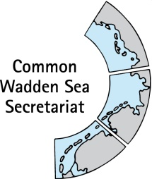
MEETING DOCUMENT
Ad hoc Working Group SWIMWAY (WG-Swimway 20-3)
07 September 2020
Online meeting

Agenda Item: 5. SWIMWAY pillar: Policies
Subject: SWIMWAY policy paper: executive summary and next steps
Document No.: WG-SWIMWAY 20-3/6/2
Date: 23 September 2020
Submitted by: Martha Buitenkamp, Paddy Walker

Within the SWIMWAY Vision and Action Programme initiation, a policy review on existing legislation relevant to the realisation of the trilateral fish targets was drafted (WG-SWIMWAY 20-2/5/1).
WG-SWIMWAY and invited guests were requested to submit their priority recommendations to the Task Group Management (TG-M) resulting from this document.
This document contains an executive summary of the policy report including next steps (Version 22 September 2020).
Proposal: The group is invited Review the ‘Executive Summary’ and decide to pass it on to the Task Group Management (TG-M).

Trilateral Fish Targets and European Policies

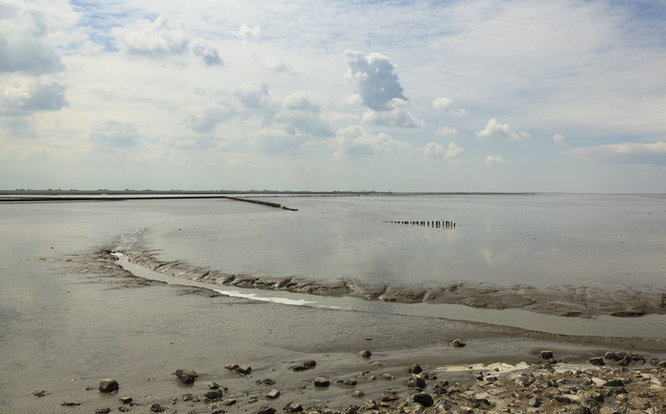
Executive summary
Inhalt
1 Introduction 3
2 Typical Wadden Sea Fish species 4
3 How Do European regulations support the protection of fish in the wadden Sea ? 5
4 Relevance of European law for the flagship and fleet species designated in the Swimway Action Programme 7
5 Trilateral Fish Targets supported by European law? 8
6 Next steps 10
Appendix I – Abbreviations & acronyms 13
Appendix II – List of typical wadden sea species 14

Introduction
Many marine and estuarine fish species depend on the Wadden Sea at some point in their life cycle. In recent decades, the populations of many fish species have declined in the Wadden Sea due to largely unknown reasons. As fish are an important part of the Wadden Sea ecosystem, the three Wadden Sea countries, Denmark, Germany and the Netherlands, declared at the Trilateral Governmental Conference on the Protection of the Wadden Sea, Leeuwarden 2018, to further develop the Trilateral Wadden Sea Swimway Vision, aiming to achieve the Trilateral Fish Targets for the Wadden Sea (adopted in the Wadden Sea Plan 2010).
The Trilateral Fish Targets have been formulated as followed:
Viable stocks of populations and a natural reproduction of typical Wadden Sea fish species;
Occurrence and abundance of fish species according to the natural dynamics in (a)biotic conditions;
Favourable living conditions for endangered fish species;
Maintenance of the diversity of natural habitats to provide substratum for spawning and nursery functions for juvenile fish;
Maintaining and restoring the possibilities for the passage of migrating fish between the Wadden Sea and inland waters.
The Swimway Vision is part of the Leeuwarden 2018 Wadden Sea Declaration as Annex 3. The Swimway Vision is described in an action programme, the so called Swimway Action Programme (Swimway, 2019). This programme is based on four pillars: research and monitoring; policy; measures; stakeholder involvement, communication and education. The policy pillar describes: “Policy objectives for fish in the Wadden Sea are formulated at the European, trilateral, national and regional levels. Within the Vision it is aimed for making an inventory of existing policies and regulations relevant to the Trilateral Fish Targets at the European, trilateral, national and regional level and to analyse their contribution to the realisation of the these targets. Following the analysis the need for additional actions could be identified. “
A trilateral working group has examined the existing guidelines and regulations with a relation to the trilateral fish targets at European level (via the national implementation of these regulations), trying to analyse their contribution to the realization of these targets. The resulting conclusions of this analysis and possible next steps are described in this document.

Typical Wadden Sea Fish species
The Wadden Sea fish populations are composed of a diverse species mix, with 163 recorded fish species. The functions that the Wadden Sea fulfils for those species may differ, with some species such as plaice using the Wadden Sea as a nursery area, whilst for others such as smelt or eel it is a migratory route between the sea and freshwater. In order to address this, the Swimway Action Programme has identified five groups, or guilds, based on the life style and functionality of the Wadden Sea for the species. This is based on occurrence patterns, feeding and reproduction behaviour, an approach which was used by Elliott et al. (2007) to increase the understanding of the use of estuaries by fishes. Each group is represented by one characteristic species (‘flagship’) and a number of related species (‘fleet’) as shown in Table 1 (Swimway, 2019).

Life cycle | Flagship | Fleet
Pelagic marine juvenile | Herring | Sprat, anchovy, horse mackerel, seabass
Demersal marine juvenile | Plaice | Sole, dab
Wadden Sea residents | Eelpout | Gobies, sandeel, sea snail, rock gunnel, mullets
Diadromous species | Smelt | Twaite shad, salmon, sea trout, houting, eel
Marine adventitious | Tope | Thornback ray, dogfish
Table 1 Flagship and fleet species for five functional life cycle groups according to occurrence patterns, feeding and reproduction behaviour (Swimway, 2019).

How Do European regulations support the protection of fish in the wadden Sea ?

The national implementation of the following existing policies relevant to the Trilateral Fish Targets at the European level were analysed regarding their contribution to the realisation of the Trilateral Fish Targets as follows:

Policy Directive | Main rationale and relevance for fish
- Natura2000 (Birds Directive - Directive 2009/147/EC and Habitats Directive - Directive 92/43/EEC) | Habitat protection and protection of selected fish species
- Water Framework Directive (WFD, Directive 2000/60/EC) | Improve water quality and removal of barriers to fish migration
- Marine Strategy Framework Directive (MSFD, Directive 2008/56/EC) | Integrated ecosystem approach for good environmental status
- European Eel Directive (ED, EC 1100/2007) | Specific species and measures for improving eel populations, other diadromous species may benefit

Of the directives, conventions and legislation described, in particular, the Danish and Dutch Natura2000 management plans based on the Birds and Habitats Directive contain specific and concrete measures for habitats and a small group of fish species in the Wadden Sea. In Germany, the Wadden Sea Plan 2010 is the Natura2000 management plan, supplemented by conservation goals for the individual protected areas, some of which deal with fish, but without concrete measures. The Natura2000 measures focus mainly on the qualifying habitats and some focal species. It seems to overlook the importance of specific measures aimed at other relevant species, which use these habitats, and underestimates the importance of fish as a crucial part of the Wadden Sea ecosystem. Nonetheless, fish species are characteristic for marine habitats and as such can be considered in management plans when specific measures are defined to improve subtidal habitats.
Fish species may benefit from the measures aimed at preserving and restoring habitats, but only if the specific needs of fish species are taken into account when developing management measures for the restoration of marine habitats. Measures to improve fish migration are implemented through policy directives such as the HD/Natura2000, WFD, MSFD and ED, but for other species the specific needs of fish species are still poorly understood and there are few specific restoration measures and those in place are not always monitored adequately. Another approach, which is derived from the N2000 conservation goals, is not to specifically implement any measures. This is the case in the German national parks: the focus is on a development of the ecosystems, which is largely not influenced by human activities (“let nature be nature”). Thus, it is recognized that fish are part of a natural ecosystem.
It can be observed, that the designation of Natura2000 areas provides the possibility to limit or even exclude certain (potential) threatening human activities. The three countries deal with this differently.
The WFD applies in parts of the coastal zone in Denmark, Germany and the Netherlands. Only in the transitional waters such as the River Ems objectives for fish are addressed. Fish are explicitly excluded in coastal waters. Much attention is paid to water quality and the removal of barriers in rivers and estuaries leading into the Wadden Sea, particularly for diadromous fish. However, due to the numerous transverse structures that still exist, which act as migration barriers, extensive efforts are still necessary to improve the passability for fish.
The MSFD differs from the specific approach of the HD and WFD as it is based on an ecosystem approach to the management of human activities having an impact on the marine environment, integrating the concepts of environmental protection and sustainable use. Therefore it can support fish communities in the Wadden Sea in Denmark and Germany, but is not applied to the Dutch Wadden Sea.
The ED has a clear and specific purpose. The measures aimed at removing physical barriers will also help other migrating fish species and a small positive trend has been noticed.
It should be noted that national and regional legislation that could contribute to achieving favourable living conditions for fish in the Wadden Sea and contribution to the realization of the Trilateral Fish Targets, was not systematically analysed. Therefore, the conclusions and proposed next steps mainly apply to the European regulations, as these provide a common basis for the trilateral Swimway Vision.

Relevance of European law for the flagship and fleet species designated in the Swimway Action Programme

The flagship and fleet species are each covered by different laws and regulations, which reflect their conservation status. See Table 2 for an overview of the policy frameworks in which the species are explicitly mentioned. Most of the species are covered by one or more frameworks, which gives scope for future work.
Life style | Flagship or fleet | Species | Relevant policy framework – for all three countries
Pelagic marine juvenile | Flagship | Herring | BHD (habitat), MSFD
 | Fleet | Sprat | WFD (transitional waters)
 |  | Anchovy | BHD (habitat), WFD (transitional waters)
 |  | Horse mackerel | -
 |  | Seabass | -
Demersal marine juvenile | Flagship | Plaice | BHD (habitat)
 | Fleet | Sole | BHD (habitat)
 |  | Dab | BHD (habitat)
Wadden Sea residents | Flagship | Eelpout | BHD (habitat)
 | Fleet | Gobies | WFD (transitional waters)
 |  | Sandeel | WFD (transitional waters)
 |  | Sea snail | BHD (habitat)
 |  | Rock gunnel | WFD (transitional waters)
 |  | Mullets | BHD (habitat)
Diadromous species | Flagship | Smelt | WFD (transitional waters)
 | Fleet | Twaite shad | BHD (species)
 |  | Salmon | WFD (transitional waters)
 |  | Sea trout | WFD (transitional waters)
 |  | Houting | BHD (DK, Ger), WFD (transitional waters)
 |  | Eel | ED
Marine adventitious | Flagship | Tope | MSFD (NL - North Sea only)
 | Fleet | Thornback ray | MSFD (NL - North Sea only)
 |  | Dogfish | MSFD (NL - North Sea only)
Table 2 Overview of policy frameworks relevant for the flagship and fleet species. Unless mentioned, these apply to all three countries. See Appendix I for a list of acronyms.

Trilateral Fish Targets supported by European law?

This chapter deals with the extent of the European legislation contribution to the realisation of the Trilateral Fish Targets as adopted in the WSP 2010. A short conclusion per targets follows hereafter.
- Viable stocks of populations and a natural reproduction of typical Wadden Sea fish species.
The definition of typical Wadden Sea fish is not consistent enough in the described regulations and policies to develop measures to enhance viable stock of Wadden Sea fish species. However, the Habitat Directive does list ‘characteristic’ species for each of the habitats which could give a framework for measures. It might also be possible for the countries to include the above mentioned flagship and fleet species in the Habitat descriptions more explicitly. These may also include some species of the typical Wadden Sea fish communities, such as plaice and herring.
2. Occurrence and abundance of fish species according to the natural dynamics in (a)biotic conditions.
The MSFD might be used to improve the natural dynamics in (a) biotic conditions, implementation of this framework has still some more potential in the three countries, based on their view that the HD and WFD requirements provide sufficient protection.
3. Favourable living conditions for endangered fish species.
The HD does not cover all endangered Wadden Sea fish species. The designated habitats (reefs, shallow large bays, estuaries, salt marshes and sand banks) are not sufficiently targeted for supporting favouring endangered fish species. Measures based on the HD and WFD regarding habitats will contribute to favourable living conditions for fish, such as reduced rates of mortality from fishing of adequate levels of food supply, unpolluted water and negative impacts of human activities. The focus of these measures however is not aimed at endangered fish species, though they would contribute to the living conditions.
The relevant of the analyzed policies for endangered fish species is the Eel Directive.
4. Maintenance of the diversity of natural habitats to provide substratum for spawning and nursery functions for juvenile fish.
The implementation of the specified Nature 2000 conservation goals differ in the three Wadden Sea states. Measures to restore, conserve and maintain the diversity of natural habitats, that have an indirect impact on fish, such as eelgrass, are part of the Natura2000 management plans in NL & DK while the goal in the National Parks in DE is to maintain natural processes as far as possible.
Additionally the MSFD provides a basis for a more integrated approach, it`s a possibility that still offers a lot more scope. The Wadden Sea states deal with that differently.
5. Maintaining and restoring the possibilities for the passage of migrating fish between the Wadden Sea and inland waters.
Both the WFD and the ED contain measures to mitigate barriers between the inland fresh water systems and the Wadden Sea.

Target | Relevant existing policy | Gaps
Viable stocks of populations and a natural reproduction of typical Wadden Sea fish species. | HD, MSFD | No conservation measures for non-commercial fish species (e.g. hook nose, gobies, etc.) and locally extirpated species (e.g. thornback ray, sturgeon, spurdog, houting, etc.).
Occurrence and abundance of fish species according to the natural dynamics in (a)biotic conditions. | HD, WFD, MSFD | No policy currently implements measures for non-commercial fish species (e.g. hook nose, gobies, etc.) and rare or locally extirpated species (e.g. thornback ray, sturgeon, spurdog)
Favourable living conditions for endangered fish species. | HD,WFD, MSFD, ED | No policy currently implements measures for rare or locally extirpated species (e.g. thornback ray, sturgeon, spurdog, etc.).
Maintenance of the diversity of natural habitats to provide substratum for spawning and nursery functions for juvenile fish. | HD, MSFD | Knowledge about spawning and nursery habitats is limited. Potential areas could be protected under HD or part of the HD management plans, CFP and/or MSFD.
Maintaining and restoring the possibilities for the passage of migrating fish between the Wadden Sea and inland waters. | WFD, ED | Knowledge on migration success differs by river basin and species. Further improvements on marine freshwater connectivity are necessary.
Table. 3. Trilateral Fish Targets and their relation to relevant existing policies and gaps.

Next steps

Proper implementation of the Trilateral Fish Targets in the national implementation of the European regulation will require more effort and collaboration at all relevant levels of legislation, especially national and regional. Regarding the regulations based on European level several ways to achieve this are suggested. Starting with a knowledge based or rational approach, this should build on what is already known to start improving the situation for fish and enable the implementation of current fish policy for the Wadden Sea with regard to the Trilateral Fish Targets. Emphasis on more research, monitoring and expertise, will – in this approach – lead to better targeted approaches and measures. Therefore the Trilateral Fish Targets should become SMART, causes of decline better known, and measures more specific defined. This is the approach that has been developed in the Swimway Action Programme (Swimway, 2019) in order to address the Trilateral Fish Targets. The Swimway Action Programme states that “…the only way to arrive at sensible measures aimed at improving the situation for fish is to view the function of the Wadden Sea within the whole life cycle of a fish species. To understand population dynamics, investing in quantifying the rates that drive population developments, such as births, deaths, immigration and emigration (demographic or vital rates) is needed” (Swimway 2019, chapter 2.1 General approach). Research on predator-prey relationships, eco-physiology, species-habitat interactions and connectivity was identified as being needed to understand this. Research programmes are already being carried out and new insights into the factors influencing fish population dynamics will feed into the process over time. The following actions are identified.
Although implementation of policy should preferably be based on scientific knowledge, thorough research as described above takes time and requires sufficient funds. And next to that, available insights and existing knowledge about the Wadden Sea, may be sufficient to be able to formulate adjustments of the implementation aiming to a better support of the Trilateral Fish Targets.

- Define Smart targets
The Trilateral Fish Targets are formulated at a generic and abstract level. This is partly due to lack of knowledge, as mentioned in the Swimway Action Programme, which concludes “The main benefit arising from the SWIMWAY research outlined above will be the identification of population bottlenecks and the translation of this knowledge into effective management and conservation measures. Closing these knowledge gaps will help to improve effective conservation” (Swimway 2019, chapter 2.9 concluding remarks). In future, it would tbe very helpful to consider making the Trilateral Fish Targets SMART by defining quantitative sub-targets for given species and habitats. The Report from the 2019 Swimway conference has developed this principal further (Dänhardt, 2019). The author proposes a four step approach: 1) formulate generic, overarching goals everybody can agree on; 2) specify these into more specific SMART targets; 3) develop a technical implementation plan; and 4) take immediate action to protect fish while specifying the targets. This means that there does not have to be any delay with implementing the targets.

- Focus on typical Wadden Sea species
The focus on fish species and communities which are (or were) typical for the Wadden Sea, also with respect to historic knowledge of local or regional extinction, is essential when addressing the Trilateral Fish Targets. An experts list of priority species which are used in analyses (Tulp et al., 2017) are attached in Appendix II as a list of ‘typical’ fish species. The Swimway Action Programme identifies 23 flagship and fleet species within five ecological groups of fish species (ecological guilds) which share similar behaviour and ecological demands within each guild. This approach has been described earlier in the document and will help to focus research and conservation efforts (see chapter 2). The current policy frameworks give enough scope to include these species. As the sturgeon is covered by the HD it might be good to include this in the list of fleet species, even though it has disappeared from the region, as there might be ample leverage to develop management measures which would benefit other diadromous species.
- Identify threats and/or causes of declines in fish populations
The ecological requirements of many species are known to a limited extent and the associated threats as mentioned in the Trilateral Fish Targets are quite generic. This calls for research specifically aimed at pinpointing the bottlenecks for the achievement of the Trilateral Fish Targets. Research into the underlying causes of the decline of fish populations will contribute to development of targeted and knowledge based proposals regarding the implementation of the current policies aiming to resolve bottlenecks. Now that these bottlenecks are insufficiently known, it is difficult to assess to what extent the existing implementation of the policy is effective. These gaps in knowledge are addressed in the SWIMWAY Programme.
- Make better use of available knowledge and expertise
A lot of knowledge is already available. By inviting experts to share their insights, by collecting and combining this knowledge and by developing collective views, a lot of questions and gaps mentioned above may receive a satisfying answer. Although it may be hard to determine which specific measures will benefit fish populations without a deeper analysis, it may be worthwhile to check what is already known and whether that can lead to appropriate measures. Identification of areas of importance for relevant processes in species’ life cycles i.e. spawning or nursery habitats and considering potential spatial measures to improve the status of extirpated, threatened or declining species.
Existing knowledge may be of great value already to provide clear recommendations for a better implementation of the existing legislative framework and trilateral declarations and the Wadden Sea Plan. At the Swimway conference in 2019 recommendation were made to improve exchange of knowledge and it is recommended to develop a framework for this.

- Make better use of the existing legislative framework,
The link between the Trilateral Fish Targets and existing European regulations could be established, but the full potential of the regulations is currently not used by either member state. The MSFD for example could be used to establish spatial management measures to protect threatened and valuable fish species in the Wadden Sea. Despite the partly required, complex coordination, there are important options for protection.
In the “fit for purpose review”, the European Commission recommended to achieve more integration between the Natura2000 (HD & BD), WFD and other directives. This aim may also benefit the Trilateral Fish Targets.
The national HD and WFD plans have to be evaluated and adapted every six years. This might provide an opportunity to enhance the attention for the Wadden Sea fish populations. Lobby to improve these plans by the trilateral partners at the national level (regarding e.g. the implementation of the EU directives in national legislation) is needed. A first step would be for the three countries to collaborate to include the flagship and fleet species more explicitly in the national management and monitoring plans. This will mean a more comprehensive approach to including species from the different ecological groups.

- Focus on national implementation
In the working group’s analysis the national policies and regulations have not been analysed. Proposals for implementation of the national and regional Wadden Sea policy will likely be a feasible way to implement the Trilateral Fish Targets successfully. Supplementary to this review of European legislation, an analysis of the national and regional policies on fish of the three Wadden Sea countries, is recommended.

Appendix I – Abbreviations & acronyms
BD | Birds Directive
CWSS | Common Wadden Sea Secretariat
ED | EU Eel Directive
HD | EU Habitat Directive
MSFD | EU Marine Strategy Framework Directive
N2000 | Natura 2000
SMART | Specific - Measurable - Achievable - Realistic -Timely
WFD | EU Water Framework Directive
WSP | Trilateral Wadden Sea Plan

Appendix II – List of typical wadden sea species
Besides the designated Flagship and Fleet species, typical Wadden Sea fish species have been selected from the QSR and N2000. Upper fourteen = priority species selected for spatial and temporal analyses by Bolle et al., 2009 and used in the Quality Status Report (QSR, Jager et al., 2009). Last seven species also mentioned in N2000 species as related to one of the major habitats designated for the Wadden Sea (H1110). Species marked with * are designated species for N2000 for the Wadden Sea. Species in bold type = in both QSR and N2000. Guild: CA = diadromous; ER = estuarine resident; MJ = marine juvenile; MS = marine seasonal. Sensitivity to driving forces: CC = climate change; FM = fishing mortality; HD = habitat degradation; LP = local pressures; NE = nutrient enrichment. Source: Walker (2015).
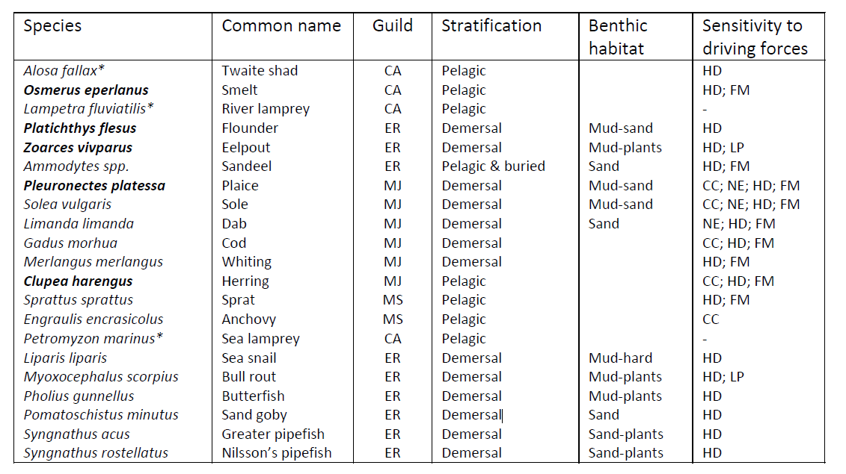

Leeuwarden Declaration 2018
Bolle et al. (2009) and Jager et al (2009) reported of 150 species including 13 freshwater species.
https://www.waddensea-worldheritage.org/node/973
https://www.waddensea-worldheritage.org/node/973
Personal message from M. Buitenkamp following consultation with the Dutch Ministry of Agriculture, Nature and Food Quality

